**Emergency Responder Radio System**

**Coverage Report Test Results**

|  |  |
| --- | --- |
| **Date Prepared:** | Sep 9, 2024 |
| **Test File:** | PRMCE 20240828 |
| **Test Location:** | _PRMCE 800 |
|  |  |
| **Technician:** | Aaron Keyte |
| **FCC#:** | PG00066071 |

**Building: _PRMCE 800**

**Result: Fail (Adjacent Area Rule)**

**Test Report Summary**

| **Channel/ Ch Group** | **Freq (MHz)** | **Technology** | **Band** | **Result** | **Area Points**  **passed (%)** | **Critical Points passed (%)** |
| --- | --- | --- | --- | --- | --- | --- |
| 852937 | 852.93750 | P25 | PRMCE | Fail (Adjacent) | 434/537 (80%) | 153/187 (81%) |

|  |  |  |  |
| --- | --- | --- | --- |
| **Test Details** | | | |
| **Number of Floors Tested:** | 22 | **Result Calculation:** | By area per floor |
| **Number of Areas Tested:** | 537 | **Area Pass Criteria:** | 95% |
| **Number of Critical Points Tested:** | 187 | **Critical Points Pass Criteria:** | 99% |
|  |  | **Apply Adjacent Area Rule:** | Yes |

|  |  |  |  |  |
| --- | --- | --- | --- | --- |
| **Equipment Configuration** | | | | |
| **Vendor** | **Application** | **Device** | **Calibration Expires** | **Antenna info** |
| PCTEL | SeeHawk Touch  rel 3.2.0.2 | SeeGull IBflex Device rel 3.10.0.0  SN: 081911044 | 2-13-2026 |  |

**Threshold Settings**

| **Measurement** | **DL Area Point** | **UL Area Point** | **DL Critical Point** | **UL Critical Point** | **Use for grading** |
| --- | --- | --- | --- | --- | --- |
| P25 Power (RSSI) | -95.0 dBm | -95.0 dBm | -95.0 dBm | -95.0 dBm | Yes |
| DAQ | 3.0 |  |  |  | Yes |

**Floors Result**

| **Floor Plan** | **852937 852.93750** |
| --- | --- |
| A1.0 | **Fail (Adjacent)** |
| A1.1 | **Fail (Adjacent)** |
| A1.2 | **Fail (Adjacent)** |
| A1.3 | **Fail (Adjacent)** |
| A1.4 | **Fail (Adjacent)** |
| A1.5 | **Pass** |
| A1.6 | **Pass** |
| A1.7 | **Pass** |
| A1.8 | **Pass** |
| A4.B | **Fail (Adjacent)** |
| A4.G | **Fail** |
| A4.1 | **Fail** |
| A4.2 | **Fail** |
| A4.3 | **Pass** |
| A4.4 | **Pass** |
| A4.5 | **Pass** |
| A4.6 | **Fail** |
| A4.7 | **Pass** |
| A4.8 | **Pass** |
| A4.9 | **Fail** |
| A4.10 | **Fail** |
| A.4R | **Pass** |

**Floor: A1.0**

**Channel: 852937**

**Result: Fail (Adjacent)**

| **Freq (MHz)** | **Tech** | **Band** | **Ant Gain** | **Cable Loss** | **Ph.** | **Type** | **Mod** | **NAC** | **Area Points passed (%)** | **Critical Points passed (%)** |
| --- | --- | --- | --- | --- | --- | --- | --- | --- | --- | --- |
| 852.93750 | P25 | PRMCE | 0.00 | 0.00 |  |  |  |  | 0/8 (0%) | 0/4 (0%) |

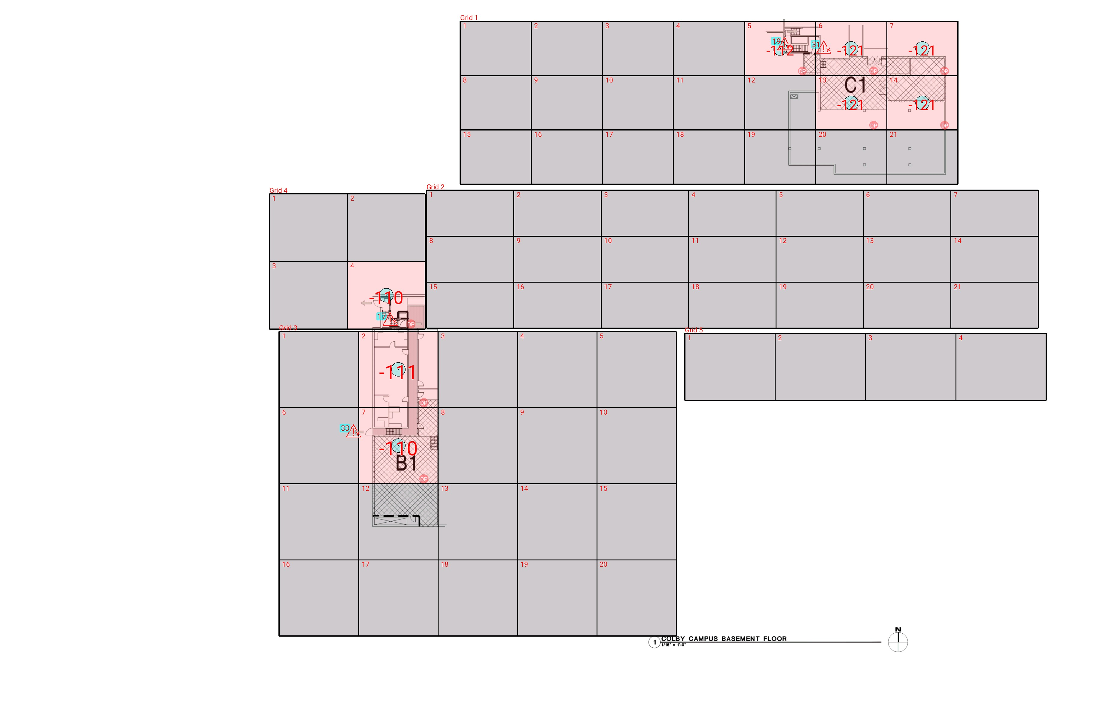

| **Grid** | **# of Areas** | **Area Size (sq. ft)** | **Area Width**  **(ft)** | **Area Height**  **(ft)** | **Ignore Area Color** | **Comments** |
| --- | --- | --- | --- | --- | --- | --- |
| 1 | 21 | 272.91 | 16.54 | 16.50 | Black |  |
| 2 | 21 | 284.23 | 20.34 | 13.98 | Black |  |
| 3 | 20 | 428.00 | 18.49 | 23.15 | Black |  |
| 4 | 4 | 372.29 | 18.13 | 20.54 | Black |  |
| 5 | 4 | 428.33 | 21.03 | 20.37 | Black |  |

**Floor: A1.0**

**Channel: 852937**

| **Critical Point Report** | | | | | | | |
| --- | --- | --- | --- | --- | --- | --- | --- |
| **Critical Point** | **DL**  **Power**  **(dBm)** | **DL**  **DAQ** | **UL**  **Power**  **(dBm)** | **UL**  **DAQ** | **Result** | **DL**  **Loss**  **(dB)** | **Comment** |
| 17 | -110.81 |  |  |  | **Fail** |  |  |
| 19 | -101.71 |  |  |  | **Fail** |  |  |
| 31 | -109.11 |  |  |  | **Fail** |  |  |
| 33 | -100.02 |  |  |  | **Fail** |  |  |

| **Area Report** | | | | | | | | |
| --- | --- | --- | --- | --- | --- | --- | --- | --- |
| **Grid** | **Area** | **DL**  **Power**  **(dBm)** | **DL**  **DAQ** | **UL**  **Power**  **(dBm)** | **UL**  **DAQ** | **Result** | **DL**  **Loss**  **(dB)** | **Comment** |
| 1 | 1 | NT | NT | NT | NT | **NT** |  |  |
| 1 | 2 | NT | NT | NT | NT | **NT** |  |  |
| 1 | 3 | NT | NT | NT | NT | **NT** |  |  |
| 1 | 4 | NT | NT | NT | NT | **NT** |  |  |
| 1 | 5 | -111.41 |  |  |  | **Fail** |  |  |
| 1 | 6 | -120.03 |  |  |  | **Fail** |  |  |
| 1 | 7 | -120.86 |  |  |  | **Fail** |  |  |
| 1 | 8 | NT | NT | NT | NT | **NT** |  |  |
| 1 | 9 | NT | NT | NT | NT | **NT** |  |  |
| 1 | 10 | NT | NT | NT | NT | **NT** |  |  |
| 1 | 11 | NT | NT | NT | NT | **NT** |  |  |
| 1 | 12 | NT | NT | NT | NT | **NT** |  |  |
| 1 | 13 | -120.76 |  |  |  | **Fail** |  |  |
| 1 | 14 | -120.52 |  |  |  | **Fail** |  |  |
| 1 | 15 | NT | NT | NT | NT | **NT** |  |  |
| 1 | 16 | NT | NT | NT | NT | **NT** |  |  |
| 1 | 17 | NT | NT | NT | NT | **NT** |  |  |
| 1 | 18 | NT | NT | NT | NT | **NT** |  |  |
| 1 | 19 | NT | NT | NT | NT | **NT** |  |  |
| 1 | 20 | NT | NT | NT | NT | **NT** |  |  |
| 1 | 21 | NT | NT | NT | NT | **NT** |  |  |
| 2 | 1 | NT | NT | NT | NT | **NT** |  |  |
| 2 | 2 | NT | NT | NT | NT | **NT** |  |  |
| 2 | 3 | NT | NT | NT | NT | **NT** |  |  |
| 2 | 4 | NT | NT | NT | NT | **NT** |  |  |
| 2 | 5 | NT | NT | NT | NT | **NT** |  |  |
| 2 | 6 | NT | NT | NT | NT | **NT** |  |  |
| 2 | 7 | NT | NT | NT | NT | **NT** |  |  |
| 2 | 8 | NT | NT | NT | NT | **NT** |  |  |
| 2 | 9 | NT | NT | NT | NT | **NT** |  |  |
| 2 | 10 | NT | NT | NT | NT | **NT** |  |  |
| 2 | 11 | NT | NT | NT | NT | **NT** |  |  |
| 2 | 12 | NT | NT | NT | NT | **NT** |  |  |
| 2 | 13 | NT | NT | NT | NT | **NT** |  |  |
| 2 | 14 | NT | NT | NT | NT | **NT** |  |  |
| 2 | 15 | NT | NT | NT | NT | **NT** |  |  |
| 2 | 16 | NT | NT | NT | NT | **NT** |  |  |
| 2 | 17 | NT | NT | NT | NT | **NT** |  |  |
| 2 | 18 | NT | NT | NT | NT | **NT** |  |  |
| 2 | 19 | NT | NT | NT | NT | **NT** |  |  |
| 2 | 20 | NT | NT | NT | NT | **NT** |  |  |
| 2 | 21 | NT | NT | NT | NT | **NT** |  |  |
| 3 | 1 | NT | NT | NT | NT | **NT** |  |  |
| 3 | 2 | -110.42 |  |  |  | **Fail** |  |  |
| 3 | 3 | NT | NT | NT | NT | **NT** |  |  |
| 3 | 4 | NT | NT | NT | NT | **NT** |  |  |
| 3 | 5 | NT | NT | NT | NT | **NT** |  |  |
| 3 | 6 | NT | NT | NT | NT | **NT** |  |  |
| 3 | 7 | -109.27 |  |  |  | **Fail** |  |  |
| 3 | 8 | NT | NT | NT | NT | **NT** |  |  |
| 3 | 9 | NT | NT | NT | NT | **NT** |  |  |
| 3 | 10 | NT | NT | NT | NT | **NT** |  |  |
| 3 | 11 | NT | NT | NT | NT | **NT** |  |  |
| 3 | 12 | NT | NT | NT | NT | **NT** |  |  |
| 3 | 13 | NT | NT | NT | NT | **NT** |  |  |
| 3 | 14 | NT | NT | NT | NT | **NT** |  |  |
| 3 | 15 | NT | NT | NT | NT | **NT** |  |  |
| 3 | 16 | NT | NT | NT | NT | **NT** |  |  |
| 3 | 17 | NT | NT | NT | NT | **NT** |  |  |
| 3 | 18 | NT | NT | NT | NT | **NT** |  |  |
| 3 | 19 | NT | NT | NT | NT | **NT** |  |  |
| 3 | 20 | NT | NT | NT | NT | **NT** |  |  |
| 4 | 1 | NT | NT | NT | NT | **NT** |  |  |
| 4 | 2 | NT | NT | NT | NT | **NT** |  |  |
| 4 | 3 | NT | NT | NT | NT | **NT** |  |  |
| 4 | 4 | -109.69 |  |  |  | **Fail** |  |  |
| 5 | 1 | NT | NT | NT | NT | **NT** |  |  |
| 5 | 2 | NT | NT | NT | NT | **NT** |  |  |
| 5 | 3 | NT | NT | NT | NT | **NT** |  |  |
| 5 | 4 | NT | NT | NT | NT | **NT** |  |  |

**Floor: A1.1**

**Channel: 852937**

**Result: Fail (Adjacent)**

| **Freq (MHz)** | **Tech** | **Band** | **Ant Gain** | **Cable Loss** | **Ph.** | **Type** | **Mod** | **NAC** | **Area Points passed (%)** | **Critical Points passed (%)** |
| --- | --- | --- | --- | --- | --- | --- | --- | --- | --- | --- |
| 852.93750 | P25 | PRMCE | 0.00 | 0.00 |  |  |  |  | 12/61 (19%) | 17/27 (62%) |

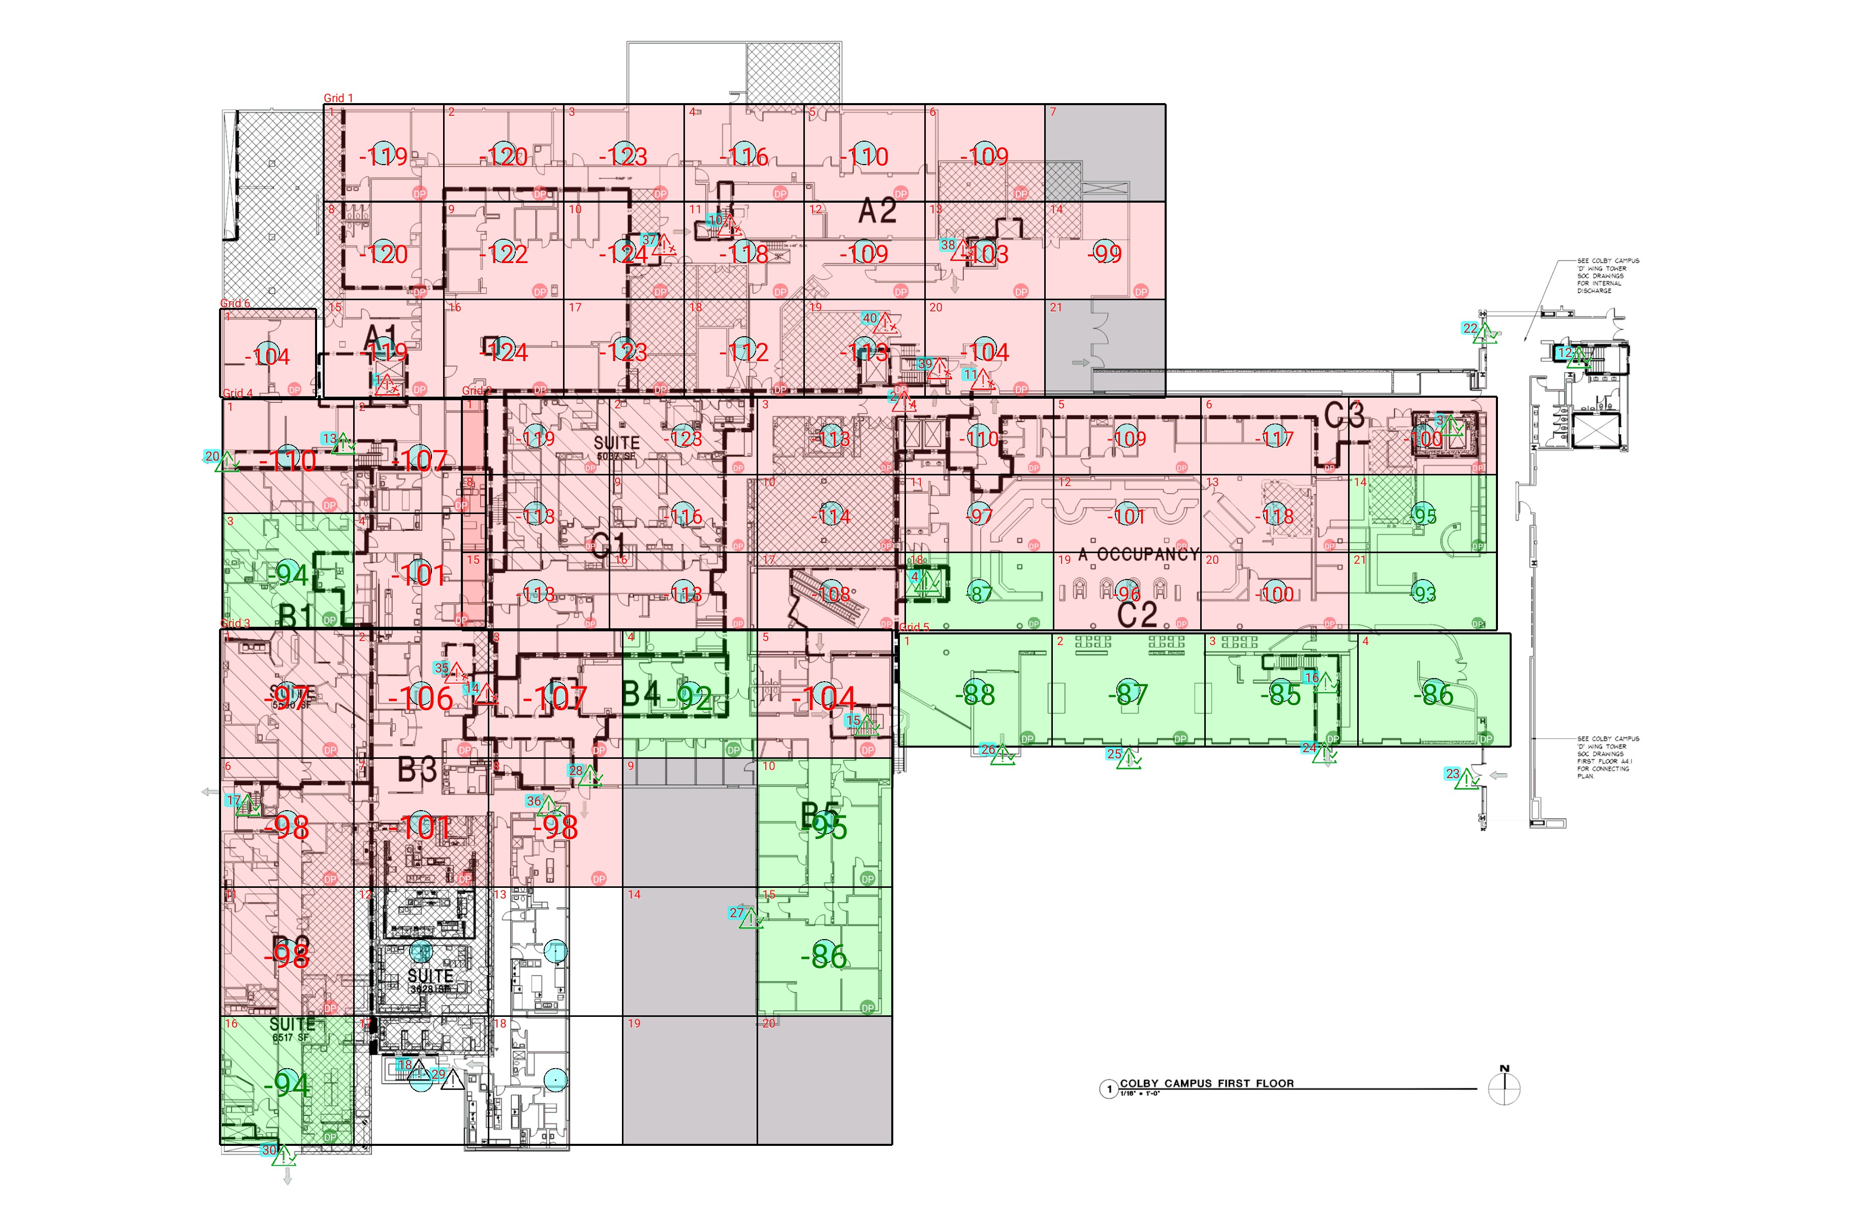

| **Grid** | **# of Areas** | **Area Size (sq. ft)** | **Area Width**  **(ft)** | **Area Height**  **(ft)** | **Ignore Area Color** | **Comments** |
| --- | --- | --- | --- | --- | --- | --- |
| 1 | 21 | 290.55 | 16.54 | 17.57 | Black |  |
| 2 | 21 | 284.23 | 20.34 | 13.98 | Black |  |
| 3 | 20 | 428.00 | 18.49 | 23.15 | Black |  |
| 4 | 4 | 372.29 | 18.13 | 20.54 | Black |  |
| 5 | 4 | 428.33 | 21.03 | 20.37 | Black |  |
| 6 | 1 | 209.75 | 13.25 | 15.83 | Black |  |

**Floor: A1.1**

**Channel: 852937**

| **Critical Point Report** | | | | | | | |
| --- | --- | --- | --- | --- | --- | --- | --- |
| **Critical Point** | **DL**  **Power**  **(dBm)** | **DL**  **DAQ** | **UL**  **Power**  **(dBm)** | **UL**  **DAQ** | **Result** | **DL**  **Loss**  **(dB)** | **Comment** |
| 1 | -120.95 |  |  |  | **Fail** |  |  |
| 2 | -107.67 |  |  |  | **Fail** |  |  |
| 3 | -94.44 |  |  |  | **Pass** |  |  |
| 4 | -89.07 |  |  |  | **Pass** |  |  |
| 10 | -122.92 |  |  |  | **Fail** |  |  |
| 11 | -107.81 |  |  |  | **Fail** |  |  |
| 12 | -85.34 |  |  |  | **Pass** |  |  |
| 13 | -94.44 |  |  |  | **Pass** |  |  |
| 14 | -115.05 |  |  |  | **Fail** |  |  |
| 15 | -93.91 |  |  |  | **Pass** |  |  |
| 16 | -90.20 |  |  |  | **Pass** |  |  |
| 17 | -84.12 |  |  |  | **Pass** |  |  |
| 18 |  |  |  |  |  |  |  |
| 20 | -92.54 |  |  |  | **Pass** |  |  |
| 22 | -85.44 |  |  |  | **Pass** |  |  |
| 23 | -85.68 |  |  |  | **Pass** |  |  |
| 24 | -72.49 |  |  |  | **Pass** |  |  |
| 25 | -88.43 |  |  |  | **Pass** |  |  |
| 26 | -83.10 |  |  |  | **Pass** |  |  |
| 27 | -82.82 |  |  |  | **Pass** |  |  |
| 28 | -85.96 |  |  |  | **Pass** |  |  |
| 29 |  |  |  |  |  |  |  |
| 30 | -86.58 |  |  |  | **Pass** |  |  |
| 35 | -107.80 |  |  |  | **Fail** |  |  |
| 36 | -94.16 |  |  |  | **Pass** |  |  |
| 37 | -120.79 |  |  |  | **Fail** |  |  |
| 38 | -101.44 |  |  |  | **Fail** |  |  |
| 39 | -100.90 |  |  |  | **Fail** |  |  |
| 40 | -101.10 |  |  |  | **Fail** |  |  |

| **Area Report** | | | | | | | | |
| --- | --- | --- | --- | --- | --- | --- | --- | --- |
| **Grid** | **Area** | **DL**  **Power**  **(dBm)** | **DL**  **DAQ** | **UL**  **Power**  **(dBm)** | **UL**  **DAQ** | **Result** | **DL**  **Loss**  **(dB)** | **Comment** |
| 1 | 1 | -118.76 |  |  |  | **Fail** |  |  |
| 1 | 2 | -119.77 |  |  |  | **Fail** |  |  |
| 1 | 3 | -122.25 |  |  |  | **Fail** |  |  |
| 1 | 4 | -115.98 |  |  |  | **Fail** |  |  |
| 1 | 5 | -109.89 |  |  |  | **Fail** |  |  |
| 1 | 6 | -108.59 |  |  |  | **Fail** |  |  |
| 1 | 7 | NT | NT | NT | NT | **NT** |  |  |
| 1 | 8 | -119.82 |  |  |  | **Fail** |  |  |
| 1 | 9 | -121.29 |  |  |  | **Fail** |  |  |
| 1 | 10 | -123.48 |  |  |  | **Fail** |  |  |
| 1 | 11 | -117.85 |  |  |  | **Fail** |  |  |
| 1 | 12 | -108.11 |  |  |  | **Fail** |  |  |
| 1 | 13 | -102.94 |  |  |  | **Fail** |  |  |
| 1 | 14 | -98.94 |  |  |  | **Fail** |  |  |
| 1 | 15 | -118.55 |  |  |  | **Fail** |  |  |
| 1 | 16 | -123.43 |  |  |  | **Fail** |  |  |
| 1 | 17 | -122.15 |  |  |  | **Fail** |  | no ul |
| 1 | 18 | -111.55 |  |  |  | **Fail** |  |  |
| 1 | 19 | -112.88 |  |  |  | **Fail** |  |  |
| 1 | 20 | -103.44 |  |  |  | **Fail** |  |  |
| 1 | 21 | NT | NT | NT | NT | **NT** |  |  |
| 2 | 1 | -118.92 |  |  |  | **Fail** |  |  |
| 2 | 2 | -122.14 |  |  |  | **Fail** |  |  |
| 2 | 3 | -112.90 |  |  |  | **Fail** |  |  |
| 2 | 4 | -109.17 |  |  |  | **Fail** |  |  |
| 2 | 5 | -108.36 |  |  |  | **Fail** |  |  |
| 2 | 6 | -116.02 |  |  |  | **Fail** |  | bad ul |
| 2 | 7 | -99.51 |  |  |  | **Fail** |  |  |
| 2 | 8 | -112.16 |  |  |  | **Fail** |  |  |
| 2 | 9 | -115.42 |  |  |  | **Fail** |  | ul bad |
| 2 | 10 | -113.12 |  |  |  | **Fail** |  | bad ul |
| 2 | 11 | -96.58 |  |  |  | **Fail** |  |  |
| 2 | 12 | -100.95 |  |  |  | **Fail** |  |  |
| 2 | 13 | -117.17 |  |  |  | **Fail** |  |  |
| 2 | 14 | -94.04 |  |  |  | **Pass** |  | bad ul |
| 2 | 15 | -112.61 |  |  |  | **Fail** |  |  |
| 2 | 16 | -112.53 |  |  |  | **Fail** |  |  |
| 2 | 17 | -107.96 |  |  |  | **Fail** |  |  |
| 2 | 18 | -86.31 |  |  |  | **Pass** |  |  |
| 2 | 19 | -95.25 |  |  |  | **Fail** |  |  |
| 2 | 20 | -99.54 |  |  |  | **Fail** |  |  |
| 2 | 21 | -92.41 |  |  |  | **Pass** |  |  |
| 3 | 1 | -96.98 |  |  |  | **Fail** |  |  |
| 3 | 2 | -105.08 |  |  |  | **Fail** |  |  |
| 3 | 3 | -106.82 |  |  |  | **Fail** |  |  |
| 3 | 4 | -91.02 |  |  |  | **Pass** |  | no ul |
| 3 | 5 | -103.10 |  |  |  | **Fail** |  |  |
| 3 | 6 | -97.45 |  |  |  | **Fail** |  |  |
| 3 | 7 | -100.62 |  |  |  | **Fail** |  |  |
| 3 | 8 | -97.35 |  |  |  | **Fail** |  | no ul |
| 3 | 9 | NT | NT | NT | NT | **NT** |  |  |
| 3 | 10 | -94.11 |  |  |  | **Pass** |  |  |
| 3 | 11 | -97.20 |  |  |  | **Fail** |  |  |
| 3 | 14 | NT | NT | NT | NT | **NT** |  |  |
| 3 | 15 | -85.80 |  |  |  | **Pass** |  |  |
| 3 | 16 | -93.83 |  |  |  | **Pass** |  |  |
| 3 | 19 | NT | NT | NT | NT | **NT** |  |  |
| 3 | 20 | NT | NT | NT | NT | **NT** |  |  |
| 4 | 1 | -109.42 |  |  |  | **Fail** |  |  |
| 4 | 2 | -106.21 |  |  |  | **Fail** |  |  |
| 4 | 3 | -93.98 |  |  |  | **Pass** |  |  |
| 4 | 4 | -100.11 |  |  |  | **Fail** |  |  |
| 5 | 1 | -87.80 |  |  |  | **Pass** |  |  |
| 5 | 2 | -86.15 |  |  |  | **Pass** |  |  |
| 5 | 3 | -84.53 |  |  |  | **Pass** |  |  |
| 5 | 4 | -85.81 |  |  |  | **Pass** |  |  |
| 6 | 1 | -103.78 |  |  |  | **Fail** |  |  |

**Floor: A1.2**

**Channel: 852937**

**Result: Fail (Adjacent)**

| **Freq (MHz)** | **Tech** | **Band** | **Ant Gain** | **Cable Loss** | **Ph.** | **Type** | **Mod** | **NAC** | **Area Points passed (%)** | **Critical Points passed (%)** |
| --- | --- | --- | --- | --- | --- | --- | --- | --- | --- | --- |
| 852.93750 | P25 | PRMCE | 0.00 | 0.00 |  |  |  |  | 25/48 (52%) | 9/18 (50%) |

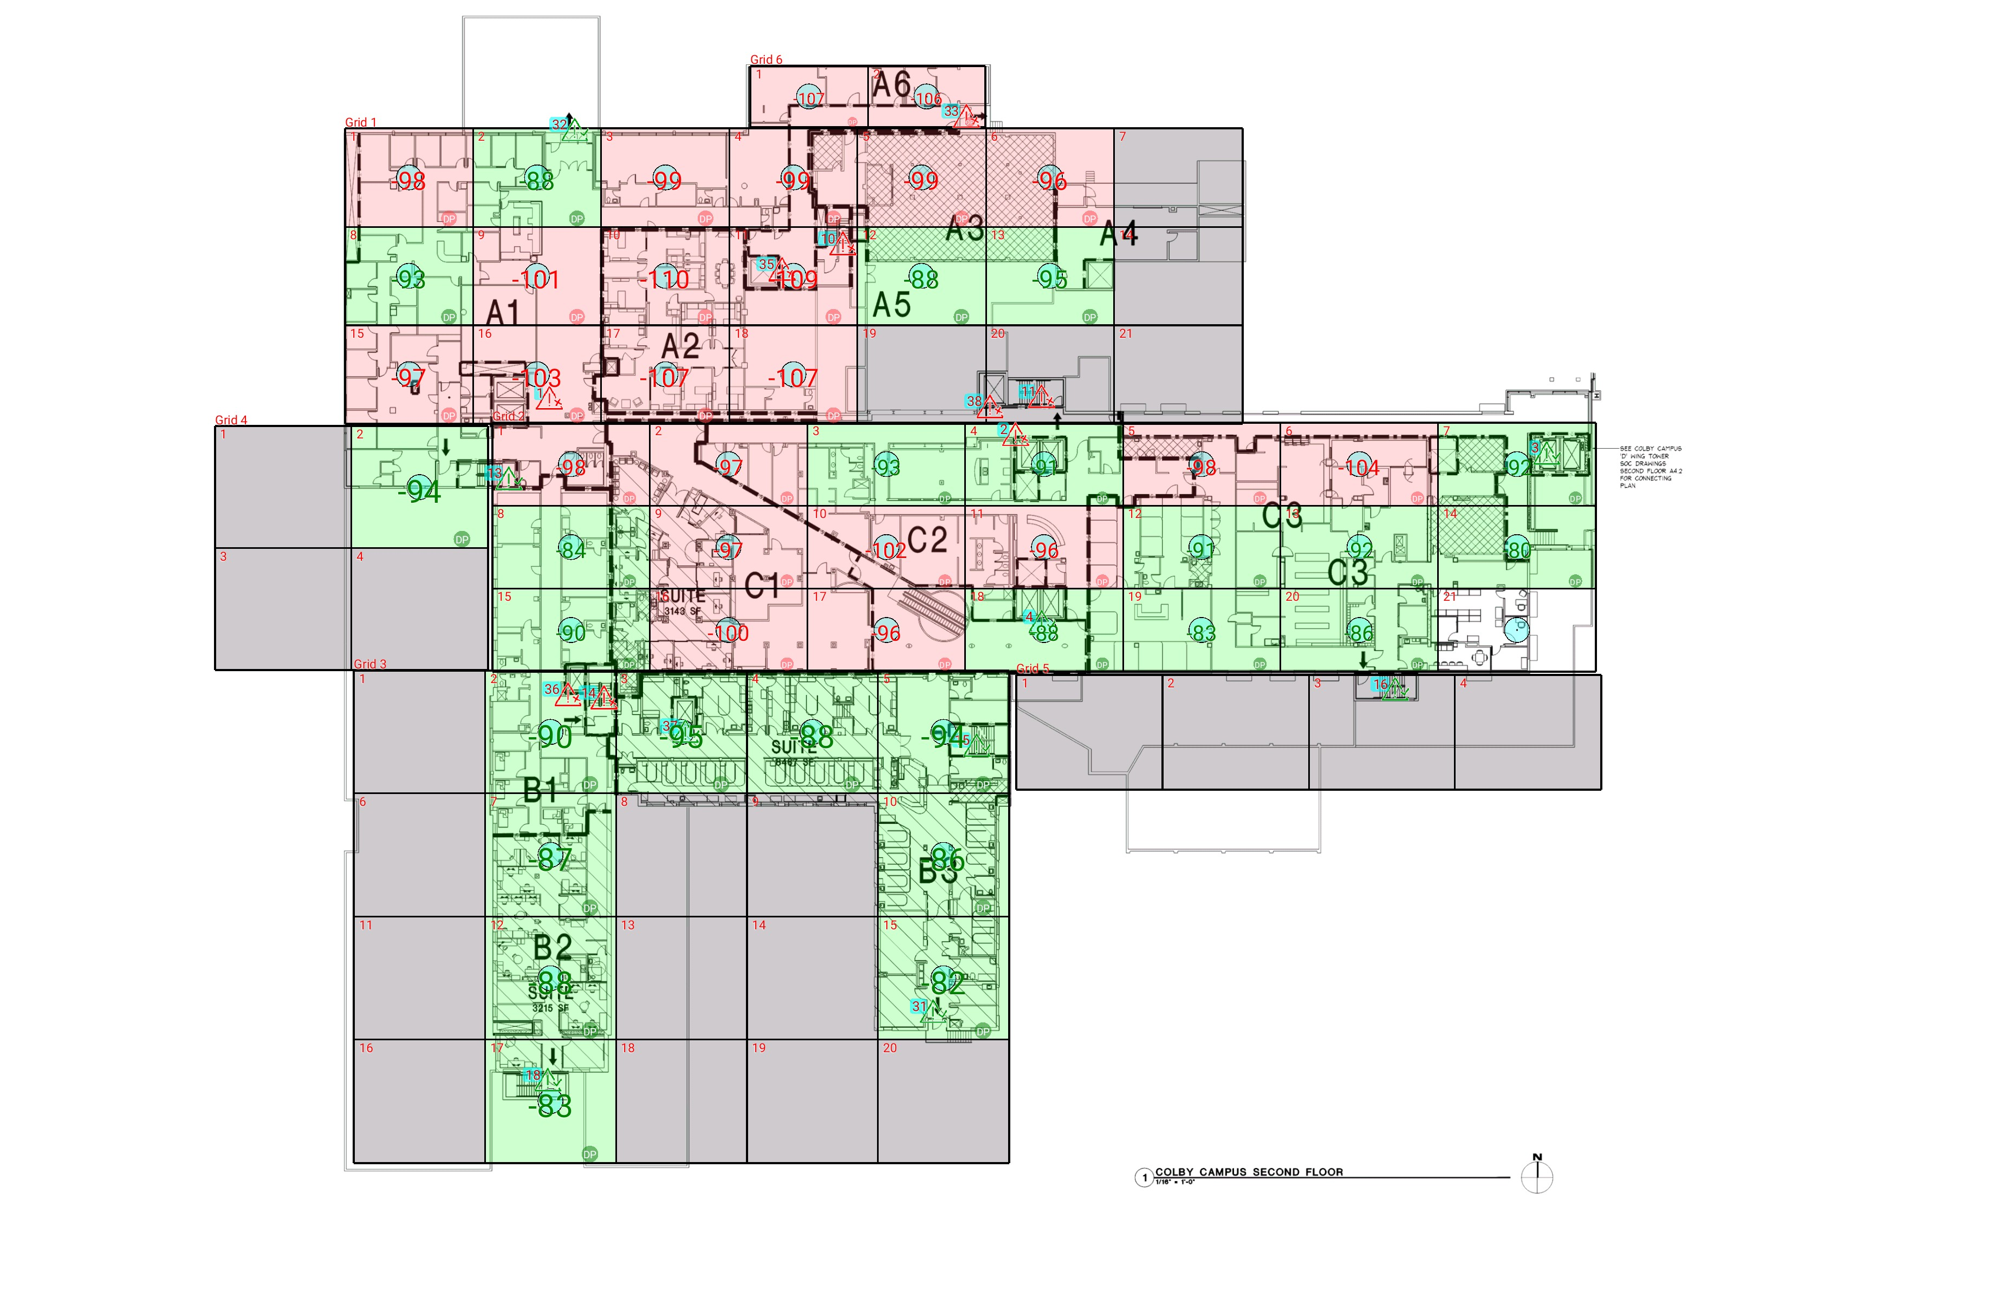

| **Grid** | **# of Areas** | **Area Size (sq. ft)** | **Area Width**  **(ft)** | **Area Height**  **(ft)** | **Ignore Area Color** | **Comments** |
| --- | --- | --- | --- | --- | --- | --- |
| 1 | 21 | 274.29 | 16.54 | 16.58 | Black |  |
| 2 | 21 | 284.23 | 20.34 | 13.98 | Black |  |
| 3 | 20 | 350.68 | 16.90 | 20.75 | Black |  |
| 4 | 4 | 361.71 | 17.61 | 20.54 | Black |  |
| 5 | 4 | 365.23 | 18.87 | 19.36 | Black |  |
| 6 | 2 | 156.85 | 15.14 | 10.36 | Black |  |

**Floor: A1.2**

**Channel: 852937**

| **Critical Point Report** | | | | | | | |
| --- | --- | --- | --- | --- | --- | --- | --- |
| **Critical Point** | **DL**  **Power**  **(dBm)** | **DL**  **DAQ** | **UL**  **Power**  **(dBm)** | **UL**  **DAQ** | **Result** | **DL**  **Loss**  **(dB)** | **Comment** |
| 1 | -101.23 |  |  |  | **Fail** |  |  |
| 2 | -98.21 |  |  |  | **Fail** |  |  |
| 3 | -94.11 |  |  |  | **Pass** |  |  |
| 4 | -82.29 |  |  |  | **Pass** |  |  |
| 10 | -96.93 |  |  |  | **Fail** |  |  |
| 11 | -96.61 |  |  |  | **Fail** |  |  |
| 13 | -68.14 |  |  |  | **Pass** |  |  |
| 14 | -98.23 |  |  |  | **Fail** |  |  |
| 15 | -83.33 |  |  |  | **Pass** |  |  |
| 16 | -82.08 |  |  |  | **Pass** |  |  |
| 18 | -69.94 |  |  |  | **Pass** |  |  |
| 31 | -71.42 |  |  |  | **Pass** |  |  |
| 32 | -85.21 |  |  |  | **Pass** |  |  |
| 33 | -108.26 |  |  |  | **Fail** |  |  |
| 35 | -112.13 |  |  |  | **Fail** |  |  |
| 36 | -95.54 |  |  |  | **Fail** |  |  |
| 37 | -87.29 |  |  |  | **Pass** |  |  |
| 38 | -99.32 |  |  |  | **Fail** |  |  |

| **Area Report** | | | | | | | | |
| --- | --- | --- | --- | --- | --- | --- | --- | --- |
| **Grid** | **Area** | **DL**  **Power**  **(dBm)** | **DL**  **DAQ** | **UL**  **Power**  **(dBm)** | **UL**  **DAQ** | **Result** | **DL**  **Loss**  **(dB)** | **Comment** |
| 1 | 1 | -97.53 |  |  |  | **Fail** |  |  |
| 1 | 2 | -87.30 |  |  |  | **Pass** |  |  |
| 1 | 3 | -98.45 |  |  |  | **Fail** |  |  |
| 1 | 4 | -98.46 |  |  |  | **Fail** |  |  |
| 1 | 5 | -98.37 |  |  |  | **Fail** |  |  |
| 1 | 6 | -95.02 |  |  |  | **Fail** |  |  |
| 1 | 7 | NT | NT | NT | NT | **NT** |  |  |
| 1 | 8 | -92.68 |  |  |  | **Pass** |  |  |
| 1 | 9 | -100.29 |  |  |  | **Fail** |  |  |
| 1 | 10 | -109.21 |  |  |  | **Fail** |  |  |
| 1 | 11 | -108.62 |  |  |  | **Fail** |  |  |
| 1 | 12 | -87.14 |  |  |  | **Pass** |  |  |
| 1 | 13 | -94.03 |  |  |  | **Pass** |  |  |
| 1 | 14 | NT | NT | NT | NT | **NT** |  |  |
| 1 | 15 | -96.02 |  |  |  | **Fail** |  |  |
| 1 | 16 | -102.08 |  |  |  | **Fail** |  |  |
| 1 | 17 | -106.53 |  |  |  | **Fail** |  |  |
| 1 | 18 | -106.27 |  |  |  | **Fail** |  |  |
| 1 | 19 | NT | NT | NT | NT | **NT** |  |  |
| 1 | 20 | NT | NT | NT | NT | **NT** |  |  |
| 1 | 21 | NT | NT | NT | NT | **NT** |  |  |
| 2 | 1 | -97.43 |  |  |  | **Fail** |  |  |
| 2 | 2 | -96.03 |  |  |  | **Fail** |  |  |
| 2 | 3 | -92.31 |  |  |  | **Pass** |  |  |
| 2 | 4 | -90.91 |  |  |  | **Pass** |  |  |
| 2 | 5 | -97.18 |  |  |  | **Fail** |  |  |
| 2 | 6 | -103.10 |  |  |  | **Fail** |  |  |
| 2 | 7 | -91.34 |  |  |  | **Pass** |  |  |
| 2 | 8 | -83.98 |  |  |  | **Pass** |  |  |
| 2 | 9 | -96.21 |  |  |  | **Fail** |  |  |
| 2 | 10 | -101.59 |  |  |  | **Fail** |  |  |
| 2 | 11 | -95.82 |  |  |  | **Fail** |  |  |
| 2 | 12 | -90.35 |  |  |  | **Pass** |  |  |
| 2 | 13 | -91.22 |  |  |  | **Pass** |  |  |
| 2 | 14 | -79.53 |  |  |  | **Pass** |  |  |
| 2 | 15 | -89.45 |  |  |  | **Pass** |  |  |
| 2 | 16 | -99.53 |  |  |  | **Fail** |  |  |
| 2 | 17 | -95.46 |  |  |  | **Fail** |  |  |
| 2 | 18 | -87.12 |  |  |  | **Pass** |  |  |
| 2 | 19 | -82.34 |  |  |  | **Pass** |  |  |
| 2 | 20 | -85.05 |  |  |  | **Pass** |  |  |
| 3 | 1 | NT | NT | NT | NT | **NT** |  |  |
| 3 | 2 | -89.36 |  |  |  | **Pass** |  |  |
| 3 | 3 | -94.19 |  |  |  | **Pass** |  |  |
| 3 | 4 | -87.84 |  |  |  | **Pass** |  |  |
| 3 | 5 | -93.40 |  |  |  | **Pass** |  |  |
| 3 | 6 | NT | NT | NT | NT | **NT** |  |  |
| 3 | 7 | -86.04 |  |  |  | **Pass** |  |  |
| 3 | 8 | NT | NT | NT | NT | **NT** |  |  |
| 3 | 9 | NT | NT | NT | NT | **NT** |  |  |
| 3 | 10 | -85.57 |  |  |  | **Pass** |  |  |
| 3 | 11 | NT | NT | NT | NT | **NT** |  |  |
| 3 | 12 | -87.40 |  |  |  | **Pass** |  |  |
| 3 | 13 | NT | NT | NT | NT | **NT** |  |  |
| 3 | 14 | NT | NT | NT | NT | **NT** |  |  |
| 3 | 15 | -81.10 |  |  |  | **Pass** |  |  |
| 3 | 16 | NT | NT | NT | NT | **NT** |  |  |
| 3 | 17 | -82.95 |  |  |  | **Pass** |  |  |
| 3 | 18 | NT | NT | NT | NT | **NT** |  |  |
| 3 | 19 | NT | NT | NT | NT | **NT** |  |  |
| 3 | 20 | NT | NT | NT | NT | **NT** |  |  |
| 4 | 1 | NT | NT | NT | NT | **NT** |  |  |
| 4 | 2 | -93.49 |  |  |  | **Pass** |  |  |
| 4 | 3 | NT | NT | NT | NT | **NT** |  |  |
| 4 | 4 | NT | NT | NT | NT | **NT** |  |  |
| 5 | 1 | NT | NT | NT | NT | **NT** |  |  |
| 5 | 2 | NT | NT | NT | NT | **NT** |  |  |
| 5 | 3 | NT | NT | NT | NT | **NT** |  |  |
| 5 | 4 | NT | NT | NT | NT | **NT** |  |  |
| 6 | 1 | -106.79 |  |  |  | **Fail** |  |  |
| 6 | 2 | -105.01 |  |  |  | **Fail** |  |  |

**Floor: A1.3**

**Channel: 852937**

**Result: Fail (Adjacent)**

| **Freq (MHz)** | **Tech** | **Band** | **Ant Gain** | **Cable Loss** | **Ph.** | **Type** | **Mod** | **NAC** | **Area Points passed (%)** | **Critical Points passed (%)** |
| --- | --- | --- | --- | --- | --- | --- | --- | --- | --- | --- |
| 852.93750 | P25 | PRMCE | 0.00 | 0.00 |  |  |  |  | 32/38 (84%) | 11/13 (84%) |

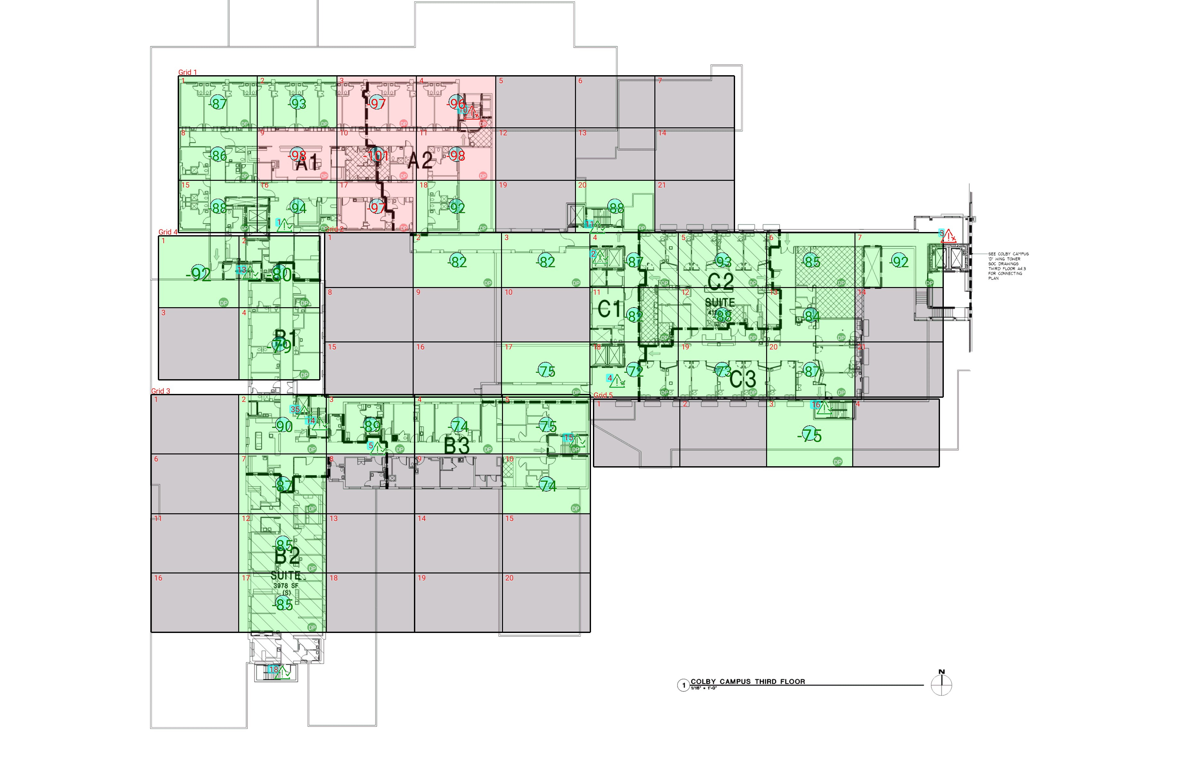

| **Grid** | **# of Areas** | **Area Size (sq. ft)** | **Area Width**  **(ft)** | **Area Height**  **(ft)** | **Ignore Area Color** | **Comments** |
| --- | --- | --- | --- | --- | --- | --- |
| 1 | 21 | 257.92 | 17.34 | 14.87 | Black |  |
| 2 | 21 | 300.92 | 19.29 | 15.60 | Black |  |
| 3 | 20 | 324.99 | 19.18 | 16.94 | Black |  |
| 4 | 4 | 361.71 | 17.61 | 20.54 | Black |  |
| 5 | 4 | 365.23 | 18.87 | 19.36 | Black |  |

**Floor: A1.3**

**Channel: 852937**

| **Critical Point Report** | | | | | | | |
| --- | --- | --- | --- | --- | --- | --- | --- |
| **Critical Point** | **DL**  **Power**  **(dBm)** | **DL**  **DAQ** | **UL**  **Power**  **(dBm)** | **UL**  **DAQ** | **Result** | **DL**  **Loss**  **(dB)** | **Comment** |
| 1 | -94.58 |  |  |  | **Pass** |  |  |
| 2 | -87.17 |  |  |  | **Pass** |  |  |
| 3 | -98.99 |  |  |  | **Fail** |  |  |
| 4 | -77.45 |  |  |  | **Pass** |  |  |
| 5 | -75.19 |  |  |  | **Pass** |  |  |
| 10 | -97.58 |  |  |  | **Fail** |  |  |
| 11 | -87.92 |  |  |  | **Pass** |  |  |
| 13 | -63.27 |  |  |  | **Pass** |  |  |
| 14 | -86.48 |  |  |  | **Pass** |  |  |
| 15 | -81.77 |  |  |  | **Pass** |  |  |
| 16 | -69.97 |  |  |  | **Pass** |  |  |
| 18 | -68.10 |  |  |  | **Pass** |  |  |
| 35 | -86.74 |  |  |  | **Pass** |  |  |

| **Area Report** | | | | | | | | |
| --- | --- | --- | --- | --- | --- | --- | --- | --- |
| **Grid** | **Area** | **DL**  **Power**  **(dBm)** | **DL**  **DAQ** | **UL**  **Power**  **(dBm)** | **UL**  **DAQ** | **Result** | **DL**  **Loss**  **(dB)** | **Comment** |
| 1 | 1 | -86.75 |  |  |  | **Pass** |  |  |
| 1 | 2 | -92.12 |  |  |  | **Pass** |  |  |
| 1 | 3 | -96.78 |  |  |  | **Fail** |  |  |
| 1 | 4 | -95.57 |  |  |  | **Fail** |  |  |
| 1 | 5 | NT | NT | NT | NT | **NT** |  |  |
| 1 | 6 | NT | NT | NT | NT | **NT** |  |  |
| 1 | 7 | NT | NT | NT | NT | **NT** |  |  |
| 1 | 8 | -85.30 |  |  |  | **Pass** |  |  |
| 1 | 9 | -97.21 |  |  |  | **Fail** |  |  |
| 1 | 10 | -100.29 |  |  |  | **Fail** |  |  |
| 1 | 11 | -97.75 |  |  |  | **Fail** |  |  |
| 1 | 12 | NT | NT | NT | NT | **NT** |  |  |
| 1 | 13 | NT | NT | NT | NT | **NT** |  |  |
| 1 | 14 | NT | NT | NT | NT | **NT** |  |  |
| 1 | 15 | -87.47 |  |  |  | **Pass** |  |  |
| 1 | 16 | -93.27 |  |  |  | **Pass** |  |  |
| 1 | 17 | -96.74 |  |  |  | **Fail** |  |  |
| 1 | 18 | -91.70 |  |  |  | **Pass** |  |  |
| 1 | 19 | NT | NT | NT | NT | **NT** |  |  |
| 1 | 20 | -87.98 |  |  |  | **Pass** |  |  |
| 1 | 21 | NT | NT | NT | NT | **NT** |  |  |
| 2 | 1 | NT | NT | NT | NT | **NT** |  |  |
| 2 | 2 | -81.66 |  |  |  | **Pass** |  |  |
| 2 | 3 | -81.09 |  |  |  | **Pass** |  |  |
| 2 | 4 | -86.54 |  |  |  | **Pass** |  |  |
| 2 | 5 | -92.42 |  |  |  | **Pass** |  |  |
| 2 | 6 | -84.29 |  |  |  | **Pass** |  |  |
| 2 | 7 | -91.25 |  |  |  | **Pass** |  |  |
| 2 | 8 | NT | NT | NT | NT | **NT** |  |  |
| 2 | 9 | NT | NT | NT | NT | **NT** |  |  |
| 2 | 10 | NT | NT | NT | NT | **NT** |  |  |
| 2 | 11 | -81.99 |  |  |  | **Pass** |  |  |
| 2 | 12 | -87.88 |  |  |  | **Pass** |  |  |
| 2 | 13 | -83.88 |  |  |  | **Pass** |  |  |
| 2 | 14 | NT | NT | NT | NT | **NT** |  |  |
| 2 | 15 | NT | NT | NT | NT | **NT** |  |  |
| 2 | 16 | NT | NT | NT | NT | **NT** |  |  |
| 2 | 17 | -74.70 |  |  |  | **Pass** |  |  |
| 2 | 18 | -71.22 |  |  |  | **Pass** |  |  |
| 2 | 19 | -72.44 |  |  |  | **Pass** |  |  |
| 2 | 20 | -86.13 |  |  |  | **Pass** |  |  |
| 2 | 21 | NT | NT | NT | NT | **NT** |  |  |
| 3 | 1 | NT | NT | NT | NT | **NT** |  |  |
| 3 | 2 | -89.18 |  |  |  | **Pass** |  |  |
| 3 | 3 | -88.57 |  |  |  | **Pass** |  |  |
| 3 | 4 | -73.37 |  |  |  | **Pass** |  |  |
| 3 | 5 | -74.10 |  |  |  | **Pass** |  |  |
| 3 | 6 | NT | NT | NT | NT | **NT** |  |  |
| 3 | 7 | -86.78 |  |  |  | **Pass** |  |  |
| 3 | 8 | NT | NT | NT | NT | **NT** |  |  |
| 3 | 9 | NT | NT | NT | NT | **NT** |  |  |
| 3 | 10 | -73.44 |  |  |  | **Pass** |  |  |
| 3 | 11 | NT | NT | NT | NT | **NT** |  |  |
| 3 | 12 | -84.51 |  |  |  | **Pass** |  |  |
| 3 | 13 | NT | NT | NT | NT | **NT** |  |  |
| 3 | 14 | NT | NT | NT | NT | **NT** |  |  |
| 3 | 15 | NT | NT | NT | NT | **NT** |  |  |
| 3 | 16 | NT | NT | NT | NT | **NT** |  |  |
| 3 | 17 | -84.60 |  |  |  | **Pass** |  |  |
| 3 | 18 | NT | NT | NT | NT | **NT** |  |  |
| 3 | 19 | NT | NT | NT | NT | **NT** |  |  |
| 3 | 20 | NT | NT | NT | NT | **NT** |  |  |
| 4 | 1 | -91.59 |  |  |  | **Pass** |  |  |
| 4 | 2 | -79.13 |  |  |  | **Pass** |  |  |
| 4 | 3 | NT | NT | NT | NT | **NT** |  |  |
| 4 | 4 | -78.94 |  |  |  | **Pass** |  |  |
| 5 | 1 | NT | NT | NT | NT | **NT** |  |  |
| 5 | 2 | NT | NT | NT | NT | **NT** |  |  |
| 5 | 3 | -74.20 |  |  |  | **Pass** |  |  |
| 5 | 4 | NT | NT | NT | NT | **NT** |  |  |

**Floor: A1.4**

**Channel: 852937**

**Result: Fail (Adjacent)**

| **Freq (MHz)** | **Tech** | **Band** | **Ant Gain** | **Cable Loss** | **Ph.** | **Type** | **Mod** | **NAC** | **Area Points passed (%)** | **Critical Points passed (%)** |
| --- | --- | --- | --- | --- | --- | --- | --- | --- | --- | --- |
| 852.93750 | P25 | PRMCE | 0.00 | 0.00 |  |  |  |  | 30/36 (83%) | 11/12 (91%) |

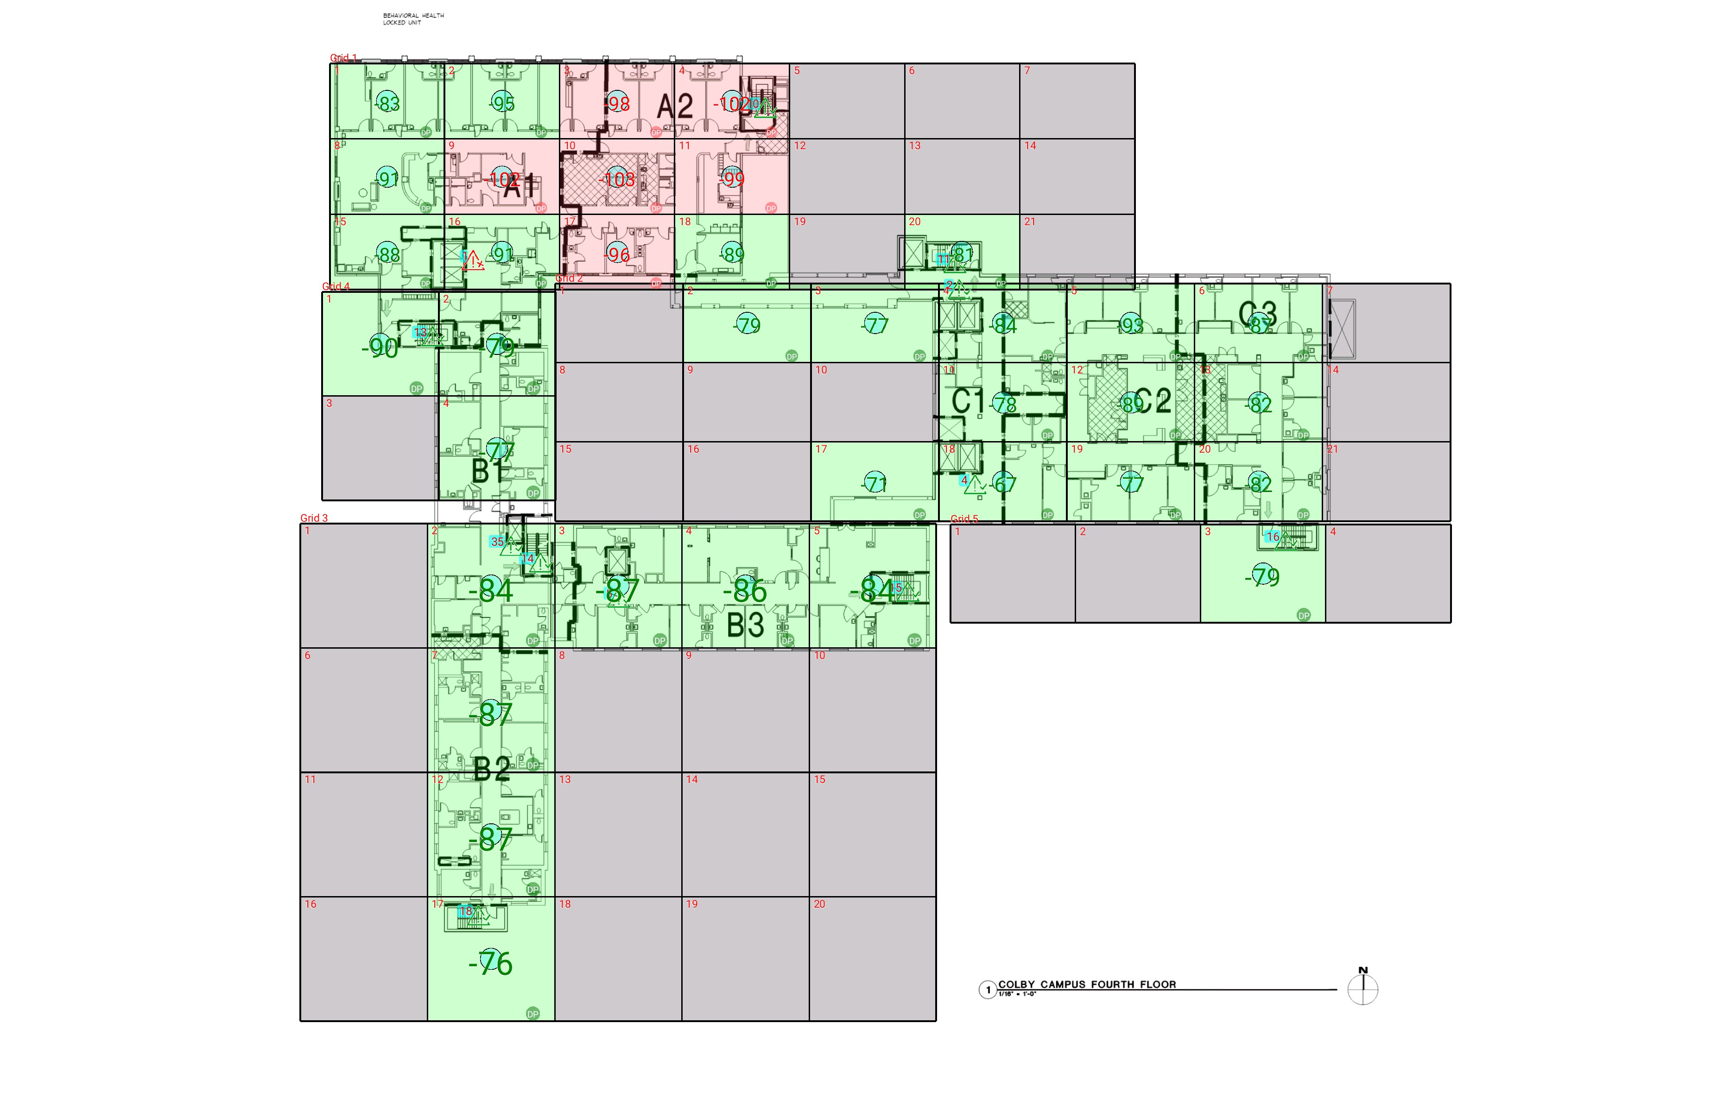

| **Grid** | **# of Areas** | **Area Size (sq. ft)** | **Area Width**  **(ft)** | **Area Height**  **(ft)** | **Ignore Area Color** | **Comments** |
| --- | --- | --- | --- | --- | --- | --- |
| 1 | 21 | 257.46 | 17.34 | 14.85 | Black |  |
| 2 | 21 | 300.92 | 19.29 | 15.60 | Black |  |
| 3 | 20 | 469.72 | 19.18 | 24.49 | Black |  |
| 4 | 4 | 361.71 | 17.61 | 20.54 | Black |  |
| 5 | 4 | 365.23 | 18.87 | 19.36 | Black |  |

**Floor: A1.4**

**Channel: 852937**

| **Critical Point Report** | | | | | | | |
| --- | --- | --- | --- | --- | --- | --- | --- |
| **Critical Point** | **DL**  **Power**  **(dBm)** | **DL**  **DAQ** | **UL**  **Power**  **(dBm)** | **UL**  **DAQ** | **Result** | **DL**  **Loss**  **(dB)** | **Comment** |
| 1 | -95.57 |  |  |  | **Fail** |  |  |
| 2 | -84.87 |  |  |  | **Pass** |  |  |
| 4 | -73.92 |  |  |  | **Pass** |  |  |
| 5 | -84.13 |  |  |  | **Pass** |  |  |
| 10 | -91.71 |  |  |  | **Pass** |  |  |
| 11 | -86.73 |  |  |  | **Pass** |  |  |
| 13 | -64.63 |  |  |  | **Pass** |  |  |
| 14 | -89.29 |  |  |  | **Pass** |  |  |
| 15 | -83.14 |  |  |  | **Pass** |  |  |
| 16 | -71.19 |  |  |  | **Pass** |  |  |
| 18 | -58.09 |  |  |  | **Pass** |  |  |
| 35 | -80.22 |  |  |  | **Pass** |  |  |

| **Area Report** | | | | | | | | |
| --- | --- | --- | --- | --- | --- | --- | --- | --- |
| **Grid** | **Area** | **DL**  **Power**  **(dBm)** | **DL**  **DAQ** | **UL**  **Power**  **(dBm)** | **UL**  **DAQ** | **Result** | **DL**  **Loss**  **(dB)** | **Comment** |
| 1 | 1 | -82.19 |  |  |  | **Pass** |  |  |
| 1 | 2 | -94.57 |  |  |  | **Pass** |  |  |
| 1 | 3 | -97.67 |  |  |  | **Fail** |  |  |
| 1 | 4 | -101.08 |  |  |  | **Fail** |  |  |
| 1 | 5 | NT | NT | NT | NT | **NT** |  |  |
| 1 | 6 | NT | NT | NT | NT | **NT** |  |  |
| 1 | 7 | NT | NT | NT | NT | **NT** |  |  |
| 1 | 8 | -90.26 |  |  |  | **Pass** |  |  |
| 1 | 9 | -101.51 |  |  |  | **Fail** |  |  |
| 1 | 10 | -102.56 |  |  |  | **Fail** |  |  |
| 1 | 11 | -98.82 |  |  |  | **Fail** |  |  |
| 1 | 12 | NT | NT | NT | NT | **NT** |  |  |
| 1 | 13 | NT | NT | NT | NT | **NT** |  |  |
| 1 | 14 | NT | NT | NT | NT | **NT** |  |  |
| 1 | 15 | -87.78 |  |  |  | **Pass** |  |  |
| 1 | 16 | -90.87 |  |  |  | **Pass** |  |  |
| 1 | 17 | -95.35 |  |  |  | **Fail** |  |  |
| 1 | 18 | -88.92 |  |  |  | **Pass** |  |  |
| 1 | 19 | NT | NT | NT | NT | **NT** |  |  |
| 1 | 20 | -80.57 |  |  |  | **Pass** |  |  |
| 1 | 21 | NT | NT | NT | NT | **NT** |  |  |
| 2 | 1 | NT | NT | NT | NT | **NT** |  |  |
| 2 | 2 | -78.14 |  |  |  | **Pass** |  |  |
| 2 | 3 | -76.95 |  |  |  | **Pass** |  |  |
| 2 | 4 | -83.46 |  |  |  | **Pass** |  |  |
| 2 | 5 | -92.09 |  |  |  | **Pass** |  |  |
| 2 | 6 | -86.29 |  |  |  | **Pass** |  |  |
| 2 | 7 | NT | NT | NT | NT | **NT** |  |  |
| 2 | 8 | NT | NT | NT | NT | **NT** |  |  |
| 2 | 9 | NT | NT | NT | NT | **NT** |  |  |
| 2 | 10 | NT | NT | NT | NT | **NT** |  |  |
| 2 | 11 | -77.88 |  |  |  | **Pass** |  |  |
| 2 | 12 | -88.09 |  |  |  | **Pass** |  |  |
| 2 | 13 | -81.14 |  |  |  | **Pass** |  |  |
| 2 | 14 | NT | NT | NT | NT | **NT** |  |  |
| 2 | 15 | NT | NT | NT | NT | **NT** |  |  |
| 2 | 16 | NT | NT | NT | NT | **NT** |  |  |
| 2 | 17 | -70.06 |  |  |  | **Pass** |  |  |
| 2 | 18 | -66.41 |  |  |  | **Pass** |  |  |
| 2 | 19 | -76.82 |  |  |  | **Pass** |  |  |
| 2 | 20 | -81.21 |  |  |  | **Pass** |  |  |
| 2 | 21 | NT | NT | NT | NT | **NT** |  |  |
| 3 | 1 | NT | NT | NT | NT | **NT** |  |  |
| 3 | 2 | -83.37 |  |  |  | **Pass** |  |  |
| 3 | 3 | -86.35 |  |  |  | **Pass** |  |  |
| 3 | 4 | -85.09 |  |  |  | **Pass** |  |  |
| 3 | 5 | -84.00 |  |  |  | **Pass** |  |  |
| 3 | 6 | NT | NT | NT | NT | **NT** |  |  |
| 3 | 7 | -86.29 |  |  |  | **Pass** |  |  |
| 3 | 8 | NT | NT | NT | NT | **NT** |  |  |
| 3 | 9 | NT | NT | NT | NT | **NT** |  |  |
| 3 | 10 | NT | NT | NT | NT | **NT** |  |  |
| 3 | 11 | NT | NT | NT | NT | **NT** |  |  |
| 3 | 12 | -86.70 |  |  |  | **Pass** |  |  |
| 3 | 13 | NT | NT | NT | NT | **NT** |  |  |
| 3 | 14 | NT | NT | NT | NT | **NT** |  |  |
| 3 | 15 | NT | NT | NT | NT | **NT** |  |  |
| 3 | 16 | NT | NT | NT | NT | **NT** |  |  |
| 3 | 17 | -75.71 |  |  |  | **Pass** |  |  |
| 3 | 18 | NT | NT | NT | NT | **NT** |  |  |
| 3 | 19 | NT | NT | NT | NT | **NT** |  |  |
| 3 | 20 | NT | NT | NT | NT | **NT** |  |  |
| 4 | 1 | -89.79 |  |  |  | **Pass** |  |  |
| 4 | 2 | -78.40 |  |  |  | **Pass** |  |  |
| 4 | 3 | NT | NT | NT | NT | **NT** |  |  |
| 4 | 4 | -76.89 |  |  |  | **Pass** |  |  |
| 5 | 1 | NT | NT | NT | NT | **NT** |  |  |
| 5 | 2 | NT | NT | NT | NT | **NT** |  |  |
| 5 | 3 | -78.42 |  |  |  | **Pass** |  |  |
| 5 | 4 | NT | NT | NT | NT | **NT** |  |  |

**Floor: A1.5**

**Channel: 852937**

**Result: Pass**

| **Freq (MHz)** | **Tech** | **Band** | **Ant Gain** | **Cable Loss** | **Ph.** | **Type** | **Mod** | **NAC** | **Area Points passed (%)** | **Critical Points passed (%)** |
| --- | --- | --- | --- | --- | --- | --- | --- | --- | --- | --- |
| 852.93750 | P25 | PRMCE | 0.00 | 0.00 |  |  |  |  | 24/24 (100%) | 8/8 (100%) |

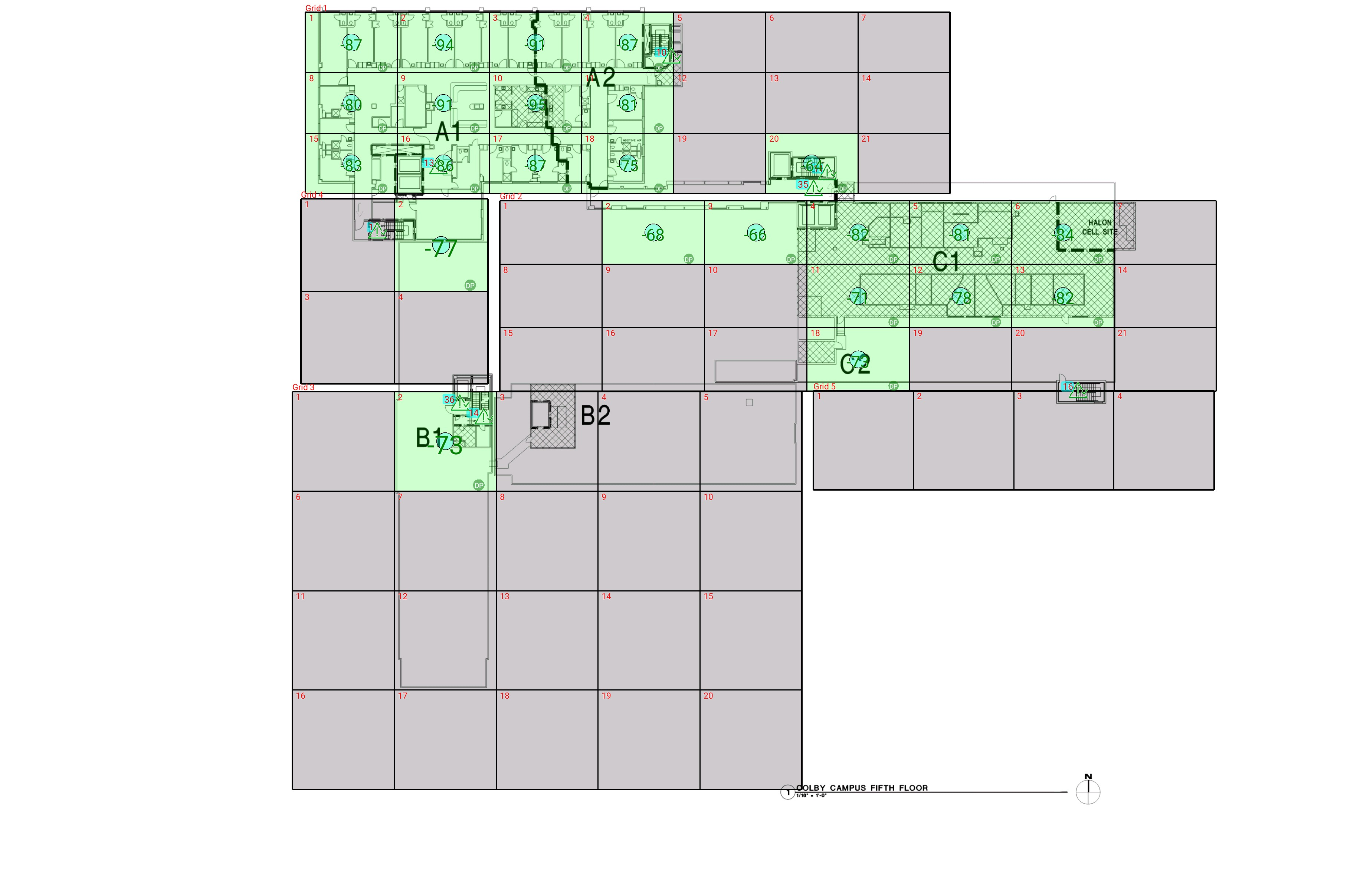

| **Grid** | **# of Areas** | **Area Size (sq. ft)** | **Area Width**  **(ft)** | **Area Height**  **(ft)** | **Ignore Area Color** | **Comments** |
| --- | --- | --- | --- | --- | --- | --- |
| 1 | 21 | 257.46 | 17.34 | 14.85 | Black |  |
| 2 | 21 | 301.44 | 19.29 | 15.63 | Black |  |
| 3 | 20 | 469.72 | 19.18 | 24.49 | Black |  |
| 4 | 4 | 400.28 | 17.61 | 22.73 | Black |  |
| 5 | 4 | 460.49 | 18.87 | 24.41 | Black |  |

**Floor: A1.5**

**Channel: 852937**

| **Critical Point Report** | | | | | | | |
| --- | --- | --- | --- | --- | --- | --- | --- |
| **Critical Point** | **DL**  **Power**  **(dBm)** | **DL**  **DAQ** | **UL**  **Power**  **(dBm)** | **UL**  **DAQ** | **Result** | **DL**  **Loss**  **(dB)** | **Comment** |
| 1 | -65.87 |  |  |  | **Pass** |  |  |
| 10 | -87.16 |  |  |  | **Pass** |  |  |
| 11 | -80.01 |  |  |  | **Pass** |  |  |
| 13 | -73.85 |  |  |  | **Pass** |  |  |
| 14 | -73.24 |  |  |  | **Pass** |  |  |
| 16 | -67.61 |  |  |  | **Pass** |  |  |
| 35 | -70.99 |  |  |  | **Pass** |  |  |
| 36 | -71.98 |  |  |  | **Pass** |  |  |

| **Area Report** | | | | | | | | |
| --- | --- | --- | --- | --- | --- | --- | --- | --- |
| **Grid** | **Area** | **DL**  **Power**  **(dBm)** | **DL**  **DAQ** | **UL**  **Power**  **(dBm)** | **UL**  **DAQ** | **Result** | **DL**  **Loss**  **(dB)** | **Comment** |
| 1 | 1 | -86.20 |  |  |  | **Pass** |  |  |
| 1 | 2 | -93.35 |  |  |  | **Pass** |  |  |
| 1 | 3 | -90.80 |  |  |  | **Pass** |  |  |
| 1 | 4 | -86.25 |  |  |  | **Pass** |  |  |
| 1 | 5 | NT | NT | NT | NT | **NT** |  |  |
| 1 | 6 | NT | NT | NT | NT | **NT** |  |  |
| 1 | 7 | NT | NT | NT | NT | **NT** |  |  |
| 1 | 8 | -79.91 |  |  |  | **Pass** |  |  |
| 1 | 9 | -90.28 |  |  |  | **Pass** |  |  |
| 1 | 10 | -94.21 |  |  |  | **Pass** |  |  |
| 1 | 11 | -80.33 |  |  |  | **Pass** |  |  |
| 1 | 12 | NT | NT | NT | NT | **NT** |  |  |
| 1 | 13 | NT | NT | NT | NT | **NT** |  |  |
| 1 | 14 | NT | NT | NT | NT | **NT** |  |  |
| 1 | 15 | -82.77 |  |  |  | **Pass** |  |  |
| 1 | 16 | -85.53 |  |  |  | **Pass** |  |  |
| 1 | 17 | -86.38 |  |  |  | **Pass** |  |  |
| 1 | 18 | -74.53 |  |  |  | **Pass** |  |  |
| 1 | 19 | NT | NT | NT | NT | **NT** |  |  |
| 1 | 20 | -63.80 |  |  |  | **Pass** |  |  |
| 1 | 21 | NT | NT | NT | NT | **NT** |  |  |
| 2 | 1 | NT | NT | NT | NT | **NT** |  |  |
| 2 | 2 | -67.53 |  |  |  | **Pass** |  |  |
| 2 | 3 | -65.82 |  |  |  | **Pass** |  |  |
| 2 | 4 | -81.60 |  |  |  | **Pass** |  |  |
| 2 | 5 | -80.25 |  |  |  | **Pass** |  |  |
| 2 | 6 | -83.02 |  |  |  | **Pass** |  |  |
| 2 | 7 | NT | NT | NT | NT | **NT** |  |  |
| 2 | 8 | NT | NT | NT | NT | **NT** |  |  |
| 2 | 9 | NT | NT | NT | NT | **NT** |  |  |
| 2 | 10 | NT | NT | NT | NT | **NT** |  |  |
| 2 | 11 | -70.13 |  |  |  | **Pass** |  |  |
| 2 | 12 | -77.60 |  |  |  | **Pass** |  |  |
| 2 | 13 | -81.30 |  |  |  | **Pass** |  |  |
| 2 | 14 | NT | NT | NT | NT | **NT** |  |  |
| 2 | 15 | NT | NT | NT | NT | **NT** |  |  |
| 2 | 16 | NT | NT | NT | NT | **NT** |  |  |
| 2 | 17 | NT | NT | NT | NT | **NT** |  |  |
| 2 | 18 | -72.26 |  |  |  | **Pass** |  |  |
| 2 | 19 | NT | NT | NT | NT | **NT** |  |  |
| 2 | 20 | NT | NT | NT | NT | **NT** |  |  |
| 2 | 21 | NT | NT | NT | NT | **NT** |  |  |
| 3 | 1 | NT | NT | NT | NT | **NT** |  |  |
| 3 | 2 | -72.69 |  |  |  | **Pass** |  |  |
| 3 | 3 | NT | NT | NT | NT | **NT** |  |  |
| 3 | 4 | NT | NT | NT | NT | **NT** |  |  |
| 3 | 5 | NT | NT | NT | NT | **NT** |  |  |
| 3 | 6 | NT | NT | NT | NT | **NT** |  |  |
| 3 | 7 | NT | NT | NT | NT | **NT** |  |  |
| 3 | 8 | NT | NT | NT | NT | **NT** |  |  |
| 3 | 9 | NT | NT | NT | NT | **NT** |  |  |
| 3 | 10 | NT | NT | NT | NT | **NT** |  |  |
| 3 | 11 | NT | NT | NT | NT | **NT** |  |  |
| 3 | 12 | NT | NT | NT | NT | **NT** |  |  |
| 3 | 13 | NT | NT | NT | NT | **NT** |  |  |
| 3 | 14 | NT | NT | NT | NT | **NT** |  |  |
| 3 | 15 | NT | NT | NT | NT | **NT** |  |  |
| 3 | 16 | NT | NT | NT | NT | **NT** |  |  |
| 3 | 17 | NT | NT | NT | NT | **NT** |  |  |
| 3 | 18 | NT | NT | NT | NT | **NT** |  |  |
| 3 | 19 | NT | NT | NT | NT | **NT** |  |  |
| 3 | 20 | NT | NT | NT | NT | **NT** |  |  |
| 4 | 1 | NT | NT | NT | NT | **NT** |  |  |
| 4 | 2 | -76.37 |  |  |  | **Pass** |  |  |
| 4 | 3 | NT | NT | NT | NT | **NT** |  |  |
| 4 | 4 | NT | NT | NT | NT | **NT** |  |  |
| 5 | 1 | NT | NT | NT | NT | **NT** |  |  |
| 5 | 2 | NT | NT | NT | NT | **NT** |  |  |
| 5 | 3 | NT | NT | NT | NT | **NT** |  |  |
| 5 | 4 | NT | NT | NT | NT | **NT** |  |  |

**Floor: A1.6**

**Channel: 852937**

**Result: Pass**

| **Freq (MHz)** | **Tech** | **Band** | **Ant Gain** | **Cable Loss** | **Ph.** | **Type** | **Mod** | **NAC** | **Area Points passed (%)** | **Critical Points passed (%)** |
| --- | --- | --- | --- | --- | --- | --- | --- | --- | --- | --- |
| 852.93750 | P25 | PRMCE | 0.00 | 0.00 |  |  |  |  | 15/15 (100%) | 5/5 (100%) |

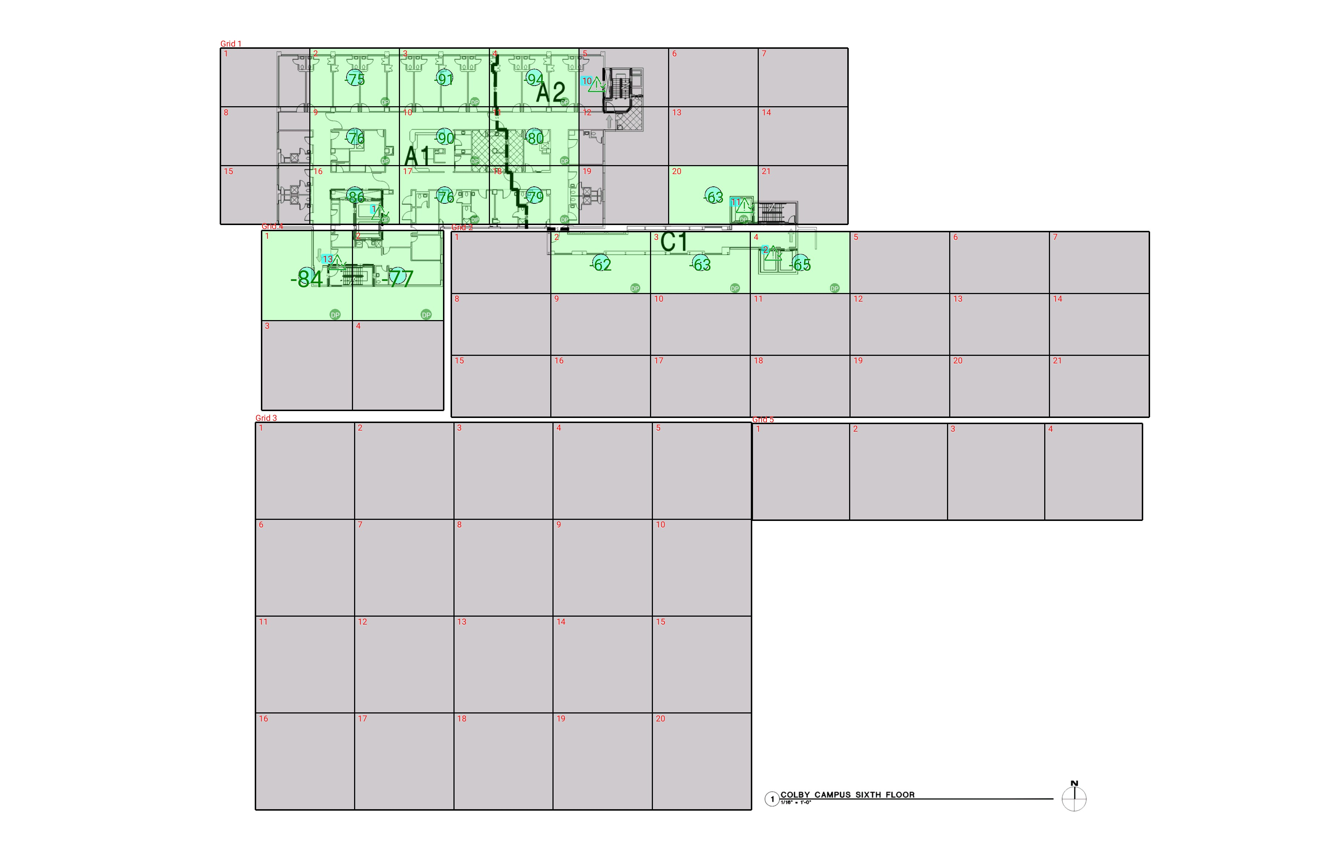

| **Grid** | **# of Areas** | **Area Size (sq. ft)** | **Area Width**  **(ft)** | **Area Height**  **(ft)** | **Ignore Area Color** | **Comments** |
| --- | --- | --- | --- | --- | --- | --- |
| 1 | 21 | 257.46 | 17.34 | 14.85 | Black |  |
| 2 | 21 | 301.44 | 19.29 | 15.63 | Black |  |
| 3 | 20 | 469.72 | 19.18 | 24.49 | Black |  |
| 4 | 4 | 400.28 | 17.61 | 22.73 | Black |  |
| 5 | 4 | 460.49 | 18.87 | 24.41 | Black |  |

**Floor: A1.6**

**Channel: 852937**

| **Critical Point Report** | | | | | | | |
| --- | --- | --- | --- | --- | --- | --- | --- |
| **Critical Point** | **DL**  **Power**  **(dBm)** | **DL**  **DAQ** | **UL**  **Power**  **(dBm)** | **UL**  **DAQ** | **Result** | **DL**  **Loss**  **(dB)** | **Comment** |
| 1 | -89.09 |  |  |  | **Pass** |  |  |
| 2 | -76.21 |  |  |  | **Pass** |  |  |
| 10 | -91.53 |  |  |  | **Pass** |  |  |
| 11 | -78.88 |  |  |  | **Pass** |  |  |
| 13 | -66.30 |  |  |  | **Pass** |  |  |

| **Area Report** | | | | | | | | |
| --- | --- | --- | --- | --- | --- | --- | --- | --- |
| **Grid** | **Area** | **DL**  **Power**  **(dBm)** | **DL**  **DAQ** | **UL**  **Power**  **(dBm)** | **UL**  **DAQ** | **Result** | **DL**  **Loss**  **(dB)** | **Comment** |
| 1 | 1 | NT | NT | NT | NT | **NT** |  |  |
| 1 | 2 | -74.71 |  |  |  | **Pass** |  |  |
| 1 | 3 | -90.91 |  |  |  | **Pass** |  |  |
| 1 | 4 | -93.87 |  |  |  | **Pass** |  |  |
| 1 | 5 | NT | NT | NT | NT | **NT** |  |  |
| 1 | 6 | NT | NT | NT | NT | **NT** |  |  |
| 1 | 7 | NT | NT | NT | NT | **NT** |  |  |
| 1 | 8 | NT | NT | NT | NT | **NT** |  |  |
| 1 | 9 | -75.77 |  |  |  | **Pass** |  |  |
| 1 | 10 | -89.52 |  |  |  | **Pass** |  |  |
| 1 | 11 | -79.72 |  |  |  | **Pass** |  |  |
| 1 | 12 | NT | NT | NT | NT | **NT** |  |  |
| 1 | 13 | NT | NT | NT | NT | **NT** |  |  |
| 1 | 14 | NT | NT | NT | NT | **NT** |  |  |
| 1 | 15 | NT | NT | NT | NT | **NT** |  |  |
| 1 | 16 | -85.80 |  |  |  | **Pass** |  |  |
| 1 | 17 | -75.58 |  |  |  | **Pass** |  |  |
| 1 | 18 | -78.39 |  |  |  | **Pass** |  |  |
| 1 | 19 | NT | NT | NT | NT | **NT** |  |  |
| 1 | 20 | -62.52 |  |  |  | **Pass** |  |  |
| 1 | 21 | NT | NT | NT | NT | **NT** |  |  |
| 2 | 1 | NT | NT | NT | NT | **NT** |  |  |
| 2 | 2 | -61.95 |  |  |  | **Pass** |  |  |
| 2 | 3 | -62.33 |  |  |  | **Pass** |  |  |
| 2 | 4 | -64.80 |  |  |  | **Pass** |  |  |
| 2 | 5 | NT | NT | NT | NT | **NT** |  |  |
| 2 | 6 | NT | NT | NT | NT | **NT** |  |  |
| 2 | 7 | NT | NT | NT | NT | **NT** |  |  |
| 2 | 8 | NT | NT | NT | NT | **NT** |  |  |
| 2 | 9 | NT | NT | NT | NT | **NT** |  |  |
| 2 | 10 | NT | NT | NT | NT | **NT** |  |  |
| 2 | 11 | NT | NT | NT | NT | **NT** |  |  |
| 2 | 12 | NT | NT | NT | NT | **NT** |  |  |
| 2 | 13 | NT | NT | NT | NT | **NT** |  |  |
| 2 | 14 | NT | NT | NT | NT | **NT** |  |  |
| 2 | 15 | NT | NT | NT | NT | **NT** |  |  |
| 2 | 16 | NT | NT | NT | NT | **NT** |  |  |
| 2 | 17 | NT | NT | NT | NT | **NT** |  |  |
| 2 | 18 | NT | NT | NT | NT | **NT** |  |  |
| 2 | 19 | NT | NT | NT | NT | **NT** |  |  |
| 2 | 20 | NT | NT | NT | NT | **NT** |  |  |
| 2 | 21 | NT | NT | NT | NT | **NT** |  |  |
| 3 | 1 | NT | NT | NT | NT | **NT** |  |  |
| 3 | 2 | NT | NT | NT | NT | **NT** |  |  |
| 3 | 3 | NT | NT | NT | NT | **NT** |  |  |
| 3 | 4 | NT | NT | NT | NT | **NT** |  |  |
| 3 | 5 | NT | NT | NT | NT | **NT** |  |  |
| 3 | 6 | NT | NT | NT | NT | **NT** |  |  |
| 3 | 7 | NT | NT | NT | NT | **NT** |  |  |
| 3 | 8 | NT | NT | NT | NT | **NT** |  |  |
| 3 | 9 | NT | NT | NT | NT | **NT** |  |  |
| 3 | 10 | NT | NT | NT | NT | **NT** |  |  |
| 3 | 11 | NT | NT | NT | NT | **NT** |  |  |
| 3 | 12 | NT | NT | NT | NT | **NT** |  |  |
| 3 | 13 | NT | NT | NT | NT | **NT** |  |  |
| 3 | 14 | NT | NT | NT | NT | **NT** |  |  |
| 3 | 15 | NT | NT | NT | NT | **NT** |  |  |
| 3 | 16 | NT | NT | NT | NT | **NT** |  |  |
| 3 | 17 | NT | NT | NT | NT | **NT** |  |  |
| 3 | 18 | NT | NT | NT | NT | **NT** |  |  |
| 3 | 19 | NT | NT | NT | NT | **NT** |  |  |
| 3 | 20 | NT | NT | NT | NT | **NT** |  |  |
| 4 | 1 | -83.82 |  |  |  | **Pass** |  |  |
| 4 | 2 | -76.66 |  |  |  | **Pass** |  |  |
| 4 | 3 | NT | NT | NT | NT | **NT** |  |  |
| 4 | 4 | NT | NT | NT | NT | **NT** |  |  |
| 5 | 1 | NT | NT | NT | NT | **NT** |  |  |
| 5 | 2 | NT | NT | NT | NT | **NT** |  |  |
| 5 | 3 | NT | NT | NT | NT | **NT** |  |  |
| 5 | 4 | NT | NT | NT | NT | **NT** |  |  |

**Floor: A1.7**

**Channel: 852937**

**Result: Pass**

| **Freq (MHz)** | **Tech** | **Band** | **Ant Gain** | **Cable Loss** | **Ph.** | **Type** | **Mod** | **NAC** | **Area Points passed (%)** | **Critical Points passed (%)** |
| --- | --- | --- | --- | --- | --- | --- | --- | --- | --- | --- |
| 852.93750 | P25 | PRMCE | 0.00 | 0.00 |  |  |  |  | 15/15 (100%) | 5/5 (100%) |

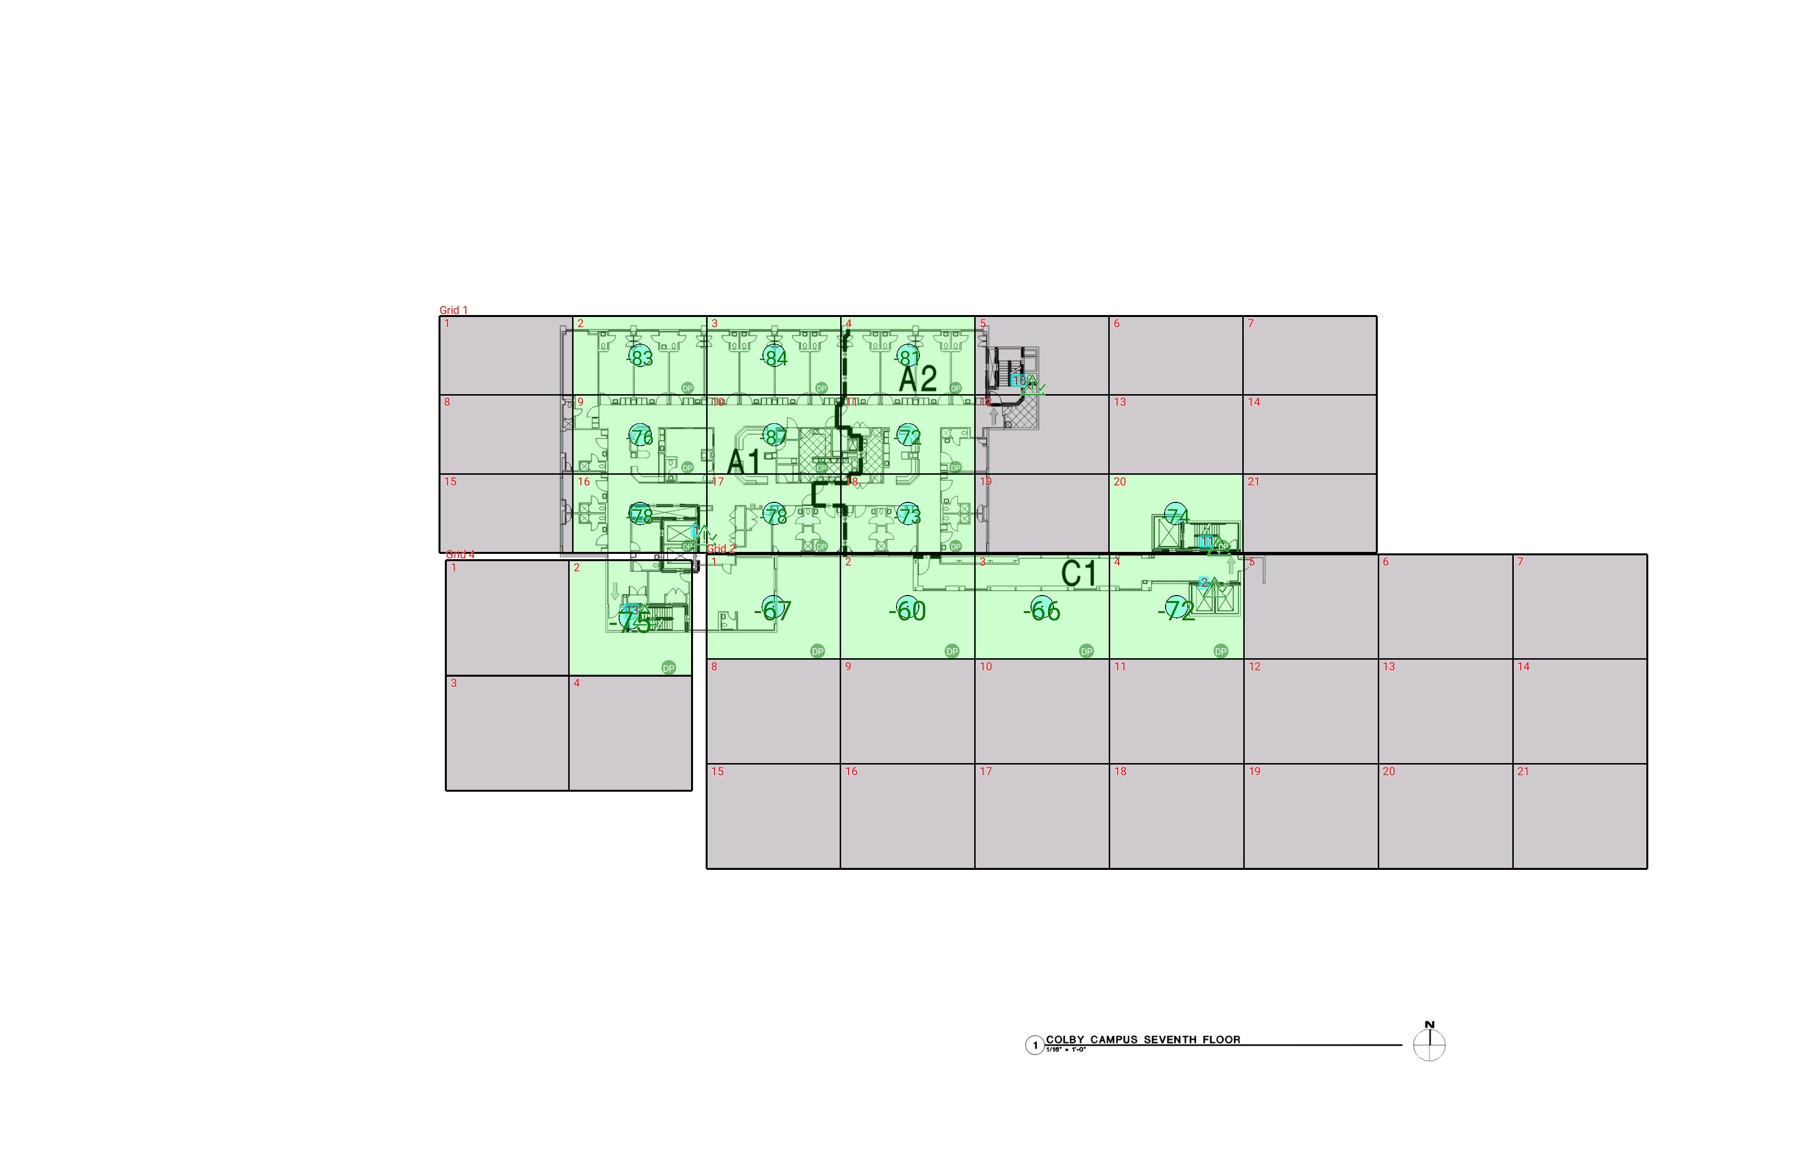

| **Grid** | **# of Areas** | **Area Size (sq. ft)** | **Area Width**  **(ft)** | **Area Height**  **(ft)** | **Ignore Area Color** | **Comments** |
| --- | --- | --- | --- | --- | --- | --- |
| 1 | 21 | 286.18 | 19.28 | 14.85 | Black |  |
| 2 | 21 | 380.74 | 19.34 | 19.69 | Black |  |
| 4 | 4 | 383.52 | 17.69 | 21.68 | Black |  |

**Floor: A1.7**

**Channel: 852937**

| **Critical Point Report** | | | | | | | |
| --- | --- | --- | --- | --- | --- | --- | --- |
| **Critical Point** | **DL**  **Power**  **(dBm)** | **DL**  **DAQ** | **UL**  **Power**  **(dBm)** | **UL**  **DAQ** | **Result** | **DL**  **Loss**  **(dB)** | **Comment** |
| 1 | -79.54 |  |  |  | **Pass** |  |  |
| 2 | -73.78 |  |  |  | **Pass** |  |  |
| 10 | -91.81 |  |  |  | **Pass** |  |  |
| 11 | -83.29 |  |  |  | **Pass** |  |  |
| 13 | -64.18 |  |  |  | **Pass** |  |  |

| **Area Report** | | | | | | | | |
| --- | --- | --- | --- | --- | --- | --- | --- | --- |
| **Grid** | **Area** | **DL**  **Power**  **(dBm)** | **DL**  **DAQ** | **UL**  **Power**  **(dBm)** | **UL**  **DAQ** | **Result** | **DL**  **Loss**  **(dB)** | **Comment** |
| 1 | 1 | NT | NT | NT | NT | **NT** |  |  |
| 1 | 2 | -82.18 |  |  |  | **Pass** |  |  |
| 1 | 3 | -83.13 |  |  |  | **Pass** |  |  |
| 1 | 4 | -80.12 |  |  |  | **Pass** |  |  |
| 1 | 5 | NT | NT | NT | NT | **NT** |  |  |
| 1 | 6 | NT | NT | NT | NT | **NT** |  |  |
| 1 | 7 | NT | NT | NT | NT | **NT** |  |  |
| 1 | 8 | NT | NT | NT | NT | **NT** |  |  |
| 1 | 9 | -75.04 |  |  |  | **Pass** |  |  |
| 1 | 10 | -86.81 |  |  |  | **Pass** |  |  |
| 1 | 11 | -71.88 |  |  |  | **Pass** |  |  |
| 1 | 12 | NT | NT | NT | NT | **NT** |  |  |
| 1 | 13 | NT | NT | NT | NT | **NT** |  |  |
| 1 | 14 | NT | NT | NT | NT | **NT** |  |  |
| 1 | 15 | NT | NT | NT | NT | **NT** |  |  |
| 1 | 16 | -77.09 |  |  |  | **Pass** |  |  |
| 1 | 17 | -77.12 |  |  |  | **Pass** |  |  |
| 1 | 18 | -72.43 |  |  |  | **Pass** |  |  |
| 1 | 19 | NT | NT | NT | NT | **NT** |  |  |
| 1 | 20 | -73.34 |  |  |  | **Pass** |  |  |
| 1 | 21 | NT | NT | NT | NT | **NT** |  |  |
| 2 | 1 | -66.32 |  |  |  | **Pass** |  |  |
| 2 | 2 | -59.54 |  |  |  | **Pass** |  |  |
| 2 | 3 | -65.14 |  |  |  | **Pass** |  |  |
| 2 | 4 | -71.26 |  |  |  | **Pass** |  |  |
| 2 | 5 | NT | NT | NT | NT | **NT** |  |  |
| 2 | 6 | NT | NT | NT | NT | **NT** |  |  |
| 2 | 7 | NT | NT | NT | NT | **NT** |  |  |
| 2 | 8 | NT | NT | NT | NT | **NT** |  |  |
| 2 | 9 | NT | NT | NT | NT | **NT** |  |  |
| 2 | 10 | NT | NT | NT | NT | **NT** |  |  |
| 2 | 11 | NT | NT | NT | NT | **NT** |  |  |
| 2 | 12 | NT | NT | NT | NT | **NT** |  |  |
| 2 | 13 | NT | NT | NT | NT | **NT** |  |  |
| 2 | 14 | NT | NT | NT | NT | **NT** |  |  |
| 2 | 15 | NT | NT | NT | NT | **NT** |  |  |
| 2 | 16 | NT | NT | NT | NT | **NT** |  |  |
| 2 | 17 | NT | NT | NT | NT | **NT** |  |  |
| 2 | 18 | NT | NT | NT | NT | **NT** |  |  |
| 2 | 19 | NT | NT | NT | NT | **NT** |  |  |
| 2 | 20 | NT | NT | NT | NT | **NT** |  |  |
| 2 | 21 | NT | NT | NT | NT | **NT** |  |  |
| 4 | 1 | NT | NT | NT | NT | **NT** |  |  |
| 4 | 2 | -74.16 |  |  |  | **Pass** |  |  |
| 4 | 3 | NT | NT | NT | NT | **NT** |  |  |
| 4 | 4 | NT | NT | NT | NT | **NT** |  |  |

**Floor: A1.8**

**Channel: 852937**

**Result: Pass**

| **Freq (MHz)** | **Tech** | **Band** | **Ant Gain** | **Cable Loss** | **Ph.** | **Type** | **Mod** | **NAC** | **Area Points passed (%)** | **Critical Points passed (%)** |
| --- | --- | --- | --- | --- | --- | --- | --- | --- | --- | --- |
| 852.93750 | P25 | PRMCE | 0.00 | 0.00 |  |  |  |  | 14/14 (100%) | 5/5 (100%) |

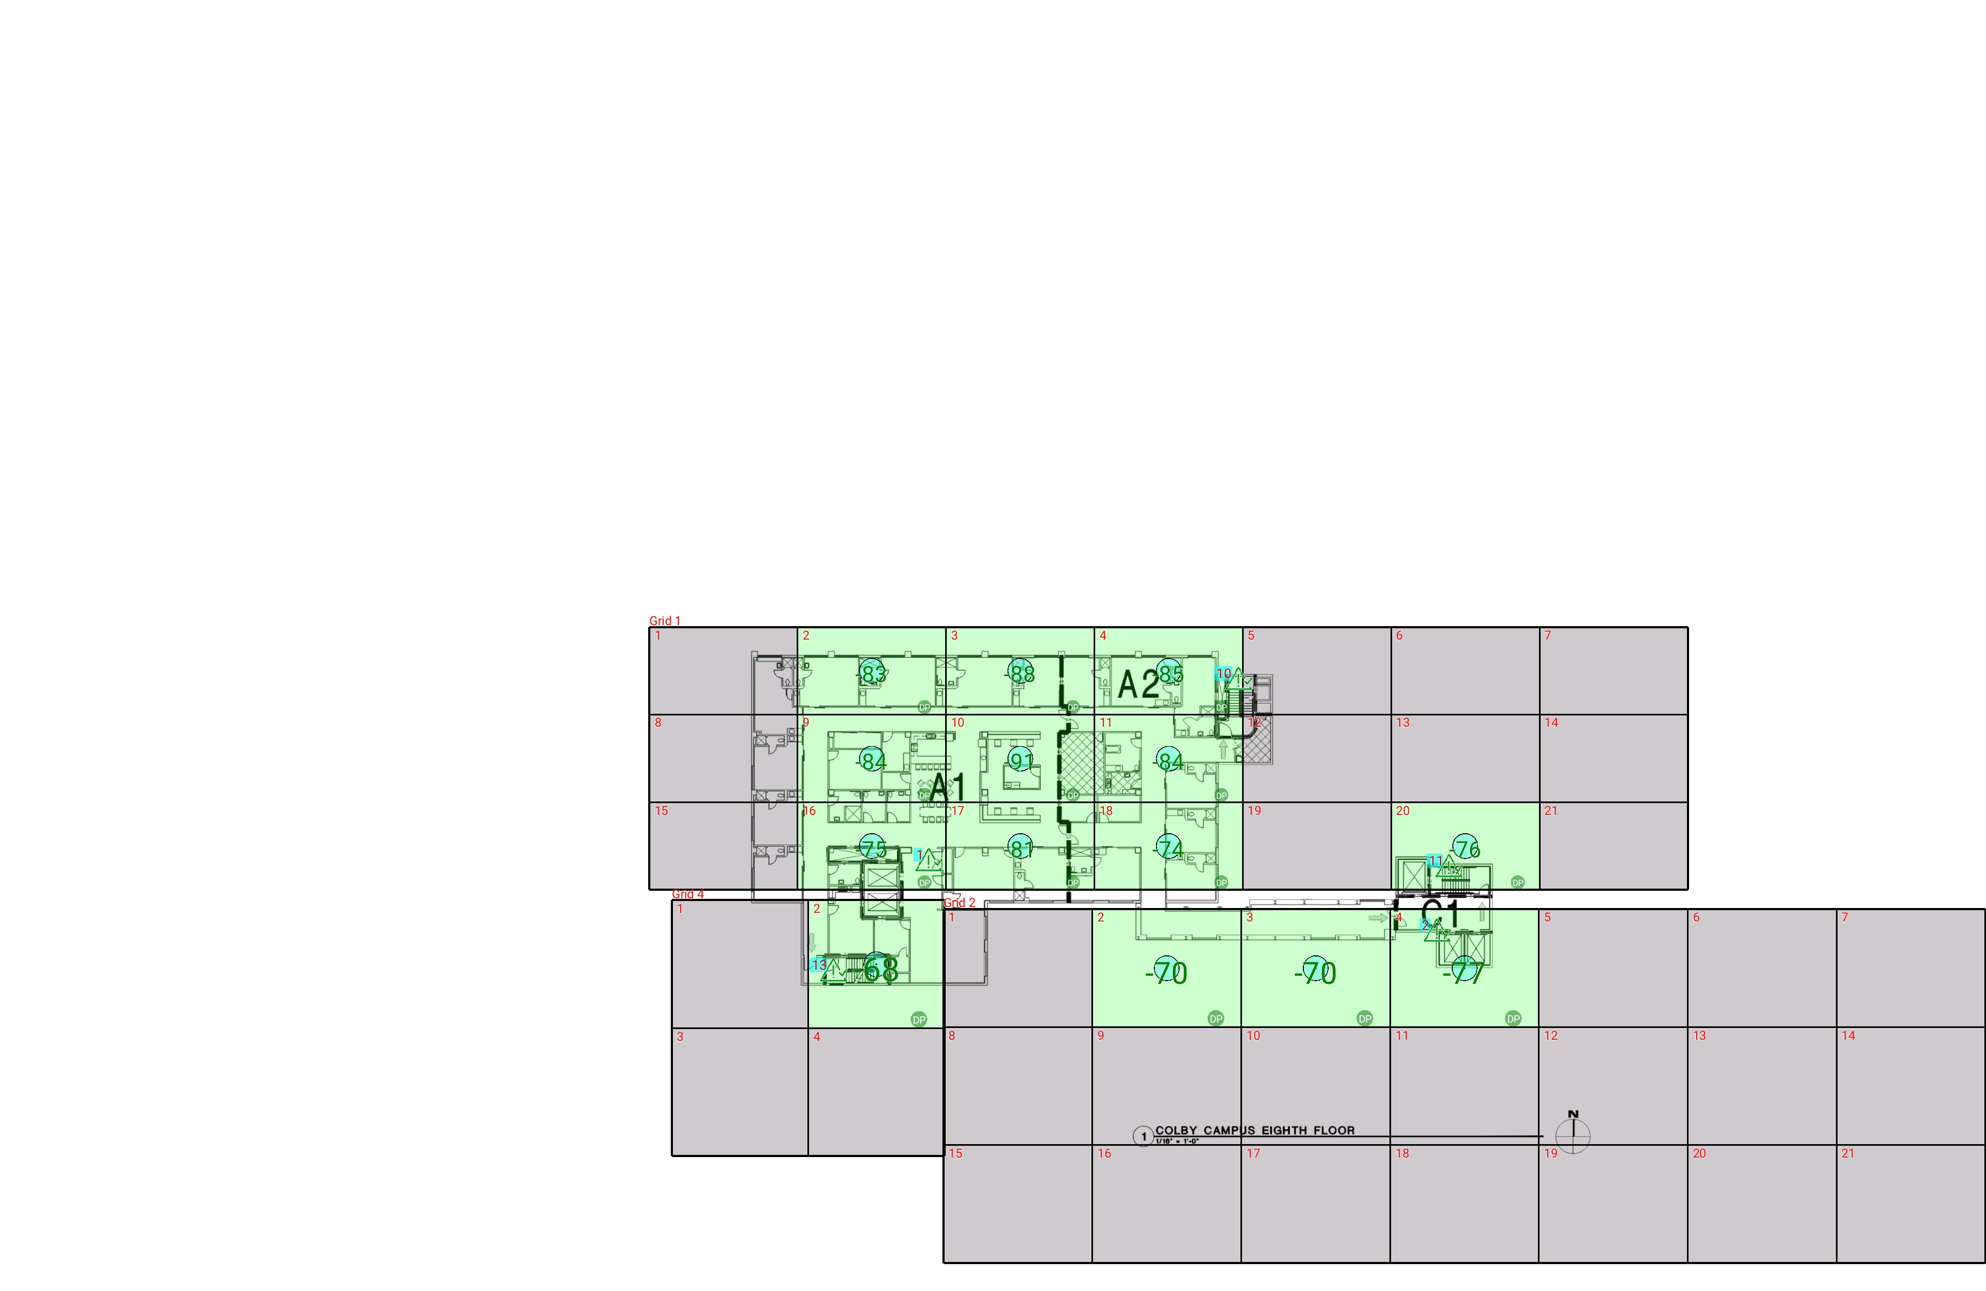

| **Grid** | **# of Areas** | **Area Size (sq. ft)** | **Area Width**  **(ft)** | **Area Height**  **(ft)** | **Ignore Area Color** | **Comments** |
| --- | --- | --- | --- | --- | --- | --- |
| 1 | 21 | 286.18 | 19.28 | 14.85 | Black |  |
| 2 | 21 | 387.02 | 19.34 | 20.01 | Black |  |
| 4 | 4 | 383.52 | 17.69 | 21.68 | Black |  |

**Floor: A1.8**

**Channel: 852937**

| **Critical Point Report** | | | | | | | |
| --- | --- | --- | --- | --- | --- | --- | --- |
| **Critical Point** | **DL**  **Power**  **(dBm)** | **DL**  **DAQ** | **UL**  **Power**  **(dBm)** | **UL**  **DAQ** | **Result** | **DL**  **Loss**  **(dB)** | **Comment** |
| 1 | -73.00 |  |  |  | **Pass** |  |  |
| 2 | -66.43 |  |  |  | **Pass** |  |  |
| 10 | -83.58 |  |  |  | **Pass** |  |  |
| 11 | -77.30 |  |  |  | **Pass** |  |  |
| 13 | -62.10 |  |  |  | **Pass** |  |  |

| **Area Report** | | | | | | | | |
| --- | --- | --- | --- | --- | --- | --- | --- | --- |
| **Grid** | **Area** | **DL**  **Power**  **(dBm)** | **DL**  **DAQ** | **UL**  **Power**  **(dBm)** | **UL**  **DAQ** | **Result** | **DL**  **Loss**  **(dB)** | **Comment** |
| 1 | 1 | NT | NT | NT | NT | **NT** |  |  |
| 1 | 2 | -82.87 |  |  |  | **Pass** |  |  |
| 1 | 3 | -87.30 |  |  |  | **Pass** |  |  |
| 1 | 4 | -84.68 |  |  |  | **Pass** |  |  |
| 1 | 5 | NT | NT | NT | NT | **NT** |  |  |
| 1 | 6 | NT | NT | NT | NT | **NT** |  |  |
| 1 | 7 | NT | NT | NT | NT | **NT** |  |  |
| 1 | 8 | NT | NT | NT | NT | **NT** |  |  |
| 1 | 9 | -83.38 |  |  |  | **Pass** |  |  |
| 1 | 10 | -90.73 |  |  |  | **Pass** |  |  |
| 1 | 11 | -83.21 |  |  |  | **Pass** |  |  |
| 1 | 12 | NT | NT | NT | NT | **NT** |  |  |
| 1 | 13 | NT | NT | NT | NT | **NT** |  |  |
| 1 | 14 | NT | NT | NT | NT | **NT** |  |  |
| 1 | 15 | NT | NT | NT | NT | **NT** |  |  |
| 1 | 16 | -74.48 |  |  |  | **Pass** |  |  |
| 1 | 17 | -80.55 |  |  |  | **Pass** |  |  |
| 1 | 18 | -73.84 |  |  |  | **Pass** |  |  |
| 1 | 19 | NT | NT | NT | NT | **NT** |  |  |
| 1 | 20 | -75.88 |  |  |  | **Pass** |  |  |
| 1 | 21 | NT | NT | NT | NT | **NT** |  |  |
| 2 | 1 | NT | NT | NT | NT | **NT** |  |  |
| 2 | 2 | -69.70 |  |  |  | **Pass** |  |  |
| 2 | 3 | -69.39 |  |  |  | **Pass** |  |  |
| 2 | 4 | -76.64 |  |  |  | **Pass** |  |  |
| 2 | 5 | NT | NT | NT | NT | **NT** |  |  |
| 2 | 6 | NT | NT | NT | NT | **NT** |  |  |
| 2 | 7 | NT | NT | NT | NT | **NT** |  |  |
| 2 | 8 | NT | NT | NT | NT | **NT** |  |  |
| 2 | 9 | NT | NT | NT | NT | **NT** |  |  |
| 2 | 10 | NT | NT | NT | NT | **NT** |  |  |
| 2 | 11 | NT | NT | NT | NT | **NT** |  |  |
| 2 | 12 | NT | NT | NT | NT | **NT** |  |  |
| 2 | 13 | NT | NT | NT | NT | **NT** |  |  |
| 2 | 14 | NT | NT | NT | NT | **NT** |  |  |
| 2 | 15 | NT | NT | NT | NT | **NT** |  |  |
| 2 | 16 | NT | NT | NT | NT | **NT** |  |  |
| 2 | 17 | NT | NT | NT | NT | **NT** |  |  |
| 2 | 18 | NT | NT | NT | NT | **NT** |  |  |
| 2 | 19 | NT | NT | NT | NT | **NT** |  |  |
| 2 | 20 | NT | NT | NT | NT | **NT** |  |  |
| 2 | 21 | NT | NT | NT | NT | **NT** |  |  |
| 4 | 1 | NT | NT | NT | NT | **NT** |  |  |
| 4 | 2 | -67.95 |  |  |  | **Pass** |  |  |
| 4 | 3 | NT | NT | NT | NT | **NT** |  |  |
| 4 | 4 | NT | NT | NT | NT | **NT** |  |  |

**Floor: A4.B**

**Channel: 852937**

**Result: Fail (Adjacent)**

| **Freq (MHz)** | **Tech** | **Band** | **Ant Gain** | **Cable Loss** | **Ph.** | **Type** | **Mod** | **NAC** | **Area Points passed (%)** | **Critical Points passed (%)** |
| --- | --- | --- | --- | --- | --- | --- | --- | --- | --- | --- |
| 852.93750 | P25 | PRMCE | 0.00 | 0.00 |  |  |  |  | 34/40 (85%) | 5/9 (55%) |

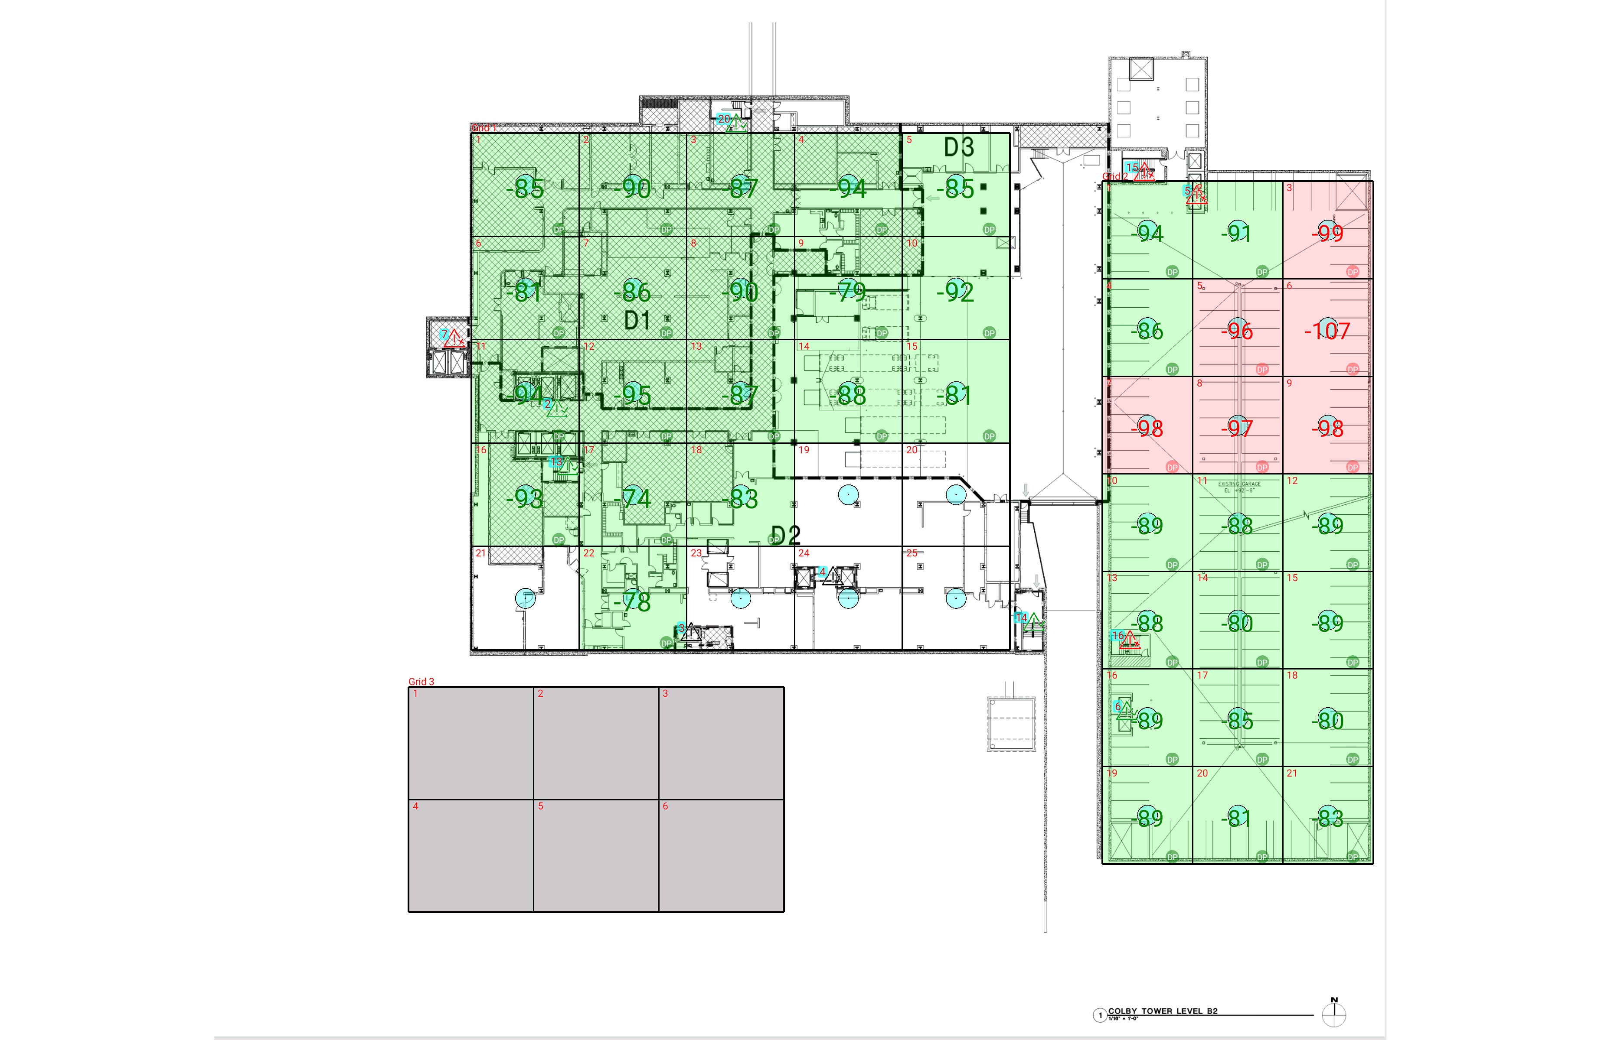

| **Grid** | **# of Areas** | **Area Size (sq. ft)** | **Area Width**  **(ft)** | **Area Height**  **(ft)** | **Ignore Area Color** | **Comments** |
| --- | --- | --- | --- | --- | --- | --- |
| 1 | 25 | 377.71 | 17.35 | 21.77 | Black |  |
| 2 | 21 | 298.85 | 14.56 | 20.53 | Black |  |
| 3 | 6 | 478.76 | 20.17 | 23.74 | Black |  |

**Floor: A4.B**

**Channel: 852937**

| **Critical Point Report** | | | | | | | |
| --- | --- | --- | --- | --- | --- | --- | --- |
| **Critical Point** | **DL**  **Power**  **(dBm)** | **DL**  **DAQ** | **UL**  **Power**  **(dBm)** | **UL**  **DAQ** | **Result** | **DL**  **Loss**  **(dB)** | **Comment** |
| 2 | -93.59 |  |  |  | **Pass** |  |  |
| 3 |  |  |  |  |  |  |  |
| 4 |  |  |  |  |  |  |  |
| 5 | -95.60 |  |  |  | **Fail** |  |  |
| 6 | -91.55 |  |  |  | **Pass** |  |  |
| 7 | -95.79 |  |  |  | **Fail** |  |  |
| 13 | -86.44 |  |  |  | **Pass** |  |  |
| 14 | -90.22 |  |  |  | **Pass** |  |  |
| 15 | -99.12 |  |  |  | **Fail** |  |  |
| 16 | -97.35 |  |  |  | **Fail** |  |  |
| 20 | -85.70 |  |  |  | **Pass** |  |  |

| **Area Report** | | | | | | | | |
| --- | --- | --- | --- | --- | --- | --- | --- | --- |
| **Grid** | **Area** | **DL**  **Power**  **(dBm)** | **DL**  **DAQ** | **UL**  **Power**  **(dBm)** | **UL**  **DAQ** | **Result** | **DL**  **Loss**  **(dB)** | **Comment** |
| 1 | 1 | -84.87 |  |  |  | **Pass** |  |  |
| 1 | 2 | -89.62 |  |  |  | **Pass** |  |  |
| 1 | 3 | -86.77 |  |  |  | **Pass** |  |  |
| 1 | 4 | -93.37 |  |  |  | **Pass** |  |  |
| 1 | 5 | -84.04 |  |  |  | **Pass** |  |  |
| 1 | 6 | -80.24 |  |  |  | **Pass** |  |  |
| 1 | 7 | -85.28 |  |  |  | **Pass** |  |  |
| 1 | 8 | -89.29 |  |  |  | **Pass** |  |  |
| 1 | 9 | -78.43 |  |  |  | **Pass** |  |  |
| 1 | 10 | -91.61 |  |  |  | **Pass** |  |  |
| 1 | 11 | -93.43 |  |  |  | **Pass** |  |  |
| 1 | 12 | -94.27 |  |  |  | **Pass** |  |  |
| 1 | 13 | -86.20 |  |  |  | **Pass** |  |  |
| 1 | 14 | -87.22 |  |  |  | **Pass** |  |  |
| 1 | 15 | -80.43 |  |  |  | **Pass** |  |  |
| 1 | 16 | -92.72 |  |  |  | **Pass** |  |  |
| 1 | 17 | -73.18 |  |  |  | **Pass** |  |  |
| 1 | 18 | -82.88 |  |  |  | **Pass** |  |  |
| 1 | 22 | -77.90 |  |  |  | **Pass** |  |  |
| 2 | 1 | -94.00 |  |  |  | **Pass** |  |  |
| 2 | 2 | -90.07 |  |  |  | **Pass** |  |  |
| 2 | 3 | -98.33 |  |  |  | **Fail** |  |  |
| 2 | 4 | -85.76 |  |  |  | **Pass** |  |  |
| 2 | 5 | -95.51 |  |  |  | **Fail** |  |  |
| 2 | 6 | -106.92 |  |  |  | **Fail** |  |  |
| 2 | 7 | -97.45 |  |  |  | **Fail** |  |  |
| 2 | 8 | -96.51 |  |  |  | **Fail** |  |  |
| 2 | 9 | -97.54 |  |  |  | **Fail** |  |  |
| 2 | 10 | -88.71 |  |  |  | **Pass** |  |  |
| 2 | 11 | -87.85 |  |  |  | **Pass** |  |  |
| 2 | 12 | -88.70 |  |  |  | **Pass** |  |  |
| 2 | 13 | -87.78 |  |  |  | **Pass** |  |  |
| 2 | 14 | -79.88 |  |  |  | **Pass** |  |  |
| 2 | 15 | -88.83 |  |  |  | **Pass** |  |  |
| 2 | 16 | -88.79 |  |  |  | **Pass** |  |  |
| 2 | 17 | -84.32 |  |  |  | **Pass** |  |  |
| 2 | 18 | -79.55 |  |  |  | **Pass** |  |  |
| 2 | 19 | -88.86 |  |  |  | **Pass** |  |  |
| 2 | 20 | -80.77 |  |  |  | **Pass** |  |  |
| 2 | 21 | -82.78 |  |  |  | **Pass** |  |  |
| 3 | 1 | NT | NT | NT | NT | **NT** |  |  |
| 3 | 2 | NT | NT | NT | NT | **NT** |  |  |
| 3 | 3 | NT | NT | NT | NT | **NT** |  |  |
| 3 | 4 | NT | NT | NT | NT | **NT** |  |  |
| 3 | 5 | NT | NT | NT | NT | **NT** |  |  |
| 3 | 6 | NT | NT | NT | NT | **NT** |  |  |

**Floor: A4.G**

**Channel: 852937**

**Result: Fail**

| **Freq (MHz)** | **Tech** | **Band** | **Ant Gain** | **Cable Loss** | **Ph.** | **Type** | **Mod** | **NAC** | **Area Points passed (%)** | **Critical Points passed (%)** |
| --- | --- | --- | --- | --- | --- | --- | --- | --- | --- | --- |
| 852.93750 | P25 | PRMCE | 0.00 | 0.00 |  |  |  |  | 46/46 (100%) | 10/11 (90%) |

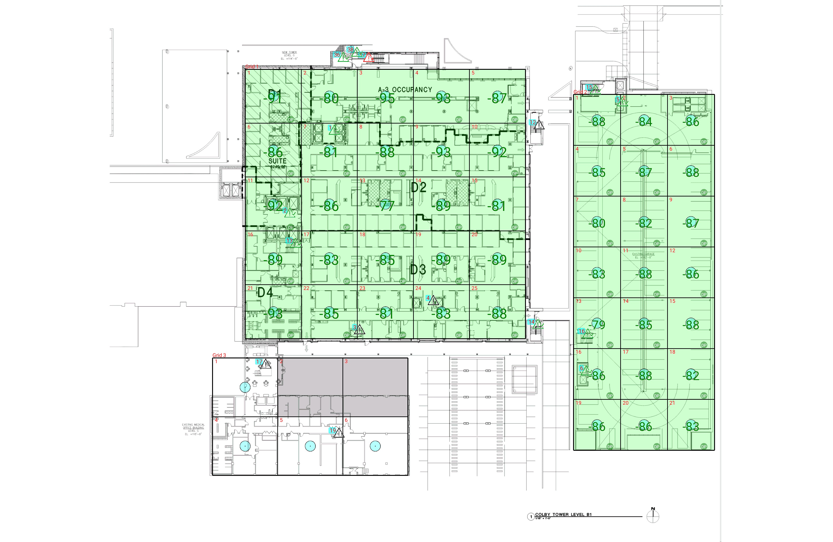

| **Grid** | **# of Areas** | **Area Size (sq. ft)** | **Area Width**  **(ft)** | **Area Height**  **(ft)** | **Ignore Area Color** | **Comments** |
| --- | --- | --- | --- | --- | --- | --- |
| 1 | 25 | 377.71 | 17.35 | 21.77 | Black |  |
| 2 | 21 | 298.85 | 14.56 | 20.53 | Black |  |
| 3 | 6 | 478.76 | 20.17 | 23.74 | Black |  |

**Floor: A4.G**

**Channel: 852937**

| **Critical Point Report** | | | | | | | |
| --- | --- | --- | --- | --- | --- | --- | --- |
| **Critical Point** | **DL**  **Power**  **(dBm)** | **DL**  **DAQ** | **UL**  **Power**  **(dBm)** | **UL**  **DAQ** | **Result** | **DL**  **Loss**  **(dB)** | **Comment** |
| 1 | -78.98 |  |  |  | **Pass** |  |  |
| 2 | -94.29 |  |  |  | **Pass** |  |  |
| 3 |  |  |  |  |  |  |  |
| 4 |  |  |  |  |  |  |  |
| 5 | -91.15 |  |  |  | **Pass** |  |  |
| 6 | -90.87 |  |  |  | **Pass** |  |  |
| 12 |  |  |  |  |  |  |  |
| 13 | -91.07 |  |  |  | **Pass** |  |  |
| 14 | -91.53 |  |  |  | **Pass** |  |  |
| 15 | -89.16 |  |  |  | **Pass** |  |  |
| 16 | -83.89 |  |  |  | **Pass** |  |  |
| 17 |  |  |  |  |  |  |  |
| 19 |  |  |  |  |  |  |  |
| 36 | -86.47 |  |  |  | **Pass** |  |  |
| 37 | -95.45 |  |  |  | **Fail** |  |  |
| 38 | -80.68 |  |  |  | **Pass** |  |  |

| **Area Report** | | | | | | | | |
| --- | --- | --- | --- | --- | --- | --- | --- | --- |
| **Grid** | **Area** | **DL**  **Power**  **(dBm)** | **DL**  **DAQ** | **UL**  **Power**  **(dBm)** | **UL**  **DAQ** | **Result** | **DL**  **Loss**  **(dB)** | **Comment** |
| 1 | 1 | -90.18 |  |  |  | **Pass** |  |  |
| 1 | 2 | -79.38 |  |  |  | **Pass** |  |  |
| 1 | 3 | -94.14 |  |  |  | **Pass** |  |  |
| 1 | 4 | -92.11 |  |  |  | **Pass** |  |  |
| 1 | 5 | -86.16 |  |  |  | **Pass** |  |  |
| 1 | 6 | -85.90 |  |  |  | **Pass** |  |  |
| 1 | 7 | -80.03 |  |  |  | **Pass** |  |  |
| 1 | 8 | -87.34 |  |  |  | **Pass** |  |  |
| 1 | 9 | -92.40 |  |  |  | **Pass** |  |  |
| 1 | 10 | -91.37 |  |  |  | **Pass** |  |  |
| 1 | 11 | -91.71 |  |  |  | **Pass** |  |  |
| 1 | 12 | -85.54 |  |  |  | **Pass** |  |  |
| 1 | 13 | -76.25 |  |  |  | **Pass** |  |  |
| 1 | 14 | -88.70 |  |  |  | **Pass** |  |  |
| 1 | 15 | -80.58 |  |  |  | **Pass** |  |  |
| 1 | 16 | -88.74 |  |  |  | **Pass** |  |  |
| 1 | 17 | -82.27 |  |  |  | **Pass** |  |  |
| 1 | 18 | -84.29 |  |  |  | **Pass** |  |  |
| 1 | 19 | -88.96 |  |  |  | **Pass** |  |  |
| 1 | 20 | -88.47 |  |  |  | **Pass** |  |  |
| 1 | 21 | -92.33 |  |  |  | **Pass** |  | uhf to aaron no response |
| 1 | 22 | -84.22 |  |  |  | **Pass** |  |  |
| 1 | 23 | -80.08 |  |  |  | **Pass** |  |  |
| 1 | 24 | -82.26 |  |  |  | **Pass** |  |  |
| 1 | 25 | -87.08 |  |  |  | **Pass** |  |  |
| 2 | 1 | -87.35 |  |  |  | **Pass** |  |  |
| 2 | 2 | -83.83 |  |  |  | **Pass** |  |  |
| 2 | 3 | -85.79 |  |  |  | **Pass** |  |  |
| 2 | 4 | -84.62 |  |  |  | **Pass** |  |  |
| 2 | 5 | -86.22 |  |  |  | **Pass** |  |  |
| 2 | 6 | -87.02 |  |  |  | **Pass** |  |  |
| 2 | 7 | -79.81 |  |  |  | **Pass** |  |  |
| 2 | 8 | -81.81 |  |  |  | **Pass** |  |  |
| 2 | 9 | -86.35 |  |  |  | **Pass** |  |  |
| 2 | 10 | -82.54 |  |  |  | **Pass** |  |  |
| 2 | 11 | -87.39 |  |  |  | **Pass** |  |  |
| 2 | 12 | -85.65 |  |  |  | **Pass** |  |  |
| 2 | 13 | -78.92 |  |  |  | **Pass** |  |  |
| 2 | 14 | -84.75 |  |  |  | **Pass** |  |  |
| 2 | 15 | -87.09 |  |  |  | **Pass** |  |  |
| 2 | 16 | -85.55 |  |  |  | **Pass** |  |  |
| 2 | 17 | -87.42 |  |  |  | **Pass** |  |  |
| 2 | 18 | -81.01 |  |  |  | **Pass** |  |  |
| 2 | 19 | -85.98 |  |  |  | **Pass** |  |  |
| 2 | 20 | -85.52 |  |  |  | **Pass** |  |  |
| 2 | 21 | -82.84 |  |  |  | **Pass** |  |  |
| 3 | 2 | NT | NT | NT | NT | **NT** |  |  |
| 3 | 3 | NT | NT | NT | NT | **NT** |  |  |

**Floor: A4.1**

**Channel: 852937**

**Result: Fail**

| **Freq (MHz)** | **Tech** | **Band** | **Ant Gain** | **Cable Loss** | **Ph.** | **Type** | **Mod** | **NAC** | **Area Points passed (%)** | **Critical Points passed (%)** |
| --- | --- | --- | --- | --- | --- | --- | --- | --- | --- | --- |
| 852.93750 | P25 | PRMCE | 0.00 | 0.00 |  |  |  |  | 48/49 (97%) | 12/14 (85%) |

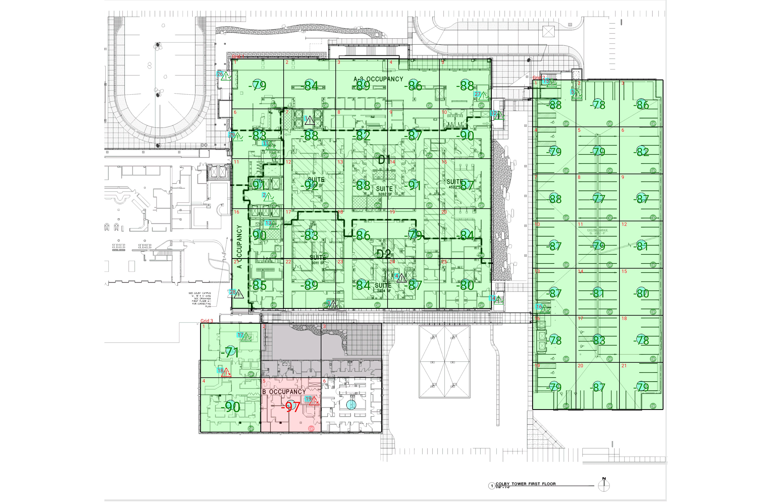

| **Grid** | **# of Areas** | **Area Size (sq. ft)** | **Area Width**  **(ft)** | **Area Height**  **(ft)** | **Ignore Area Color** | **Comments** |
| --- | --- | --- | --- | --- | --- | --- |
| 1 | 25 | 377.71 | 17.35 | 21.77 | Black |  |
| 2 | 21 | 298.85 | 14.56 | 20.53 | Black |  |
| 3 | 6 | 478.76 | 20.17 | 23.74 | Black |  |

**Floor: A4.1**

**Channel: 852937**

| **Critical Point Report** | | | | | | | |
| --- | --- | --- | --- | --- | --- | --- | --- |
| **Critical Point** | **DL**  **Power**  **(dBm)** | **DL**  **DAQ** | **UL**  **Power**  **(dBm)** | **UL**  **DAQ** | **Result** | **DL**  **Loss**  **(dB)** | **Comment** |
| 1 |  |  |  |  |  |  |  |
| 2 | -89.77 |  |  |  | **Pass** |  |  |
| 3 |  |  |  |  |  |  |  |
| 4 |  |  |  |  |  |  |  |
| 5 | -91.19 |  |  |  | **Pass** |  |  |
| 11 | -86.60 |  |  |  | **Pass** |  |  |
| 12 | -87.44 |  |  |  | **Pass** |  |  |
| 13 | -83.68 |  |  |  | **Pass** |  |  |
| 14 | -89.90 |  |  |  | **Pass** |  |  |
| 15 | -90.26 |  |  |  | **Pass** |  |  |
| 16 | -91.19 |  |  |  | **Pass** |  |  |
| 17 | -78.79 |  |  |  | **Pass** |  |  |
| 18 | -97.01 |  |  |  | **Fail** |  |  |
| 19 | -99.29 |  |  |  | **Fail** |  |  |
| 26 | -91.94 |  |  |  | **Pass** |  |  |
| 27 | -80.90 |  |  |  | **Pass** |  |  |
| 28 |  |  |  |  |  |  |  |
| 29 | -84.06 |  |  |  | **Pass** |  |  |

| **Area Report** | | | | | | | | |
| --- | --- | --- | --- | --- | --- | --- | --- | --- |
| **Grid** | **Area** | **DL**  **Power**  **(dBm)** | **DL**  **DAQ** | **UL**  **Power**  **(dBm)** | **UL**  **DAQ** | **Result** | **DL**  **Loss**  **(dB)** | **Comment** |
| 1 | 1 | -78.67 |  |  |  | **Pass** |  |  |
| 1 | 2 | -83.82 |  |  |  | **Pass** |  |  |
| 1 | 3 | -88.04 |  |  |  | **Pass** |  |  |
| 1 | 4 | -85.23 |  |  |  | **Pass** |  |  |
| 1 | 5 | -87.90 |  |  |  | **Pass** |  |  |
| 1 | 6 | -82.17 |  |  |  | **Pass** |  |  |
| 1 | 7 | -87.09 |  |  |  | **Pass** |  |  |
| 1 | 8 | -81.68 |  |  |  | **Pass** |  |  |
| 1 | 9 | -86.11 |  |  |  | **Pass** |  |  |
| 1 | 10 | -89.65 |  |  |  | **Pass** |  |  |
| 1 | 11 | -90.55 |  |  |  | **Pass** |  |  |
| 1 | 12 | -91.54 |  |  |  | **Pass** |  |  |
| 1 | 13 | -87.29 |  |  |  | **Pass** |  |  |
| 1 | 14 | -90.16 |  |  |  | **Pass** |  |  |
| 1 | 15 | -86.48 |  |  |  | **Pass** |  |  |
| 1 | 16 | -89.37 |  |  |  | **Pass** |  |  |
| 1 | 17 | -82.10 |  |  |  | **Pass** |  |  |
| 1 | 18 | -85.23 |  |  |  | **Pass** |  | dead uhf |
| 1 | 19 | -78.09 |  |  |  | **Pass** |  |  |
| 1 | 20 | -83.52 |  |  |  | **Pass** |  |  |
| 1 | 21 | -84.32 |  |  |  | **Pass** |  |  |
| 1 | 22 | -88.55 |  |  |  | **Pass** |  |  |
| 1 | 23 | -83.79 |  |  |  | **Pass** |  |  |
| 1 | 24 | -86.62 |  |  |  | **Pass** |  |  |
| 1 | 25 | -79.25 |  |  |  | **Pass** |  |  |
| 2 | 1 | -87.35 |  |  |  | **Pass** |  |  |
| 2 | 2 | -77.42 |  |  |  | **Pass** |  |  |
| 2 | 3 | -85.91 |  |  |  | **Pass** |  |  |
| 2 | 4 | -78.07 |  |  |  | **Pass** |  |  |
| 2 | 5 | -78.76 |  |  |  | **Pass** |  |  |
| 2 | 6 | -81.62 |  |  |  | **Pass** |  |  |
| 2 | 7 | -87.42 |  |  |  | **Pass** |  |  |
| 2 | 8 | -76.85 |  |  |  | **Pass** |  |  |
| 2 | 9 | -86.44 |  |  |  | **Pass** |  |  |
| 2 | 10 | -86.12 |  |  |  | **Pass** |  |  |
| 2 | 11 | -78.42 |  |  |  | **Pass** |  |  |
| 2 | 12 | -80.30 |  |  |  | **Pass** |  |  |
| 2 | 13 | -86.64 |  |  |  | **Pass** |  |  |
| 2 | 14 | -80.81 |  |  |  | **Pass** |  |  |
| 2 | 15 | -79.42 |  |  |  | **Pass** |  |  |
| 2 | 16 | -77.34 |  |  |  | **Pass** |  |  |
| 2 | 17 | -82.77 |  |  |  | **Pass** |  |  |
| 2 | 18 | -77.47 |  |  |  | **Pass** |  |  |
| 2 | 19 | -78.03 |  |  |  | **Pass** |  |  |
| 2 | 20 | -86.26 |  |  |  | **Pass** |  |  |
| 2 | 21 | -78.56 |  |  |  | **Pass** |  |  |
| 3 | 1 | -70.01 |  |  |  | **Pass** |  |  |
| 3 | 2 | NT | NT | NT | NT | **NT** |  |  |
| 3 | 3 | NT | NT | NT | NT | **NT** |  |  |
| 3 | 4 | -89.75 |  |  |  | **Pass** |  |  |
| 3 | 5 | -96.08 |  |  |  | **Fail** |  |  |

**Floor: A4.2**

**Channel: 852937**

**Result: Fail**

| **Freq (MHz)** | **Tech** | **Band** | **Ant Gain** | **Cable Loss** | **Ph.** | **Type** | **Mod** | **NAC** | **Area Points passed (%)** | **Critical Points passed (%)** |
| --- | --- | --- | --- | --- | --- | --- | --- | --- | --- | --- |
| 852.93750 | P25 | PRMCE | 0.00 | 0.00 |  |  |  |  | 35/35 (100%) | 11/12 (91%) |

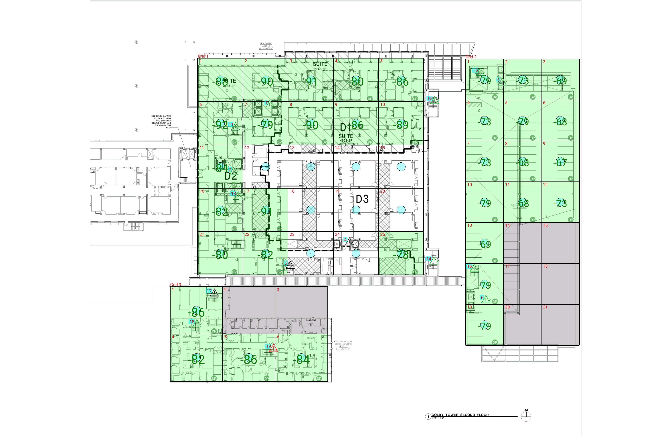

| **Grid** | **# of Areas** | **Area Size (sq. ft)** | **Area Width**  **(ft)** | **Area Height**  **(ft)** | **Ignore Area Color** | **Comments** |
| --- | --- | --- | --- | --- | --- | --- |
| 1 | 25 | 377.71 | 17.35 | 21.77 | Black |  |
| 2 | 21 | 298.85 | 14.56 | 20.53 | Black |  |
| 3 | 6 | 478.76 | 20.17 | 23.74 | Black |  |

**Floor: A4.2**

**Channel: 852937**

| **Critical Point Report** | | | | | | | |
| --- | --- | --- | --- | --- | --- | --- | --- |
| **Critical Point** | **DL**  **Power**  **(dBm)** | **DL**  **DAQ** | **UL**  **Power**  **(dBm)** | **UL**  **DAQ** | **Result** | **DL**  **Loss**  **(dB)** | **Comment** |
| 1 | -86.95 |  |  |  | **Pass** |  |  |
| 2 | -86.39 |  |  |  | **Pass** |  |  |
| 3 |  |  |  |  |  |  |  |
| 4 |  |  |  |  |  |  |  |
| 5 | -85.40 |  |  |  | **Pass** |  |  |
| 6 | -83.18 |  |  |  | **Pass** |  |  |
| 11 | -88.61 |  |  |  | **Pass** |  |  |
| 12 | -84.03 |  |  |  | **Pass** |  |  |
| 13 | -85.72 |  |  |  | **Pass** |  |  |
| 14 | -77.69 |  |  |  | **Pass** |  |  |
| 15 | -82.52 |  |  |  | **Pass** |  |  |
| 16 | -90.00 |  |  |  | **Pass** |  |  |
| 17 |  |  |  |  |  |  |  |
| 18 | -87.26 |  |  |  | **Pass** |  |  |
| 19 | -100.33 |  |  |  | **Fail** |  |  |

| **Area Report** | | | | | | | | |
| --- | --- | --- | --- | --- | --- | --- | --- | --- |
| **Grid** | **Area** | **DL**  **Power**  **(dBm)** | **DL**  **DAQ** | **UL**  **Power**  **(dBm)** | **UL**  **DAQ** | **Result** | **DL**  **Loss**  **(dB)** | **Comment** |
| 1 | 1 | -87.92 |  |  |  | **Pass** |  |  |
| 1 | 2 | -89.25 |  |  |  | **Pass** |  |  |
| 1 | 3 | -90.35 |  |  |  | **Pass** |  |  |
| 1 | 4 | -79.70 |  |  |  | **Pass** |  |  |
| 1 | 5 | -85.36 |  |  |  | **Pass** |  |  |
| 1 | 6 | -91.30 |  |  |  | **Pass** |  |  |
| 1 | 7 | -78.60 |  |  |  | **Pass** |  |  |
| 1 | 8 | -89.51 |  |  |  | **Pass** |  |  |
| 1 | 9 | -85.38 |  |  |  | **Pass** |  |  |
| 1 | 10 | -88.75 |  |  |  | **Pass** |  |  |
| 1 | 11 | -83.79 |  |  |  | **Pass** |  |  |
| 1 | 16 | -81.78 |  |  |  | **Pass** |  |  |
| 1 | 17 | -90.74 |  |  |  | **Pass** |  |  |
| 1 | 21 | -79.92 |  |  |  | **Pass** |  |  |
| 1 | 22 | -81.65 |  |  |  | **Pass** |  |  |
| 1 | 25 | -77.60 |  |  |  | **Pass** |  |  |
| 2 | 1 | -78.30 |  |  |  | **Pass** |  |  |
| 2 | 2 | -72.86 |  |  |  | **Pass** |  |  |
| 2 | 3 | -68.71 |  |  |  | **Pass** |  |  |
| 2 | 4 | -72.94 |  |  |  | **Pass** |  |  |
| 2 | 5 | -78.30 |  |  |  | **Pass** |  |  |
| 2 | 6 | -67.90 |  |  |  | **Pass** |  |  |
| 2 | 7 | -72.57 |  |  |  | **Pass** |  |  |
| 2 | 8 | -67.12 |  |  |  | **Pass** |  |  |
| 2 | 9 | -66.35 |  |  |  | **Pass** |  |  |
| 2 | 10 | -78.12 |  |  |  | **Pass** |  |  |
| 2 | 11 | -67.31 |  |  |  | **Pass** |  |  |
| 2 | 12 | -72.54 |  |  |  | **Pass** |  |  |
| 2 | 13 | -68.26 |  |  |  | **Pass** |  |  |
| 2 | 14 | NT | NT | NT | NT | **NT** |  |  |
| 2 | 15 | NT | NT | NT | NT | **NT** |  |  |
| 2 | 16 | -78.25 |  |  |  | **Pass** |  |  |
| 2 | 17 | NT | NT | NT | NT | **NT** |  |  |
| 2 | 18 | NT | NT | NT | NT | **NT** |  |  |
| 2 | 19 | -78.09 |  |  |  | **Pass** |  |  |
| 2 | 20 | NT | NT | NT | NT | **NT** |  |  |
| 2 | 21 | NT | NT | NT | NT | **NT** |  |  |
| 3 | 1 | -85.35 |  |  |  | **Pass** |  |  |
| 3 | 2 | NT | NT | NT | NT | **NT** |  |  |
| 3 | 3 | NT | NT | NT | NT | **NT** |  |  |
| 3 | 4 | -81.61 |  |  |  | **Pass** |  |  |
| 3 | 5 | -85.02 |  |  |  | **Pass** |  |  |
| 3 | 6 | -83.21 |  |  |  | **Pass** |  |  |

**Floor: A4.3**

**Channel: 852937**

**Result: Pass**

| **Freq (MHz)** | **Tech** | **Band** | **Ant Gain** | **Cable Loss** | **Ph.** | **Type** | **Mod** | **NAC** | **Area Points passed (%)** | **Critical Points passed (%)** |
| --- | --- | --- | --- | --- | --- | --- | --- | --- | --- | --- |
| 852.93750 | P25 | PRMCE | 0.00 | 0.00 |  |  |  |  | 19/20 (95%) | 8/8 (100%) |

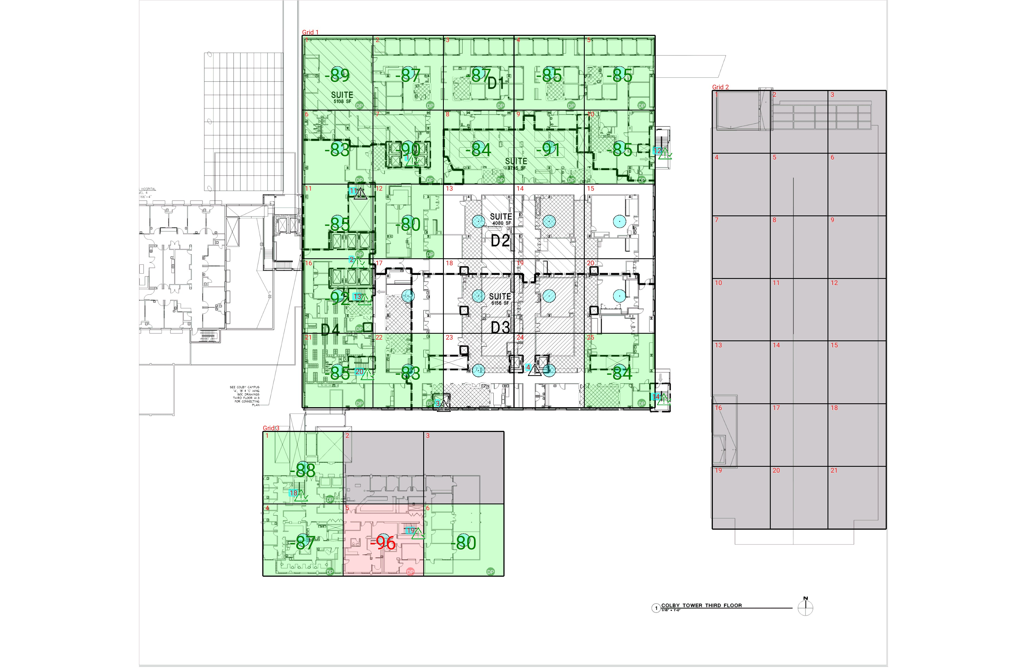

| **Grid** | **# of Areas** | **Area Size (sq. ft)** | **Area Width**  **(ft)** | **Area Height**  **(ft)** | **Ignore Area Color** | **Comments** |
| --- | --- | --- | --- | --- | --- | --- |
| 1 | 25 | 431.80 | 17.70 | 24.39 | Black |  |
| 2 | 21 | 298.85 | 14.56 | 20.53 | Black |  |
| 3 | 6 | 478.76 | 20.17 | 23.74 | Black |  |

**Floor: A4.3**

**Channel: 852937**

| **Critical Point Report** | | | | | | | |
| --- | --- | --- | --- | --- | --- | --- | --- |
| **Critical Point** | **DL**  **Power**  **(dBm)** | **DL**  **DAQ** | **UL**  **Power**  **(dBm)** | **UL**  **DAQ** | **Result** | **DL**  **Loss**  **(dB)** | **Comment** |
| 1 | -84.82 |  |  |  | **Pass** |  |  |
| 2 | -79.45 |  |  |  | **Pass** |  |  |
| 3 |  |  |  |  |  |  |  |
| 4 |  |  |  |  |  |  |  |
| 11 |  |  |  |  |  |  |  |
| 12 | -82.97 |  |  |  | **Pass** |  |  |
| 13 | -87.82 |  |  |  | **Pass** |  |  |
| 14 | -70.83 |  |  |  | **Pass** |  |  |
| 18 | -84.20 |  |  |  | **Pass** |  |  |
| 19 | -84.81 |  |  |  | **Pass** |  |  |
| 20 | -84.86 |  |  |  | **Pass** |  |  |

| **Area Report** | | | | | | | | |
| --- | --- | --- | --- | --- | --- | --- | --- | --- |
| **Grid** | **Area** | **DL**  **Power**  **(dBm)** | **DL**  **DAQ** | **UL**  **Power**  **(dBm)** | **UL**  **DAQ** | **Result** | **DL**  **Loss**  **(dB)** | **Comment** |
| 1 | 1 | -88.59 |  |  |  | **Pass** |  |  |
| 1 | 2 | -87.00 |  |  |  | **Pass** |  |  |
| 1 | 3 | -86.74 |  |  |  | **Pass** |  |  |
| 1 | 4 | -84.99 |  |  |  | **Pass** |  |  |
| 1 | 5 | -84.13 |  |  |  | **Pass** |  |  |
| 1 | 6 | -82.15 |  |  |  | **Pass** |  |  |
| 1 | 7 | -89.93 |  |  |  | **Pass** |  |  |
| 1 | 8 | -83.78 |  |  |  | **Pass** |  |  |
| 1 | 9 | -90.59 |  |  |  | **Pass** |  |  |
| 1 | 10 | -84.44 |  |  |  | **Pass** |  |  |
| 1 | 11 | -84.35 |  |  |  | **Pass** |  |  |
| 1 | 12 | -79.33 |  |  |  | **Pass** |  |  |
| 1 | 16 | -91.92 |  |  |  | **Pass** |  |  |
| 1 | 21 | -84.94 |  |  |  | **Pass** |  |  |
| 1 | 22 | -82.40 |  |  |  | **Pass** |  |  |
| 1 | 25 | -83.82 |  |  |  | **Pass** |  |  |
| 2 | 1 | NT | NT | NT | NT | **NT** |  |  |
| 2 | 2 | NT | NT | NT | NT | **NT** |  |  |
| 2 | 3 | NT | NT | NT | NT | **NT** |  |  |
| 2 | 4 | NT | NT | NT | NT | **NT** |  |  |
| 2 | 5 | NT | NT | NT | NT | **NT** |  |  |
| 2 | 6 | NT | NT | NT | NT | **NT** |  |  |
| 2 | 7 | NT | NT | NT | NT | **NT** |  |  |
| 2 | 8 | NT | NT | NT | NT | **NT** |  |  |
| 2 | 9 | NT | NT | NT | NT | **NT** |  |  |
| 2 | 10 | NT | NT | NT | NT | **NT** |  |  |
| 2 | 11 | NT | NT | NT | NT | **NT** |  |  |
| 2 | 12 | NT | NT | NT | NT | **NT** |  |  |
| 2 | 13 | NT | NT | NT | NT | **NT** |  |  |
| 2 | 14 | NT | NT | NT | NT | **NT** |  |  |
| 2 | 15 | NT | NT | NT | NT | **NT** |  |  |
| 2 | 16 | NT | NT | NT | NT | **NT** |  |  |
| 2 | 17 | NT | NT | NT | NT | **NT** |  |  |
| 2 | 18 | NT | NT | NT | NT | **NT** |  |  |
| 2 | 19 | NT | NT | NT | NT | **NT** |  |  |
| 2 | 20 | NT | NT | NT | NT | **NT** |  |  |
| 2 | 21 | NT | NT | NT | NT | **NT** |  |  |
| 3 | 1 | -87.90 |  |  |  | **Pass** |  |  |
| 3 | 2 | NT | NT | NT | NT | **NT** |  |  |
| 3 | 3 | NT | NT | NT | NT | **NT** |  |  |
| 3 | 4 | -86.85 |  |  |  | **Pass** |  |  |
| 3 | 5 | -95.23 |  |  |  | **Fail** |  |  |
| 3 | 6 | -79.94 |  |  |  | **Pass** |  |  |

**Floor: A4.4**

**Channel: 852937**

**Result: Pass**

| **Freq (MHz)** | **Tech** | **Band** | **Ant Gain** | **Cable Loss** | **Ph.** | **Type** | **Mod** | **NAC** | **Area Points passed (%)** | **Critical Points passed (%)** |
| --- | --- | --- | --- | --- | --- | --- | --- | --- | --- | --- |
| 852.93750 | P25 | PRMCE | 0.00 | 0.00 |  |  |  |  | 14/14 (100%) | 4/4 (100%) |

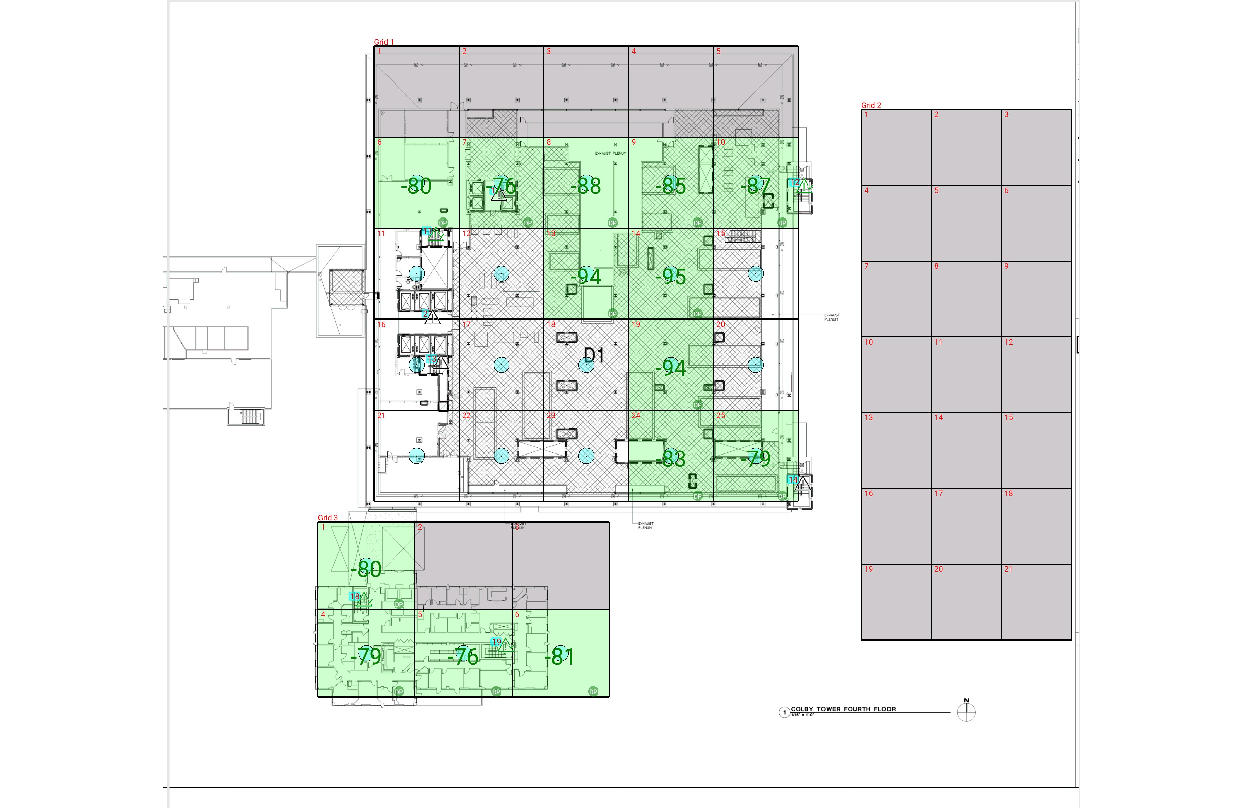

| **Grid** | **# of Areas** | **Area Size (sq. ft)** | **Area Width**  **(ft)** | **Area Height**  **(ft)** | **Ignore Area Color** | **Comments** |
| --- | --- | --- | --- | --- | --- | --- |
| 1 | 25 | 434.17 | 17.60 | 24.67 | Black |  |
| 2 | 21 | 298.85 | 14.56 | 20.53 | Black |  |
| 3 | 6 | 478.76 | 20.17 | 23.74 | Black |  |

**Floor: A4.4**

**Channel: 852937**

| **Critical Point Report** | | | | | | | |
| --- | --- | --- | --- | --- | --- | --- | --- |
| **Critical Point** | **DL**  **Power**  **(dBm)** | **DL**  **DAQ** | **UL**  **Power**  **(dBm)** | **UL**  **DAQ** | **Result** | **DL**  **Loss**  **(dB)** | **Comment** |
| 1 |  |  |  |  |  |  |  |
| 2 |  |  |  |  |  |  |  |
| 11 | -85.88 |  |  |  | **Pass** |  |  |
| 12 | -90.01 |  |  |  | **Pass** |  |  |
| 13 |  |  |  |  |  |  |  |
| 14 |  |  |  |  |  |  |  |
| 18 | -82.81 |  |  |  | **Pass** |  |  |
| 19 | -85.92 |  |  |  | **Pass** |  |  |

| **Area Report** | | | | | | | | |
| --- | --- | --- | --- | --- | --- | --- | --- | --- |
| **Grid** | **Area** | **DL**  **Power**  **(dBm)** | **DL**  **DAQ** | **UL**  **Power**  **(dBm)** | **UL**  **DAQ** | **Result** | **DL**  **Loss**  **(dB)** | **Comment** |
| 1 | 1 | NT | NT | NT | NT | **NT** |  |  |
| 1 | 2 | NT | NT | NT | NT | **NT** |  |  |
| 1 | 3 | NT | NT | NT | NT | **NT** |  |  |
| 1 | 4 | NT | NT | NT | NT | **NT** |  |  |
| 1 | 5 | NT | NT | NT | NT | **NT** |  |  |
| 1 | 6 | -79.16 |  |  |  | **Pass** |  |  |
| 1 | 7 | -75.56 |  |  |  | **Pass** |  |  |
| 1 | 8 | -87.68 |  |  |  | **Pass** |  |  |
| 1 | 9 | -84.11 |  |  |  | **Pass** |  |  |
| 1 | 10 | -86.84 |  |  |  | **Pass** |  |  |
| 1 | 13 | -93.09 |  |  |  | **Pass** |  |  |
| 1 | 14 | -94.13 |  |  |  | **Pass** |  |  |
| 1 | 19 | -93.03 |  |  |  | **Pass** |  |  |
| 1 | 24 | -82.06 |  |  |  | **Pass** |  |  |
| 1 | 25 | -78.21 |  |  |  | **Pass** |  |  |
| 2 | 1 | NT | NT | NT | NT | **NT** |  |  |
| 2 | 2 | NT | NT | NT | NT | **NT** |  |  |
| 2 | 3 | NT | NT | NT | NT | **NT** |  |  |
| 2 | 4 | NT | NT | NT | NT | **NT** |  |  |
| 2 | 5 | NT | NT | NT | NT | **NT** |  |  |
| 2 | 6 | NT | NT | NT | NT | **NT** |  |  |
| 2 | 7 | NT | NT | NT | NT | **NT** |  |  |
| 2 | 8 | NT | NT | NT | NT | **NT** |  |  |
| 2 | 9 | NT | NT | NT | NT | **NT** |  |  |
| 2 | 10 | NT | NT | NT | NT | **NT** |  |  |
| 2 | 11 | NT | NT | NT | NT | **NT** |  |  |
| 2 | 12 | NT | NT | NT | NT | **NT** |  |  |
| 2 | 13 | NT | NT | NT | NT | **NT** |  |  |
| 2 | 14 | NT | NT | NT | NT | **NT** |  |  |
| 2 | 15 | NT | NT | NT | NT | **NT** |  |  |
| 2 | 16 | NT | NT | NT | NT | **NT** |  |  |
| 2 | 17 | NT | NT | NT | NT | **NT** |  |  |
| 2 | 18 | NT | NT | NT | NT | **NT** |  |  |
| 2 | 19 | NT | NT | NT | NT | **NT** |  |  |
| 2 | 20 | NT | NT | NT | NT | **NT** |  |  |
| 2 | 21 | NT | NT | NT | NT | **NT** |  |  |
| 3 | 1 | -79.33 |  |  |  | **Pass** |  |  |
| 3 | 2 | NT | NT | NT | NT | **NT** |  |  |
| 3 | 3 | NT | NT | NT | NT | **NT** |  |  |
| 3 | 4 | -78.46 |  |  |  | **Pass** |  |  |
| 3 | 5 | -75.54 |  |  |  | **Pass** |  |  |
| 3 | 6 | -80.38 |  |  |  | **Pass** |  |  |

**Floor: A4.5**

**Channel: 852937**

**Result: Pass**

| **Freq (MHz)** | **Tech** | **Band** | **Ant Gain** | **Cable Loss** | **Ph.** | **Type** | **Mod** | **NAC** | **Area Points passed (%)** | **Critical Points passed (%)** |
| --- | --- | --- | --- | --- | --- | --- | --- | --- | --- | --- |
| 852.93750 | P25 | PRMCE | 0.00 | 0.00 |  |  |  |  | 14/14 (100%) | 5/5 (100%) |

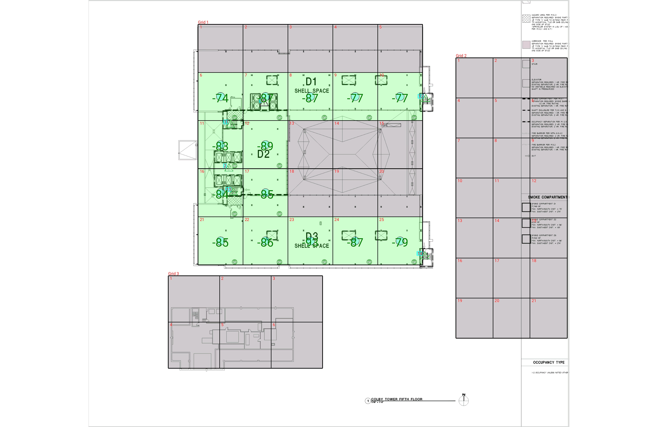

| **Grid** | **# of Areas** | **Area Size (sq. ft)** | **Area Width**  **(ft)** | **Area Height**  **(ft)** | **Ignore Area Color** | **Comments** |
| --- | --- | --- | --- | --- | --- | --- |
| 1 | 25 | 434.17 | 17.60 | 24.67 | Black |  |
| 2 | 21 | 298.85 | 14.56 | 20.53 | Black |  |
| 3 | 6 | 478.76 | 20.17 | 23.74 | Black |  |

**Floor: A4.5**

**Channel: 852937**

| **Critical Point Report** | | | | | | | |
| --- | --- | --- | --- | --- | --- | --- | --- |
| **Critical Point** | **DL**  **Power**  **(dBm)** | **DL**  **DAQ** | **UL**  **Power**  **(dBm)** | **UL**  **DAQ** | **Result** | **DL**  **Loss**  **(dB)** | **Comment** |
| 1 |  |  |  |  |  |  |  |
| 2 | -90.17 |  |  |  | **Pass** |  |  |
| 11 | -90.90 |  |  |  | **Pass** |  |  |
| 12 | -86.21 |  |  |  | **Pass** |  |  |
| 13 | -91.05 |  |  |  | **Pass** |  |  |
| 14 | -80.21 |  |  |  | **Pass** |  |  |

| **Area Report** | | | | | | | | |
| --- | --- | --- | --- | --- | --- | --- | --- | --- |
| **Grid** | **Area** | **DL**  **Power**  **(dBm)** | **DL**  **DAQ** | **UL**  **Power**  **(dBm)** | **UL**  **DAQ** | **Result** | **DL**  **Loss**  **(dB)** | **Comment** |
| 1 | 1 | NT | NT | NT | NT | **NT** |  |  |
| 1 | 2 | NT | NT | NT | NT | **NT** |  |  |
| 1 | 3 | NT | NT | NT | NT | **NT** |  |  |
| 1 | 4 | NT | NT | NT | NT | **NT** |  |  |
| 1 | 5 | NT | NT | NT | NT | **NT** |  |  |
| 1 | 6 | -73.24 |  |  |  | **Pass** |  |  |
| 1 | 7 | -86.95 |  |  |  | **Pass** |  |  |
| 1 | 8 | -86.65 |  |  |  | **Pass** |  |  |
| 1 | 9 | -76.66 |  |  |  | **Pass** |  |  |
| 1 | 10 | -76.49 |  |  |  | **Pass** |  |  |
| 1 | 11 | -82.66 |  |  |  | **Pass** |  |  |
| 1 | 12 | -88.91 |  |  |  | **Pass** |  |  |
| 1 | 13 | NT | NT | NT | NT | **NT** |  |  |
| 1 | 14 | NT | NT | NT | NT | **NT** |  |  |
| 1 | 15 | NT | NT | NT | NT | **NT** |  |  |
| 1 | 16 | -83.47 |  |  |  | **Pass** |  |  |
| 1 | 17 | -84.27 |  |  |  | **Pass** |  |  |
| 1 | 18 | NT | NT | NT | NT | **NT** |  |  |
| 1 | 19 | NT | NT | NT | NT | **NT** |  |  |
| 1 | 20 | NT | NT | NT | NT | **NT** |  |  |
| 1 | 21 | -84.69 |  |  |  | **Pass** |  |  |
| 1 | 22 | -85.65 |  |  |  | **Pass** |  |  |
| 1 | 23 | -92.36 |  |  |  | **Pass** |  |  |
| 1 | 24 | -86.33 |  |  |  | **Pass** |  |  |
| 1 | 25 | -78.96 |  |  |  | **Pass** |  |  |
| 2 | 1 | NT | NT | NT | NT | **NT** |  |  |
| 2 | 2 | NT | NT | NT | NT | **NT** |  |  |
| 2 | 3 | NT | NT | NT | NT | **NT** |  |  |
| 2 | 4 | NT | NT | NT | NT | **NT** |  |  |
| 2 | 5 | NT | NT | NT | NT | **NT** |  |  |
| 2 | 6 | NT | NT | NT | NT | **NT** |  |  |
| 2 | 7 | NT | NT | NT | NT | **NT** |  |  |
| 2 | 8 | NT | NT | NT | NT | **NT** |  |  |
| 2 | 9 | NT | NT | NT | NT | **NT** |  |  |
| 2 | 10 | NT | NT | NT | NT | **NT** |  |  |
| 2 | 11 | NT | NT | NT | NT | **NT** |  |  |
| 2 | 12 | NT | NT | NT | NT | **NT** |  |  |
| 2 | 13 | NT | NT | NT | NT | **NT** |  |  |
| 2 | 14 | NT | NT | NT | NT | **NT** |  |  |
| 2 | 15 | NT | NT | NT | NT | **NT** |  |  |
| 2 | 16 | NT | NT | NT | NT | **NT** |  |  |
| 2 | 17 | NT | NT | NT | NT | **NT** |  |  |
| 2 | 18 | NT | NT | NT | NT | **NT** |  |  |
| 2 | 19 | NT | NT | NT | NT | **NT** |  |  |
| 2 | 20 | NT | NT | NT | NT | **NT** |  |  |
| 2 | 21 | NT | NT | NT | NT | **NT** |  |  |
| 3 | 1 | NT | NT | NT | NT | **NT** |  |  |
| 3 | 2 | NT | NT | NT | NT | **NT** |  |  |
| 3 | 3 | NT | NT | NT | NT | **NT** |  |  |
| 3 | 4 | NT | NT | NT | NT | **NT** |  |  |
| 3 | 5 | NT | NT | NT | NT | **NT** |  |  |
| 3 | 6 | NT | NT | NT | NT | **NT** |  |  |

**Floor: A4.6**

**Channel: 852937**

**Result: Fail**

| **Freq (MHz)** | **Tech** | **Band** | **Ant Gain** | **Cable Loss** | **Ph.** | **Type** | **Mod** | **NAC** | **Area Points passed (%)** | **Critical Points passed (%)** |
| --- | --- | --- | --- | --- | --- | --- | --- | --- | --- | --- |
| 852.93750 | P25 | PRMCE | 0.00 | 0.00 |  |  |  |  | 11/12 (91%) | 5/5 (100%) |

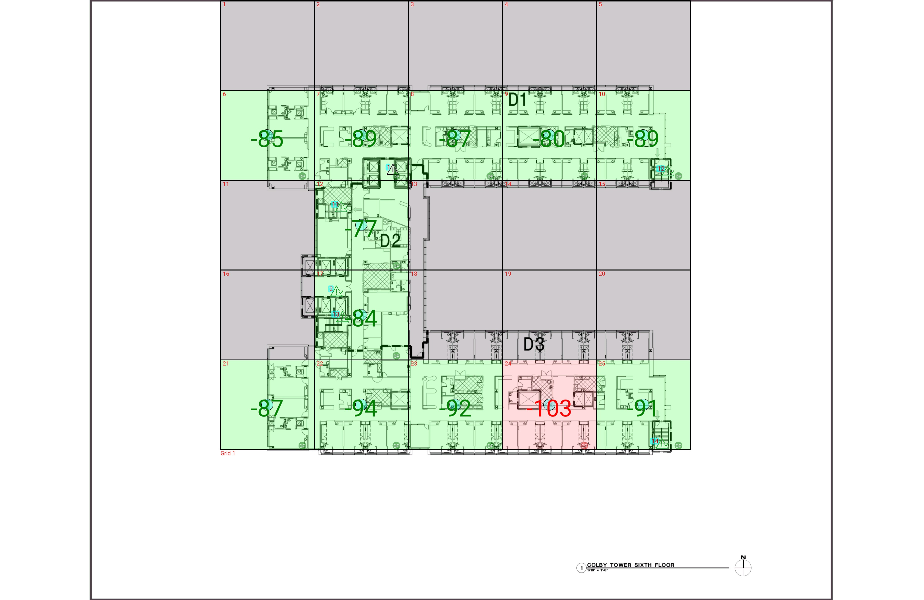

| **Grid** | **# of Areas** | **Area Size (sq. ft)** | **Area Width**  **(ft)** | **Area Height**  **(ft)** | **Ignore Area Color** | **Comments** |
| --- | --- | --- | --- | --- | --- | --- |
| 1 | 25 | 860.38 | 26.25 | 32.77 | Black |  |

**Floor: A4.6**

**Channel: 852937**

| **Critical Point Report** | | | | | | | |
| --- | --- | --- | --- | --- | --- | --- | --- |
| **Critical Point** | **DL**  **Power**  **(dBm)** | **DL**  **DAQ** | **UL**  **Power**  **(dBm)** | **UL**  **DAQ** | **Result** | **DL**  **Loss**  **(dB)** | **Comment** |
| 1 |  |  |  |  |  |  |  |
| 2 | -83.41 |  |  |  | **Pass** |  |  |
| 11 | -84.86 |  |  |  | **Pass** |  |  |
| 12 | -81.18 |  |  |  | **Pass** |  |  |
| 13 | -90.33 |  |  |  | **Pass** |  |  |
| 14 | -93.56 |  |  |  | **Pass** |  |  |

| **Area Report** | | | | | | | | |
| --- | --- | --- | --- | --- | --- | --- | --- | --- |
| **Grid** | **Area** | **DL**  **Power**  **(dBm)** | **DL**  **DAQ** | **UL**  **Power**  **(dBm)** | **UL**  **DAQ** | **Result** | **DL**  **Loss**  **(dB)** | **Comment** |
| 1 | 1 | NT | NT | NT | NT | **NT** |  |  |
| 1 | 2 | NT | NT | NT | NT | **NT** |  |  |
| 1 | 3 | NT | NT | NT | NT | **NT** |  |  |
| 1 | 4 | NT | NT | NT | NT | **NT** |  |  |
| 1 | 5 | NT | NT | NT | NT | **NT** |  |  |
| 1 | 6 | -84.79 |  |  |  | **Pass** |  |  |
| 1 | 7 | -88.74 |  |  |  | **Pass** |  |  |
| 1 | 8 | -86.07 |  |  |  | **Pass** |  |  |
| 1 | 9 | -79.44 |  |  |  | **Pass** |  |  |
| 1 | 10 | -88.37 |  |  |  | **Pass** |  |  |
| 1 | 11 | NT | NT | NT | NT | **NT** |  |  |
| 1 | 12 | -76.53 |  |  |  | **Pass** |  |  |
| 1 | 13 | NT | NT | NT | NT | **NT** |  |  |
| 1 | 14 | NT | NT | NT | NT | **NT** |  |  |
| 1 | 15 | NT | NT | NT | NT | **NT** |  |  |
| 1 | 16 | NT | NT | NT | NT | **NT** |  |  |
| 1 | 17 | -83.62 |  |  |  | **Pass** |  |  |
| 1 | 18 | NT | NT | NT | NT | **NT** |  |  |
| 1 | 19 | NT | NT | NT | NT | **NT** |  |  |
| 1 | 20 | NT | NT | NT | NT | **NT** |  |  |
| 1 | 21 | -86.73 |  |  |  | **Pass** |  |  |
| 1 | 22 | -93.94 |  |  |  | **Pass** |  |  |
| 1 | 23 | -91.40 |  |  |  | **Pass** |  |  |
| 1 | 24 | -102.02 |  |  |  | **Fail** |  |  |
| 1 | 25 | -90.25 |  |  |  | **Pass** |  |  |

**Floor: A4.7**

**Channel: 852937**

**Result: Pass**

| **Freq (MHz)** | **Tech** | **Band** | **Ant Gain** | **Cable Loss** | **Ph.** | **Type** | **Mod** | **NAC** | **Area Points passed (%)** | **Critical Points passed (%)** |
| --- | --- | --- | --- | --- | --- | --- | --- | --- | --- | --- |
| 852.93750 | P25 | PRMCE | 0.00 | 0.00 |  |  |  |  | 12/12 (100%) | 5/5 (100%) |

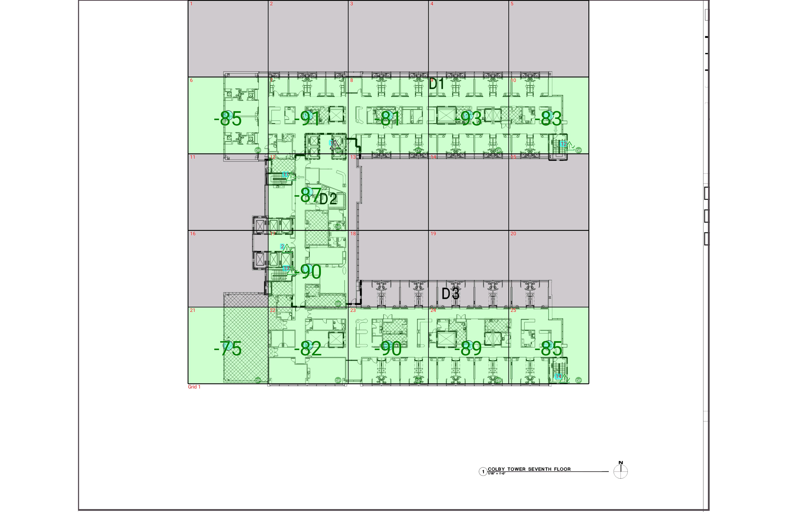

| **Grid** | **# of Areas** | **Area Size (sq. ft)** | **Area Width**  **(ft)** | **Area Height**  **(ft)** | **Ignore Area Color** | **Comments** |
| --- | --- | --- | --- | --- | --- | --- |
| 1 | 25 | 860.38 | 26.25 | 32.77 | Black |  |

**Floor: A4.7**

**Channel: 852937**

| **Critical Point Report** | | | | | | | |
| --- | --- | --- | --- | --- | --- | --- | --- |
| **Critical Point** | **DL**  **Power**  **(dBm)** | **DL**  **DAQ** | **UL**  **Power**  **(dBm)** | **UL**  **DAQ** | **Result** | **DL**  **Loss**  **(dB)** | **Comment** |
| 1 |  |  |  |  |  |  |  |
| 2 | -83.71 |  |  |  | **Pass** |  |  |
| 11 | -91.87 |  |  |  | **Pass** |  |  |
| 12 | -81.56 |  |  |  | **Pass** |  |  |
| 13 | -84.87 |  |  |  | **Pass** |  |  |
| 14 | -86.63 |  |  |  | **Pass** |  |  |

| **Area Report** | | | | | | | | |
| --- | --- | --- | --- | --- | --- | --- | --- | --- |
| **Grid** | **Area** | **DL**  **Power**  **(dBm)** | **DL**  **DAQ** | **UL**  **Power**  **(dBm)** | **UL**  **DAQ** | **Result** | **DL**  **Loss**  **(dB)** | **Comment** |
| 1 | 1 | NT | NT | NT | NT | **NT** |  |  |
| 1 | 2 | NT | NT | NT | NT | **NT** |  |  |
| 1 | 3 | NT | NT | NT | NT | **NT** |  |  |
| 1 | 4 | NT | NT | NT | NT | **NT** |  |  |
| 1 | 5 | NT | NT | NT | NT | **NT** |  |  |
| 1 | 6 | -84.21 |  |  |  | **Pass** |  |  |
| 1 | 7 | -90.64 |  |  |  | **Pass** |  |  |
| 1 | 8 | -80.84 |  |  |  | **Pass** |  |  |
| 1 | 9 | -92.83 |  |  |  | **Pass** |  |  |
| 1 | 10 | -82.37 |  |  |  | **Pass** |  |  |
| 1 | 11 | NT | NT | NT | NT | **NT** |  |  |
| 1 | 12 | -86.17 |  |  |  | **Pass** |  |  |
| 1 | 13 | NT | NT | NT | NT | **NT** |  |  |
| 1 | 14 | NT | NT | NT | NT | **NT** |  |  |
| 1 | 15 | NT | NT | NT | NT | **NT** |  |  |
| 1 | 16 | NT | NT | NT | NT | **NT** |  |  |
| 1 | 17 | -89.84 |  |  |  | **Pass** |  |  |
| 1 | 18 | NT | NT | NT | NT | **NT** |  |  |
| 1 | 19 | NT | NT | NT | NT | **NT** |  |  |
| 1 | 20 | NT | NT | NT | NT | **NT** |  |  |
| 1 | 21 | -74.59 |  |  |  | **Pass** |  |  |
| 1 | 22 | -81.54 |  |  |  | **Pass** |  |  |
| 1 | 23 | -89.33 |  |  |  | **Pass** |  |  |
| 1 | 24 | -89.00 |  |  |  | **Pass** |  |  |
| 1 | 25 | -84.43 |  |  |  | **Pass** |  |  |

**Floor: A4.8**

**Channel: 852937**

**Result: Pass**

| **Freq (MHz)** | **Tech** | **Band** | **Ant Gain** | **Cable Loss** | **Ph.** | **Type** | **Mod** | **NAC** | **Area Points passed (%)** | **Critical Points passed (%)** |
| --- | --- | --- | --- | --- | --- | --- | --- | --- | --- | --- |
| 852.93750 | P25 | PRMCE | 0.00 | 0.00 |  |  |  |  | 12/12 (100%) | 5/5 (100%) |

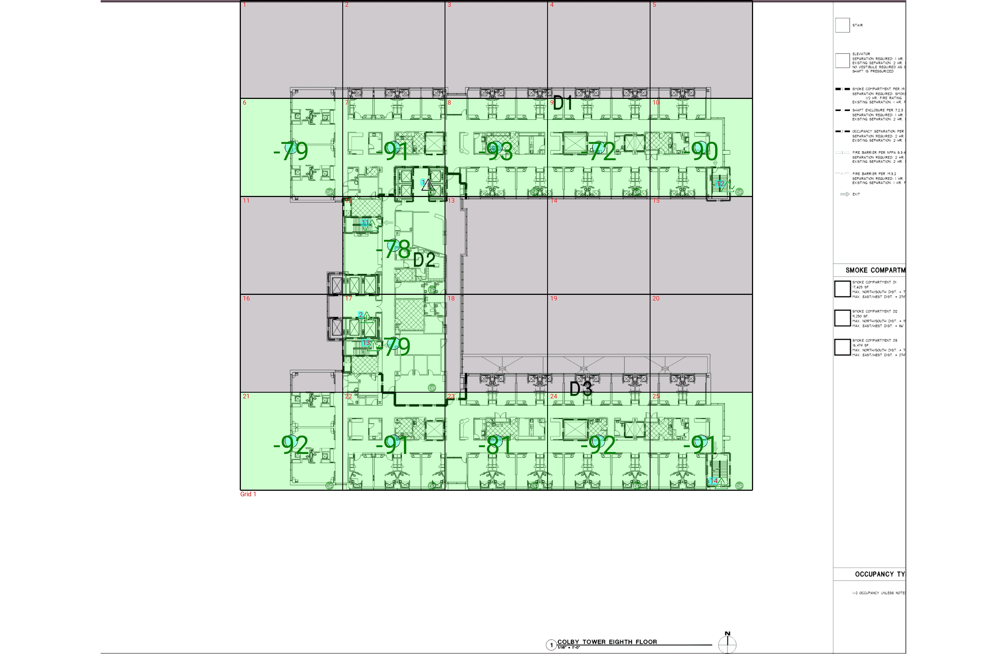

| **Grid** | **# of Areas** | **Area Size (sq. ft)** | **Area Width**  **(ft)** | **Area Height**  **(ft)** | **Ignore Area Color** | **Comments** |
| --- | --- | --- | --- | --- | --- | --- |
| 1 | 25 | 860.38 | 26.25 | 32.77 | Black |  |

**Floor: A4.8**

**Channel: 852937**

| **Critical Point Report** | | | | | | | |
| --- | --- | --- | --- | --- | --- | --- | --- |
| **Critical Point** | **DL**  **Power**  **(dBm)** | **DL**  **DAQ** | **UL**  **Power**  **(dBm)** | **UL**  **DAQ** | **Result** | **DL**  **Loss**  **(dB)** | **Comment** |
| 1 |  |  |  |  |  |  |  |
| 2 | -79.32 |  |  |  | **Pass** |  |  |
| 11 | -86.24 |  |  |  | **Pass** |  |  |
| 12 | -73.52 |  |  |  | **Pass** |  |  |
| 13 | -77.23 |  |  |  | **Pass** |  |  |
| 14 | -86.82 |  |  |  | **Pass** |  |  |

| **Area Report** | | | | | | | | |
| --- | --- | --- | --- | --- | --- | --- | --- | --- |
| **Grid** | **Area** | **DL**  **Power**  **(dBm)** | **DL**  **DAQ** | **UL**  **Power**  **(dBm)** | **UL**  **DAQ** | **Result** | **DL**  **Loss**  **(dB)** | **Comment** |
| 1 | 1 | NT | NT | NT | NT | **NT** |  |  |
| 1 | 2 | NT | NT | NT | NT | **NT** |  |  |
| 1 | 3 | NT | NT | NT | NT | **NT** |  |  |
| 1 | 4 | NT | NT | NT | NT | **NT** |  |  |
| 1 | 5 | NT | NT | NT | NT | **NT** |  |  |
| 1 | 6 | -78.04 |  |  |  | **Pass** |  |  |
| 1 | 7 | -90.66 |  |  |  | **Pass** |  |  |
| 1 | 8 | -92.35 |  |  |  | **Pass** |  |  |
| 1 | 9 | -71.81 |  |  |  | **Pass** |  |  |
| 1 | 10 | -89.36 |  |  |  | **Pass** |  |  |
| 1 | 11 | NT | NT | NT | NT | **NT** |  |  |
| 1 | 12 | -77.95 |  |  |  | **Pass** |  |  |
| 1 | 13 | NT | NT | NT | NT | **NT** |  |  |
| 1 | 14 | NT | NT | NT | NT | **NT** |  |  |
| 1 | 15 | NT | NT | NT | NT | **NT** |  |  |
| 1 | 16 | NT | NT | NT | NT | **NT** |  |  |
| 1 | 17 | -78.24 |  |  |  | **Pass** |  |  |
| 1 | 18 | NT | NT | NT | NT | **NT** |  |  |
| 1 | 19 | NT | NT | NT | NT | **NT** |  |  |
| 1 | 20 | NT | NT | NT | NT | **NT** |  |  |
| 1 | 21 | -91.98 |  |  |  | **Pass** |  |  |
| 1 | 22 | -90.76 |  |  |  | **Pass** |  |  |
| 1 | 23 | -80.40 |  |  |  | **Pass** |  |  |
| 1 | 24 | -91.40 |  |  |  | **Pass** |  |  |
| 1 | 25 | -90.73 |  |  |  | **Pass** |  |  |

**Floor: A4.9**

**Channel: 852937**

**Result: Fail**

| **Freq (MHz)** | **Tech** | **Band** | **Ant Gain** | **Cable Loss** | **Ph.** | **Type** | **Mod** | **NAC** | **Area Points passed (%)** | **Critical Points passed (%)** |
| --- | --- | --- | --- | --- | --- | --- | --- | --- | --- | --- |
| 852.93750 | P25 | PRMCE | 0.00 | 0.00 |  |  |  |  | 11/12 (91%) | 5/5 (100%) |

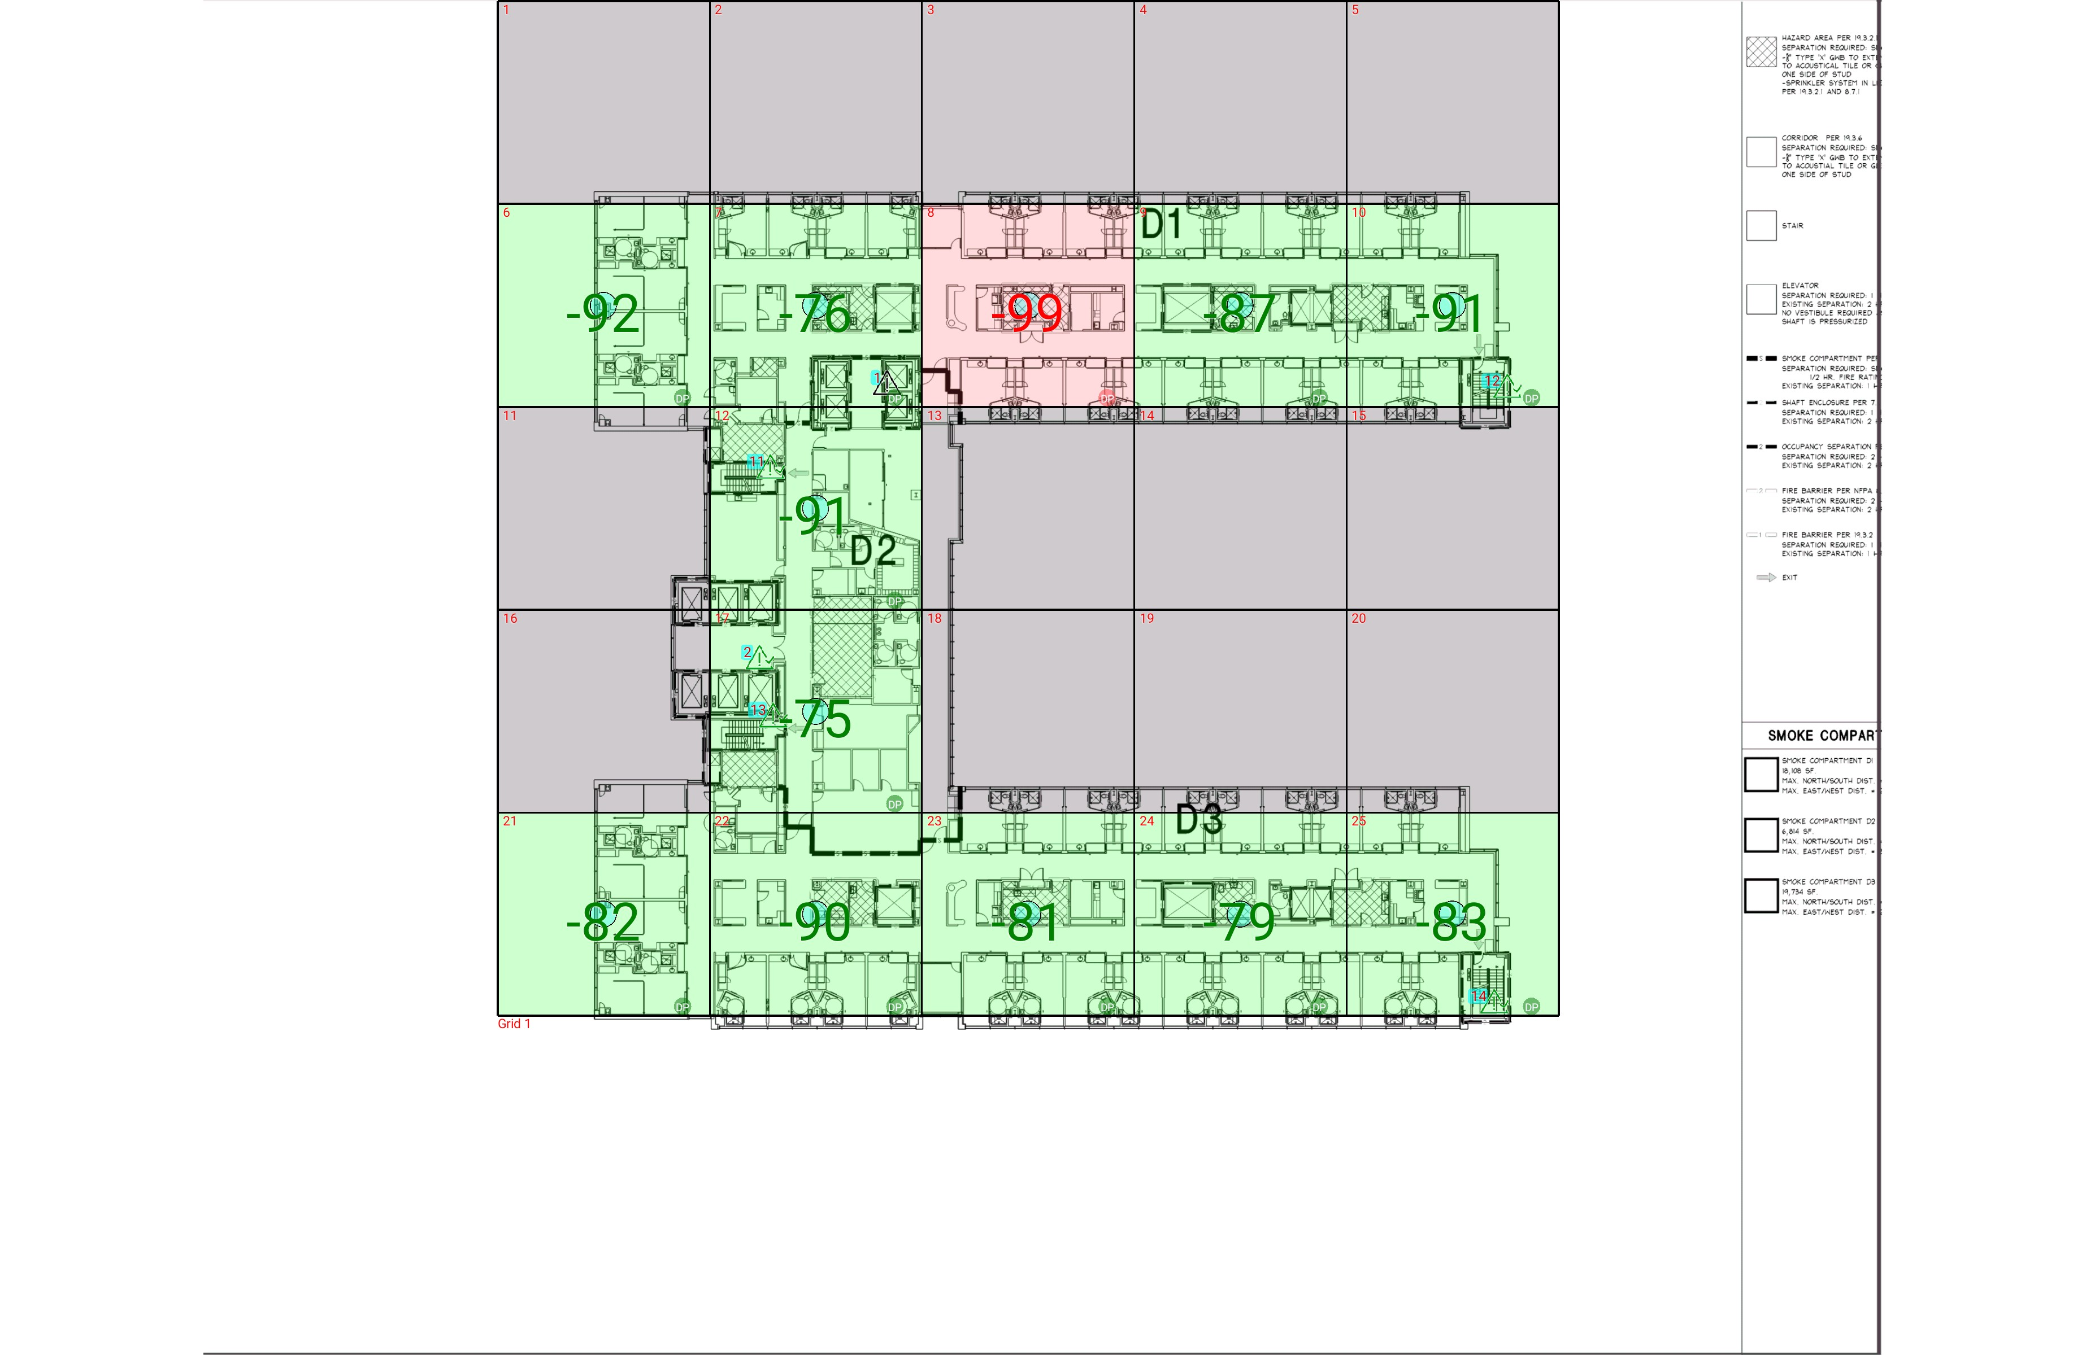

| **Grid** | **# of Areas** | **Area Size (sq. ft)** | **Area Width**  **(ft)** | **Area Height**  **(ft)** | **Ignore Area Color** | **Comments** |
| --- | --- | --- | --- | --- | --- | --- |
| 1 | 25 | 860.38 | 26.25 | 32.77 | Black |  |

**Floor: A4.9**

**Channel: 852937**

| **Critical Point Report** | | | | | | | |
| --- | --- | --- | --- | --- | --- | --- | --- |
| **Critical Point** | **DL**  **Power**  **(dBm)** | **DL**  **DAQ** | **UL**  **Power**  **(dBm)** | **UL**  **DAQ** | **Result** | **DL**  **Loss**  **(dB)** | **Comment** |
| 1 |  |  |  |  |  |  |  |
| 2 | -78.71 |  |  |  | **Pass** |  |  |
| 11 | -88.31 |  |  |  | **Pass** |  |  |
| 12 | -92.07 |  |  |  | **Pass** |  |  |
| 13 | -72.97 |  |  |  | **Pass** |  |  |
| 14 | -82.80 |  |  |  | **Pass** |  |  |

| **Area Report** | | | | | | | | |
| --- | --- | --- | --- | --- | --- | --- | --- | --- |
| **Grid** | **Area** | **DL**  **Power**  **(dBm)** | **DL**  **DAQ** | **UL**  **Power**  **(dBm)** | **UL**  **DAQ** | **Result** | **DL**  **Loss**  **(dB)** | **Comment** |
| 1 | 1 | NT | NT | NT | NT | **NT** |  |  |
| 1 | 2 | NT | NT | NT | NT | **NT** |  |  |
| 1 | 3 | NT | NT | NT | NT | **NT** |  |  |
| 1 | 4 | NT | NT | NT | NT | **NT** |  |  |
| 1 | 5 | NT | NT | NT | NT | **NT** |  |  |
| 1 | 6 | -91.14 |  |  |  | **Pass** |  |  |
| 1 | 7 | -75.12 |  |  |  | **Pass** |  |  |
| 1 | 8 | -98.63 |  |  |  | **Fail** |  |  |
| 1 | 9 | -86.57 |  |  |  | **Pass** |  |  |
| 1 | 10 | -90.98 |  |  |  | **Pass** |  |  |
| 1 | 11 | NT | NT | NT | NT | **NT** |  |  |
| 1 | 12 | -90.04 |  |  |  | **Pass** |  |  |
| 1 | 13 | NT | NT | NT | NT | **NT** |  |  |
| 1 | 14 | NT | NT | NT | NT | **NT** |  |  |
| 1 | 15 | NT | NT | NT | NT | **NT** |  |  |
| 1 | 16 | NT | NT | NT | NT | **NT** |  |  |
| 1 | 17 | -74.77 |  |  |  | **Pass** |  |  |
| 1 | 18 | NT | NT | NT | NT | **NT** |  |  |
| 1 | 19 | NT | NT | NT | NT | **NT** |  |  |
| 1 | 20 | NT | NT | NT | NT | **NT** |  |  |
| 1 | 21 | -81.59 |  |  |  | **Pass** |  |  |
| 1 | 22 | -89.93 |  |  |  | **Pass** |  |  |
| 1 | 23 | -80.97 |  |  |  | **Pass** |  |  |
| 1 | 24 | -78.31 |  |  |  | **Pass** |  |  |
| 1 | 25 | -82.04 |  |  |  | **Pass** |  |  |

**Floor: A4.10**

**Channel: 852937**

**Result: Fail**

| **Freq (MHz)** | **Tech** | **Band** | **Ant Gain** | **Cable Loss** | **Ph.** | **Type** | **Mod** | **NAC** | **Area Points passed (%)** | **Critical Points passed (%)** |
| --- | --- | --- | --- | --- | --- | --- | --- | --- | --- | --- |
| 852.93750 | P25 | PRMCE | 0.00 | 0.00 |  |  |  |  | 11/12 (91%) | 5/5 (100%) |

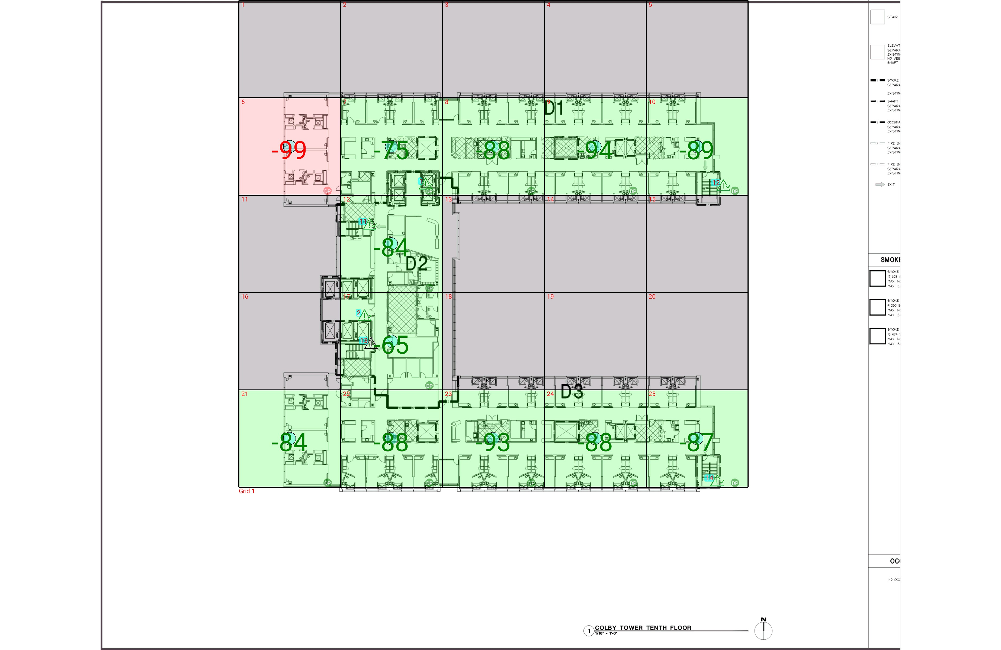

| **Grid** | **# of Areas** | **Area Size (sq. ft)** | **Area Width**  **(ft)** | **Area Height**  **(ft)** | **Ignore Area Color** | **Comments** |
| --- | --- | --- | --- | --- | --- | --- |
| 1 | 25 | 860.38 | 26.25 | 32.77 | Black |  |

**Floor: A4.10**

**Channel: 852937**

| **Critical Point Report** | | | | | | | |
| --- | --- | --- | --- | --- | --- | --- | --- |
| **Critical Point** | **DL**  **Power**  **(dBm)** | **DL**  **DAQ** | **UL**  **Power**  **(dBm)** | **UL**  **DAQ** | **Result** | **DL**  **Loss**  **(dB)** | **Comment** |
| 1 | -67.72 |  |  |  | **Pass** |  |  |
| 2 | -65.07 |  |  |  | **Pass** |  |  |
| 11 | -87.91 |  |  |  | **Pass** |  |  |
| 12 | -91.91 |  |  |  | **Pass** |  |  |
| 13 |  |  |  |  |  |  |  |
| 14 | -84.63 |  |  |  | **Pass** |  |  |

| **Area Report** | | | | | | | | |
| --- | --- | --- | --- | --- | --- | --- | --- | --- |
| **Grid** | **Area** | **DL**  **Power**  **(dBm)** | **DL**  **DAQ** | **UL**  **Power**  **(dBm)** | **UL**  **DAQ** | **Result** | **DL**  **Loss**  **(dB)** | **Comment** |
| 1 | 1 | NT | NT | NT | NT | **NT** |  |  |
| 1 | 2 | NT | NT | NT | NT | **NT** |  |  |
| 1 | 3 | NT | NT | NT | NT | **NT** |  |  |
| 1 | 4 | NT | NT | NT | NT | **NT** |  |  |
| 1 | 5 | NT | NT | NT | NT | **NT** |  |  |
| 1 | 6 | -98.16 |  |  |  | **Fail** |  |  |
| 1 | 7 | -74.61 |  |  |  | **Pass** |  |  |
| 1 | 8 | -87.93 |  |  |  | **Pass** |  |  |
| 1 | 9 | -93.77 |  |  |  | **Pass** |  |  |
| 1 | 10 | -88.14 |  |  |  | **Pass** |  |  |
| 1 | 11 | NT | NT | NT | NT | **NT** |  |  |
| 1 | 12 | -83.06 |  |  |  | **Pass** |  |  |
| 1 | 13 | NT | NT | NT | NT | **NT** |  |  |
| 1 | 14 | NT | NT | NT | NT | **NT** |  |  |
| 1 | 15 | NT | NT | NT | NT | **NT** |  |  |
| 1 | 16 | NT | NT | NT | NT | **NT** |  |  |
| 1 | 17 | -64.96 |  |  |  | **Pass** |  |  |
| 1 | 18 | NT | NT | NT | NT | **NT** |  |  |
| 1 | 19 | NT | NT | NT | NT | **NT** |  |  |
| 1 | 20 | NT | NT | NT | NT | **NT** |  |  |
| 1 | 21 | -83.45 |  |  |  | **Pass** |  |  |
| 1 | 22 | -87.38 |  |  |  | **Pass** |  |  |
| 1 | 23 | -92.82 |  |  |  | **Pass** |  |  |
| 1 | 24 | -87.48 |  |  |  | **Pass** |  |  |
| 1 | 25 | -86.04 |  |  |  | **Pass** |  |  |

**Floor: A.4R**

**Channel: 852937**

**Result: Pass**

| **Freq (MHz)** | **Tech** | **Band** | **Ant Gain** | **Cable Loss** | **Ph.** | **Type** | **Mod** | **NAC** | **Area Points passed (%)** | **Critical Points passed (%)** |
| --- | --- | --- | --- | --- | --- | --- | --- | --- | --- | --- |
| 852.93750 | P25 | PRMCE | 0.00 | 0.00 |  |  |  |  | 0/0 (0%) | 2/2 (100%) |

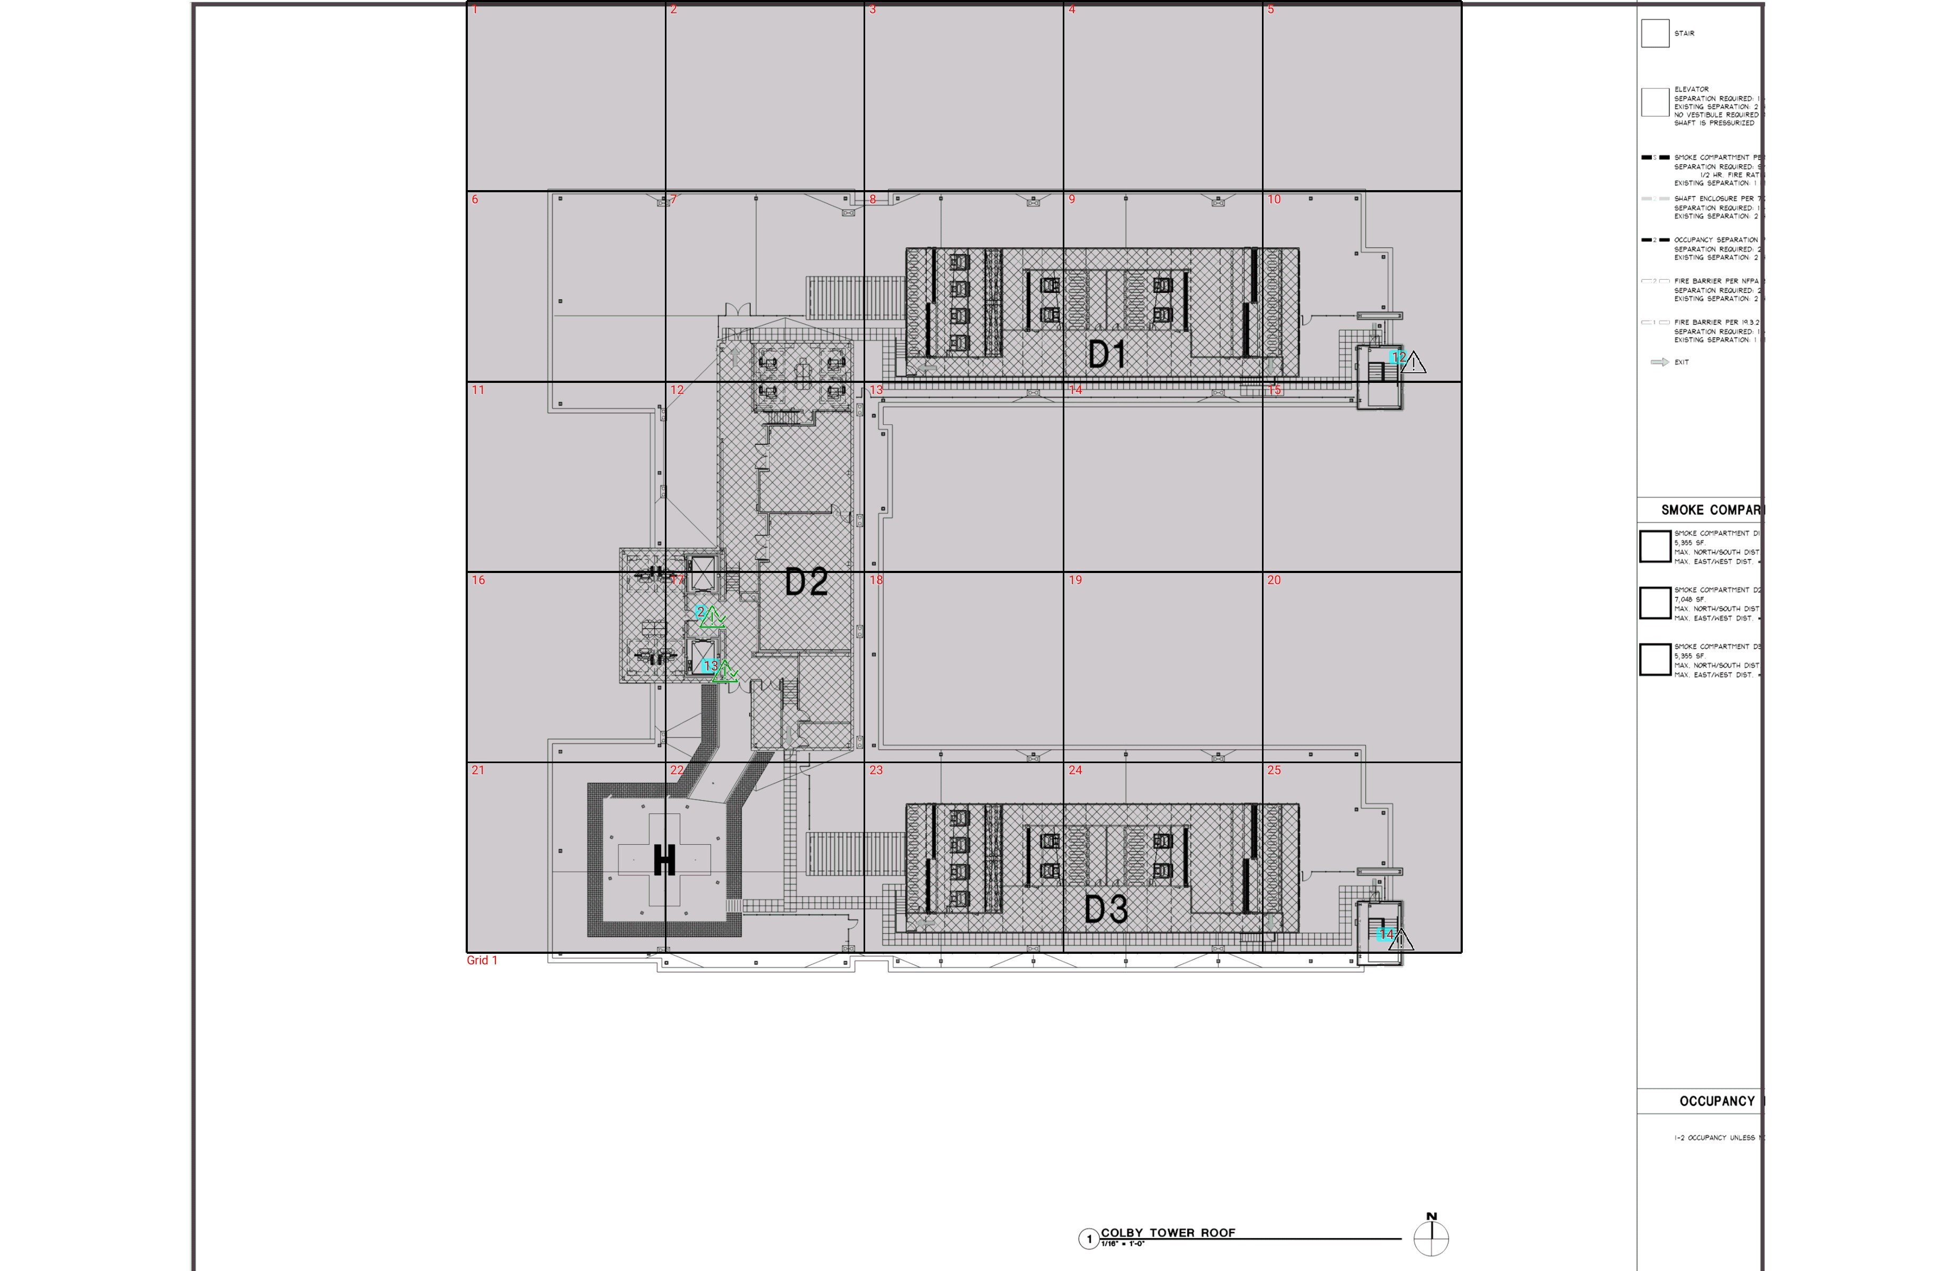

| **Grid** | **# of Areas** | **Area Size (sq. ft)** | **Area Width**  **(ft)** | **Area Height**  **(ft)** | **Ignore Area Color** | **Comments** |
| --- | --- | --- | --- | --- | --- | --- |
| 1 | 25 | 860.38 | 26.25 | 32.77 | Black |  |

**Floor: A.4R**

**Channel: 852937**

| **Critical Point Report** | | | | | | | |
| --- | --- | --- | --- | --- | --- | --- | --- |
| **Critical Point** | **DL**  **Power**  **(dBm)** | **DL**  **DAQ** | **UL**  **Power**  **(dBm)** | **UL**  **DAQ** | **Result** | **DL**  **Loss**  **(dB)** | **Comment** |
| 2 | -77.15 |  |  |  | **Pass** |  |  |
| 12 |  |  |  |  |  |  |  |
| 13 | -82.41 |  |  |  | **Pass** |  |  |
| 14 |  |  |  |  |  |  |  |

| **Area Report** | | | | | | | | |
| --- | --- | --- | --- | --- | --- | --- | --- | --- |
| **Grid** | **Area** | **DL**  **Power**  **(dBm)** | **DL**  **DAQ** | **UL**  **Power**  **(dBm)** | **UL**  **DAQ** | **Result** | **DL**  **Loss**  **(dB)** | **Comment** |
| 1 | 1 | NT | NT | NT | NT | **NT** |  |  |
| 1 | 2 | NT | NT | NT | NT | **NT** |  |  |
| 1 | 3 | NT | NT | NT | NT | **NT** |  |  |
| 1 | 4 | NT | NT | NT | NT | **NT** |  |  |
| 1 | 5 | NT | NT | NT | NT | **NT** |  |  |
| 1 | 6 | NT | NT | NT | NT | **NT** |  |  |
| 1 | 7 | NT | NT | NT | NT | **NT** |  |  |
| 1 | 8 | NT | NT | NT | NT | **NT** |  |  |
| 1 | 9 | NT | NT | NT | NT | **NT** |  |  |
| 1 | 10 | NT | NT | NT | NT | **NT** |  |  |
| 1 | 11 | NT | NT | NT | NT | **NT** |  |  |
| 1 | 12 | NT | NT | NT | NT | **NT** |  |  |
| 1 | 13 | NT | NT | NT | NT | **NT** |  |  |
| 1 | 14 | NT | NT | NT | NT | **NT** |  |  |
| 1 | 15 | NT | NT | NT | NT | **NT** |  |  |
| 1 | 16 | NT | NT | NT | NT | **NT** |  |  |
| 1 | 17 | NT | NT | NT | NT | **NT** |  |  |
| 1 | 18 | NT | NT | NT | NT | **NT** |  |  |
| 1 | 19 | NT | NT | NT | NT | **NT** |  |  |
| 1 | 20 | NT | NT | NT | NT | **NT** |  |  |
| 1 | 21 | NT | NT | NT | NT | **NT** |  |  |
| 1 | 22 | NT | NT | NT | NT | **NT** |  |  |
| 1 | 23 | NT | NT | NT | NT | **NT** |  |  |
| 1 | 24 | NT | NT | NT | NT | **NT** |  |  |
| 1 | 25 | NT | NT | NT | NT | **NT** |  |  |

**Additional Info**